Grade: 6 | Unit: Ratios and Proportional Relationships. Course 1 Chapter 5 |  | Time: 35 days
Critical Skills: (Student Outcomes) | NJ Learning Standards: | Samples/Exemplars: | Resources: | Assessments:
- Understand ratio concepts and use ratio reasoning to solve problems. | 6.RP.A.1. Understand the concept of a ratio and use ratio language to describe a ratio relationship  between two quantities. | The ratio of wings to beaks in the bird house at the zoo was 2:1, because for every 2 wings there was 1 beak.  For every vote candidate A received, candidate C received nearly three votes. | Text(Units/Pages)  5-1  Technology/Open Resources:  https://www.illustrativemathematics.org/content-standards/6/RP/A/1/tasks/76 | Unit 1 assessment  Unit 2 assessment  Unit 3 assessment  Unit 4 assessment  Unit 5 assessment
 | 6.RP.A.2. Understand the concept of a unit rate a/b associated with a ratio a:b with b≠0, and use rate  language in the context of a ratio relationship. | This recipe has a ratio of 3 cups of flour to 4 cups of sugar, so there is 3/4 cup of flour for each cup of sugar.  We paid $75 for  15 hamburgers, which is a rate of $5 per hamburger. | Text(Units/Pages)  5-2  Technology/Open Resources:  https://www.illustrativemathematics.org/content-standards/6/RP/A/2/tasks/549
 | 6.RP.A.3. Use ratio and rate reasoning to solve real-world and mathematical problems. | Reasoning about tables of equivalent ratios, tape diagrams, double number line diagrams, or equations. | Text(Units/Pages)  5-1, 5-2, 5-3  Technology/Open Resources:  https://www.illustrativemathematics.org/content-standards/6/RP/A/3/tasks/66
 | 6.RP.A.3.a  Make tables of equivalent ratios relating quantities with whole number measurements,  find missing values in the tables, and plot the pairs of values on the coordinate plane. Use tables to compare ratios. | Milligrams Grams  ? 6  7,000 7  Which of the following is the missing value in the table above?  A. 6,500  B. 6,000 | Text(Units/Pages)  5-3  Technology/Open Resources  Study Island lesson 2c: Ratios and Units of Measurement
 | 6.RP.A.3.b.  Solve unit rate problems including those involving unit pricing and constant speed. | If it took 7 hours to mow 4 lawns, then at that rate, how many lawns could be in 35 hours? At what rate were lawns being mowed? | Text(Units/Pages)  5-2  Technology/Open Resources  Study Island lesson 2d: Solve Unit Rate Problems
 | 6.RP.A.3.c.  Find a percent of a quantity as a rate per 100 (e.g., 30% of a quantity means 30/100 times the quantity); solve problems involving finding the whole, given a part and the percent. | Selina bought a shirt on sale that was 20% less than the original price. The original price was $5 more than the sale price. What was the original price? Explain or show work.  Solutions  Solution: Tape diagram  Solution: A tape diagram (known in some circles as a strip or bar diagram) shows the solution in a very succinct way:  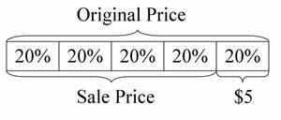  Since the difference between the original price and the sale price is $5, which is also 20% of the original price, the original price is 5 times $5.  The original price was $25.  Solution: Dividing by a fraction  We know that 20% of the original price is $5. Furthermore, 20% of the original price is the same thing as 20100=15 of the original price. We know that 15 of a quantity is 5, so we can solve this problem by dividing 5 by 15 (this is a Group Size Unknown problem).  5÷15=25  So the original price was $25. | Text(Units/Pages)  5-5, 5-6, 5-7, 5-8  Technology/Open Resources:  https://www.illustrativemathematics.org/content-standards/6/RP/A/3/tasks/54
 | 6.RP.A.3.d. Use ratio reasoning to convert measurement units; manipulate and transform units appropriately when multiplying or dividing quantities. | Example:  Convert 16 cups to pints.  Solution:  Since 1 pint equals 2 cups, use that ratio to find how many pints is equal to 16 cups.  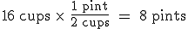  So, 8 pints is equal to 16 cups. | Text(Units/Pages)  5-4  Technology/Open Resources  Study Island lesson 2c: Ratios and Units of Measurement

Grade: 6 | Unit: The Number System. Course 1 chapters 1,3,4,6,7 |  | Time: 35 Days
Critical Skills: (Student Outcomes) | NJ Learning Standards: | Samples/Exemplars: | Resources: | Assessments:
A.  Apply and extend previous understandings of multiplication and division to divide fractions by fractions. | 6.NS.A.1. Interpret and compute quotients of fractions, and solve word problems involving division of  fractions by fractions, e.g., by using visual fraction models and equations to represent the problem. | Create a story context for (2/3) ÷ (3/4) and use a visual fraction model to show the quotient; use the relationship between multiplication and division to explain that (2/3) ÷ (3/4) = 8/9 because 3/4 of 8/9 is 2/3. (In general, (a/b) ÷ (c/d) =ad/bc). How much chocolate will each person get if 3 people share 1/2 lb of chocolate equally? How many 3/4-cup servings are in 2/3 of a cup of yogurt? How wide is a rectangular strip of land with length  3/4 mi and area 1/2 square mi? | Text(Units/Pages)  4-2 through 4-4  Technology/Open Resources:  https://www.illustrativemathematics.org/content-standards/6/NS/A/1/tasks/464
B.  Compute fluently with multi-digit numbers and find common factors and multiples. | 6.NS.B.2. Fluently divide multi-digit numbers using the standard algorithm. | Ray owns a goat farm. He bought 4 baby goats for $520. If they all cost the same amount, how much did each baby goat cost? | Text(Units/Pages)  1-6  Technology/Open Resources  Study Island lesson 3b: Division of Whole Numbers
 | 6.NS.B.3. Fluently add, subtract, multiply, and divide multi-digit decimals using the standard algorithm  for each operation. | Use the fact that 13×17=221 to find the following.  - 13×1.7  Solution  All these solutions use the associative and commutative properties of multiplication (explicitly or implicitly).  - 13×1.7=13×(17×0.1)=(13×17)×0.1, so the product is one-tenth the product of 13 and 17. In other words,  13×1.7=22.1 | Text(Units/Pages)  1-4, 1-5, 1-6  Technology/Open Resources:  https://www.illustrativemathematics.org/content-standards/6/NS/B/3/tasks/272
 | 6.NS.B.4. Find the greatest common factor of two whole numbers less than or equal to 100 and the least common multiple of two whole numbers less than or equal to 12. Use the distributive  property to express a sum of two whole numbers 1–100 with a common factor as a multiple of a sum of two whole numbers with no common factor. | Express 36 + 8 as 4 (9+ 2). | Text(Units/Pages)  3-4, 3-5  Technology/Open Resources:  https://www.illustrativemathematics.org/content-standards/6/NS/B/4/tasks/255  https://www.illustrativemathematics.org/content-standards/6/NS/B/4/tasks/256
C. Apply and extend previous understandings of numbers to the system of rational numbers. | 6.NS.C.5. Understand that positive and negative numbers are used together to describe quantities having opposite directions or values ; use positive and negative numbers to represent quantities in real-world contexts, explaining the meaning of 0 in each situation | Temperature above/below zero, elevation above/below sea level, credits/debits, positive/negative electric charge); | Text(Units/Pages)  6-1, 6-3, 6-4  Technology/Open Resources:  https://www.illustrativemathematics.org/content-standards/6/NS/C/5/tasks/277  https://www.illustrativemathematics.org/content-standards/6/NS/C/5/tasks/278
 | 6.NS.C.6. Understand a rational number as a point on the number line. Extend number line diagrams  and coordinate axes familiar from previous grades to represent points on the line and in the plane with negative number coordinates. |  | Text(Units/Pages)  6-1, 6-3, 6-4, 7-1  Technology/Open Resources  Khan Academy, LearnZillion
 | 6.NS.C.6.a.  Recognize opposite signs of numbers as indicating locations on opposite sides of 0 on the number line; recognize that the opposite of the opposite of a number is the number itself, | –(–3) = 3, and that 0 is its own opposite. | Text(Units/Pages)  6-1  Technology/Open Resources  Study Island Lesson 3f: Opposites
 | 6.NS.C.6.b.  Understand signs of numbers in ordered pairs as indicating locations in quadrants of the coordinate plane; recognize that when two ordered pairs differ only by signs, the locations of the points are related by reflections across one or both axes. |  | Text(Units/Pages)  7-2  Technology/Open Resources  LearnZillion, Khan Academy
 | 6.NS.C.6.c.  Find and position integers and other rational numbers on a horizontal or vertical number  line diagram; find and position pairs of integers and other rational numbers on a  coordinate plane. | What value does the red dot represent on the number line?  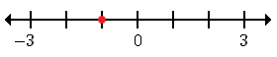 | Text(Units/Pages)  6-1, 6-3, 6-4, 7-1  Technology/Open Resources  Study Island lesson 3g: Number Lines
 | 6.NS.C.7. Understand ordering and absolute value of rational numbers. | A flea is jumping around on the number line.  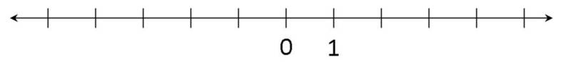If he starts at 1 and jumps 3 units to the right, then where is he on the number line? How far away from zero is he?  Solution: If he starts at 1 and jumps 3 units to the right, then the flea is at 4. He is 4 units away from zero. | Text(Units/Pages)  Technology/Open Resources:  https://www.illustrativemathematics.org/content-standards/6/NS/C/7/tasks/286
 | 6.NS.C.7.a.  Interpret statements of inequality as statements about the relative position of two numbers on a number line diagram. | Interpret –3 > –7 as a statement that –3  is located to the right of –7 on a number line oriented from left to right. | Text(Units/Pages)  6-2, 6-4  Technology/Open Resources:  https://www.illustrativemathematics.org/content-standards/6/NS/C/7/tasks/284
 | 6.NS.C.7.b. Write, interpret, and explain statements of order for rational numbers in real world contexts. | write –3 degrees C >  –7 degrees C to express the fact that  –3 C is warmer than  –7 degrees C. | Text(Units/Pages)  6-3, 6-4  Technology/Open Resources:  https://www.illustrativemathematics.org/content-standards/6/NS/C/7/tasks/285
 | 6.NS.C.7.c.  Understand the absolute value of a rational number as its distance from 0 on the number  line; interpret absolute value as magnitude for a positive or negative quantity in a real‐world situation. | For an account balance of –30 dollars, write |–30| = 30 to describe the size of the debt in dollars. | Text(Units/Pages)  6-1  Technology/Open Resources  Study Island lesson 3i: Absolute Value
 | 6.NS.C.7.d.  Distinguish comparisons of absolute value from statements about order. | Recognize that an account balance less than –30 dollars represents a debt greater than 30 dollars. | Text(Units/Pages)  6-5  Technology/Open Resources  Study Island lesson 3i: Absolute Value
 | 6.NS.C.8. Solve real‐world and mathematical problems by graphing points in all four quadrants of the coordinate plane. Include use of coordinates and absolute value to find distances between points with the same first coordinate or the same second  coordinate | The high and low temperatures, in degrees Fahrenheit, are plotted in the coordinate plane for 8 days in Nome, Alaska.  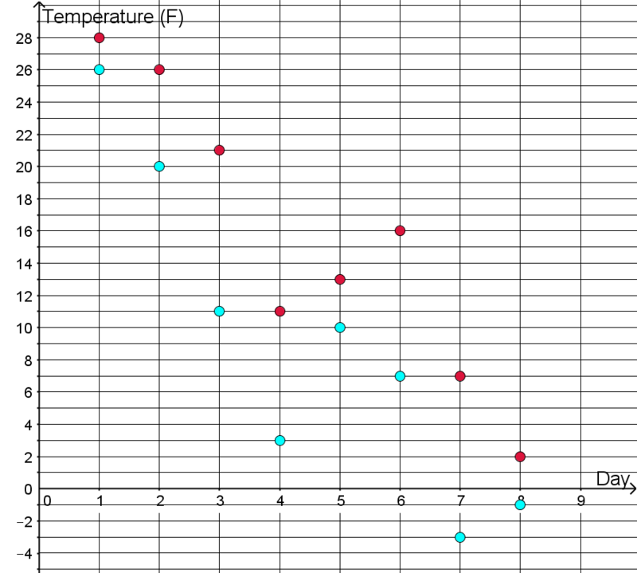  What was the biggest same-day difference between the high and low temperature? On what day did it occur?  Solution: There is a 10 degree difference between the high and low temperature on days 3 and 7. | Text(Units/Pages)  7-1, 7-2  Technology/Open Resources:  https://www.illustrativemathematics.org/content-standards/6/NS/C/8/tasks/2221

Grade: 6 | Unit: Expressions and Equations; Course 1 Chapters 1, 2, 3, 6, 7 |  | Time: 35 Days
Critical Skills: (Student Outcomes) | NJ Learning Standards: | Samples/Exemplars: | Resources: | Assessments:
A. Apply and extend previous understandings of arithmetic to algebraic expressions. | 6.EE.A.1. Write and evaluate numerical expressions involving whole‐number exponents. | After opening an ancient bottle you find on the beach, a Djinni appears. In payment for his freedom, he gives you a choice of either 50,000 gold coins or one magical gold coin. The magic coin will turn into two gold coins on the first day. The two coins will turn into four coins total at the end of two days. By the end or the third day there will be eight gold coins total. The Djinni explains that the magic coins will continue this pattern of doubling each day for one moon cycle, 28 days. Which prize do you choose?  When you have made your choice, answer these questions:  - The number of coins on the third day will be 2×2×2. Can you write another expression using exponents for the number of coins there will be on the third day?  - Write an expression for the number of coins there will be on the 28th day. Is this more or less than a million coins? | Text(Units/Pages)  3-2  Technology/Open Resources:  https://www.illustrativemathematics.org/content-standards/6/EE/A/1/tasks/532
 | 6.EE.A.2. Write, read, and evaluate expressions in which letters stand for numbers. | Give a students any algebraic expression (e.g. 3b+7), and have them evaluate for a particular value (e.g. b=5). | Text(Units/Pages)  2-1, 2-2, 3-2  Technology/Open Resources:  https://www.illustrativemathematics.org/content-standards/6/EE/A/2/tasks/421
 | 6.EE.A.2.a. Write expressions that record operations with numbers and with letters standing for numbers. | Express the calculation “Subtract y from 5” as 5 –y. | Text(Units/Pages)  2-2  Technology/Open Resources  Study Island lesson 4b: Write Expressions with Variables
 | 6.EE.A.2.b.  Identify parts of an expression using mathematical terms (sum,term, product, factor, quotient, coefficient); view one or more parts of an expression as a single entity. | 4 × (2 + 3)  Which of the following describes (2 + 3) in the expression above?  A. product  B. quotient  C. sum  D. difference | Text(Units/Pages) :  1-1, 1-2, 1-5, 1-6, 2-2, 3-6, 3-7,  Technology/Open Resources  Study Island lesson 4c: Parts of an Expression
 | 6.EE.A.2.c. Evaluate  expressions at specific values of their variables. Include  expressions that arise  from formulas used in real‐world problems.  Perform arithmetic operations, including those involving whole  number exponents, in the conventional order when there are no  parentheses to specify  a particular order (Order of Operations). | Use the formulas V = s ᶟ  and A = 6 s²  to find the volume  and surface area of a cube with sides of  length s = 1/2 | Text(Units/Pages)  1-2, 2-1, 3-2  Technology/Open Resources:  https://www.illustrativemathematics.org/content-standards/6/EE/A/2/tasks/2206
 | 6.EE.A.3 Apply the properties of operations to generate equivalent  expressions. | For example, apply  the distributive property to the expression 3 (2 + x) to produce the equivalent expression 6 + 3x; apply the distributive property  to the expression 24x + 18y to produce the equivalent expression  6 (4x + 3y); apply properties of operations to y + y + y to produce the equivalent  expression 3y. | Text(Units/Pages)  1-1, 3-6, 3-7  Technology/Open Resources  Study Island lesson 4e: Equivalent Expressions
 | 6.EE.A.4. Identify when two expressions are equivalent (i.e., when the two expressions name the same  number regardless of which value is  substituted into them). | The expressions y +y + y and 3y are equivalent because they name the same number regardless of which  number y stands for. | Text(Units/Pages)  3-6, 3-7  Technology/Open Resources: https://www.illustrativemathematics.org/content-standards/6/EE/A/4/tasks/461  https://www.illustrativemathematics.org/content-standards/6/EE/A/4/tasks/542
B. Reason about and solve one‐  variable equations and inequalities. | 6.EE.B.5. Understand solving an equation or inequality as a process of answering a question: which  values from a specified set, if any, make the equation or inequality true? Use substitution to determine whether a given number in a specified set makes an equation or inequality true | Think about what this equation means, and find its solution. Write a sentence explaining how you know your solution is correct.  x+6=10  Solution  The number you add to 6 to get 10 is 4, so x=4. | Text(Units/Pages)  2-3, 2-4, 2-5, 2-6, 6-5,6-6  Technology/Open Resources:  https://www.illustrativemathematics.org/content-standards/6/EE/B/5/tasks/2203
 | 6.EE.B.6. Use variables to represent numbers and write expressions when solving a real‐  world or mathematical problem; understand that a variable can represent an unknown number, or, depending on the purpose at hand, any number in a specified set. | Which of the following represents the quotient of and  a.  b.  c.  d. | Text(Units/Pages)  2-1, 2-2, 2-3, 2-4, 2-5, 2-6, 4-5,6-5  Technology/Open Resources  Study Island lesson 4g: Symbolize Problem Situations
 | 6.EE.B.7. Solve real-world and mathematical problems by writing and solving equations of the form x+p = q and px = q for cases in which p, q and x are all nonnegative rational numbers. | Tanner went to the movies on Saturday. He spent $8.25 on the movie ticket plus an additional amount at the snack bar. If Tanner spent a total of $21.20 on his ticket and snacks at the movies, how much did he spend at the snack bar? | Text(Units/Pages)  2-3, 2-4, 4-5  Technology/Open Resources:  https://www.illustrativemathematics.org/content-standards/6/EE/B/7/tasks/1107
 | 6.EE.B.8. Write an inequality of the form  x > c or x < c  to represent a constraint or condition in a real‐world or mathematical problem. Recognize that  inequalities of the form x > c or x < c  have infinitely many solutions; represent solutions of such inequalities on number line diagrams. | Marshall is collecting canned food for his school's food drive. Any student that collects at least 25 cans for the food drive gets an ice cream cone next Friday. As of today, Marshall has not collected enough cans to get an ice cream cone on Friday. Determine an equation or inequality that represents the number of cans Marshall has collected for the food drive as of today.  Solution  Since the number of cans Marshall has collected is unknown, let c stand for the number of cans.  Marshall needs to collect at least 25 cans to get an ice cream cone next Friday. However, as of today, Marshall has not collected enough cans, c, yet. This indicates that the number of cans, c, Marshall has collected as of today must be less than 25.  Therefore, the inequality that represents the number of cans Marshall has collected for the food drive as of today is shown below.  c < 25 | Text(Units/Pages)  6-5  Technology/Open Resources:  https://www.illustrativemathematics.org/content-standards/6/EE/B/8/tasks/642
C. Represent and analyze quantitative relationships between dependent and independent variables. | 6.EE.C.9. Use variables to represent two quantities in a real‐  world problem that  change in relationship  to one another; write an equation to express  one quantity, thought of as the dependent  variable, in terms of the other quantity, thought of as the independent variable. Analyze the  relationship between the dependent and independent variables using graphs and tables, and relate these to the equation. | In a problem involving motion at constant speed, list and graph ordered pairs of distances and times, and write the equation d = 65t to represent the relationship between distance and time involving motion at constant speed,  list and graph ordered pairs of distances and times, and write the equation d = 65t to  represent the  relationship between distance and time. | Text(Units/Pages)  7-3 through 7-5  Technology/Open Resources:  https://www.illustrativemathematics.org/content-standards/6/EE/A/2/tasks/2206

Grade: 6 | Unit: Geometry. Course 1 Chapters 7 and 8 |  | Time: 35 Days
Critical Skills: (Student Outcomes) | NJ Learning Standards: | Samples/Exemplars: | Resources: | Assessments:
 | 6.G.A.2. Find the volume of a right rectangular prism with fractional edge  lengths by packing it with unit cubes of the appropriate unit fraction edge lengths, and show that the volume is the same as would be found by multiplying the edge lengths of the prism. Apply the formulas  V = l w h  and V = B h  to find volumes of right rectangular  prisms with fractional edge lengths in  the context of solving real‐world and mathematical problems. | A dubsnap is a length equal to two snap cube edges. Build a cube using 8 snap cubes of one color. Call this a dubsnap cube, with side length equal to 1 dubsnap, so it has a volume of 1×1×1=1 cubic dubsnap.  - How long (in dubsnaps) are the side lengths of a single snap cube?  - What is the volume of a single snap cube, in cubic dubsnaps? | Text(Units/Pages)  8-5  Technology/Open Resources:  https://www.illustrativemathematics.org/content-standards/6/G/A/2/tasks/2193
 | 6.G.A.3 Draw polygons in the coordinate plane given coordinates for the vertices; use coordinates to find the length of a side joining points with  the same first coordinate or the same second coordinate. Apply these techniques in the context of solving real-world and mathematical problems. | 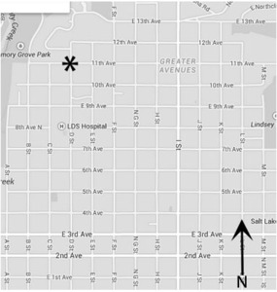  Here is a map of part of Downtown Salt Lake City. You are starting at the corner of 11th Ave. and D St. (on the star).  - If you walk East to I St., South to 7th Ave., West to D St. and then North to your starting point, how many blocks will you have walked in total? Describe the shape of your path.  - Draw and describe in words at least two different ways that you can walk exactly 8 blocks and end up where you started.  - Jessica said the path she took on her walk enclosed a polygon that had an area of 6 square blocks. Draw some possible shapes that her walk could have taken. Was her path necessarily rectangular? | Text(Units/Pages)  7-2  Technology/Open Resources:  https://www.illustrativemathematics.org/content-standards/6/G/A/1/tasks/1188
 | 6.G.A.4 Represent three-dimensional figures using nets made up of rectangles and triangles, and use the nets to find the surface area of these figures. Apply these techniques in the context of solving real-world and mathematical problems | • Below is a net for a three dimensional shape  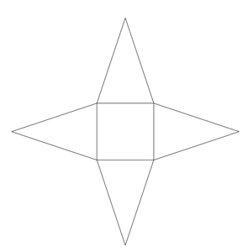  The inner quadrilateral is a square and the four triangles all have the same size and shape.  - What three dimensional shape does this net make? Explain.  - If the side length of the square is 2 units and the height of the triangles is 3 units, what is the surface area of this shape? | Text(Units/Pages)  8-4  Technology/Open Resources:  https://www.illustrativemathematics.org/content-standards/6/G/A/4/tasks/1985

Grade: 6 | Unit: Statistics and Probability. Course 1 chapter 9 |  | Time: 35 Days
Critical Skills: (Student Outcomes) | NJ Learning Standards: | Samples/Exemplars: | Resources: | Assessments:
A. Develop understanding of statistical variability. | 6.SP.A.1 Recognize a statistical question as one that anticipates variability in the data related to the question and accounts for it in the answers. | “How old am I?” is not a statistical  question, but “How old are the students in my school?” is a statistical question because one anticipates  variability in students’ ages. | Text(Units/Pages)  9-8  Technology/Open Resources:  https://www.illustrativemathematics.org/content-standards/6/SP/A/1/tasks/703
 | 6.SP.A.2 Understand that a set of data collected to answer a statistical question  has a distribution which can be described by its center, spread, and  overall shape. | Below are the 25 birth weights, in ounces, of all the Labrador Retriever puppies born at Kingston Kennels in the last six months.  13, 14, 15, 15, 16, 16, 16, 16, 17, 17, 17, 17, 17, 17, 17, 18, 18, 18, 18, 18, 18, 18, 18, 19, 20  a. Use an appropriate graph to summarize these birth weights.  b. Describe the distribution of birth weights for puppies born at Kingston Kennels in the last six months. Be sure to describe shape, center and variability.  c. What is a typical birth weight for puppies born at Kingston Kennels in the last six months? Explain why you chose this value. | Text(Units/Pages)  9-6, 9-7, 9-8  Technology/Open Resources:  https://www.illustrativemathematics.org/content-standards/6/SP/A/3/tasks/2097  https://www.illustrativemathematics.org/content-standards/6/SP/B/5/tasks/2043  https://www.illustrativemathematics.org/content-standards/6/SP/B/4/tasks/1026
 | 6.SP.A.3 Recognize that a measure of center for a numerical data set summarizes all of its values with a single number, while a measure of variation describes how its values vary with a single number. | Bags of M&Ms don’t all have exactly the same number of candies in each bag. Suppose you count the number of candies in each of 25 bags of plain M&Ms and in each of 25 bags of peanut M&Ms, and make two dot plots—one for the number of candies in the plain M&M bags and one for the number of candies in the peanut M&M bags. Question If you wanted to give each student in your class a bag of M&Ms and you wanted to try to make sure that each student got the same number of candies, should you give them bags of plain M&Ms or bags of peanut M&Ms? | Text(Units/Pages)  9-1, 9-2, 9-6  Technology/Open Resources:  https://www.illustrativemathematics.org/content-standards/6/SP/A/3/tasks/2097
B. Summarize and describe distributions. | 6.SP.B.4 Display numerical data in plots on a number line, including dot plots,  histograms, and box plots. | The number of siblings for a group of sixth grade students is shown below:  1,0,2,1,6,0,2,0,1,10.  - Make a dot plot of the data. | Text(Units/Pages)  9-3, 9-4, 9-5  Technology/Open Resources:  https://www.illustrativemathematics.org/content-standards/6/SP/B/5/tasks/2043  https://www.illustrativemathematics.org/content-standards/6/SP/B/4/tasks/1026
 | 6.SP.B.5. a Summarize numerical data sets in relation to their context, such as by reporting the number of observations. | The number of siblings for a group of sixth grade students is shown below:  1,0,2,1,6,0,2,0,1,10.  - Make a dot plot of the data.  - Find the mean and median of the data.  - What does the mean tell you about the data? What about the median?  - Which measure of average (mean or median) do you think best describes the data? Why? | Text(Units/Pages)  9-1, 9-2, 9-4, 9-5  Technology/Open Resources  Study Island lesson 6e: Interpreting Data
 | 6.SP.B.5. b Summarize numerical data sets in relation to their context, such as describing the nature of the attribute under investigation,  including how it was measured and its units of measurement. | How many people rented at least 6 movies during the summer?  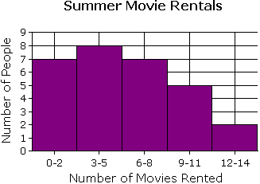  Solution:  To find the number of people who rented at least 6 movies, add up the number of people who rented 6 to 8 movies, 9 to 11 movies, and 12 to 14 movies during the summer.  According to the graph, seven people rented 6 to 8 movies, five people rented 9 to 11 movies, and two people rented 12 to 14 movies.  Therefore, 14 people rented at least 6 movies during the summer. | Text(Units/Pages)  9-4, 9-5  Technology/Open Resources  Study Island lesson 6e: Interpreting Data
 | 6.SP.B.5.c Summarize numerical data sets in relation to their context, such as giving quantitative measures of center (median and/or mean) and variability (interquartile range and/or mean absolute deviation), as well as describing any overall pattern and any  striking deviations  from the overall pattern with reference to the context in which the data were gathered. | The number of siblings for a group of sixth grade students is shown below:  1,0,2,1,6,0,2,0,1,10.  - Find the mean and median of the data.  - What does the mean tell you about the data? What about the median?  - Which measure of average (mean or median) do you think best describes the data? Why? | Text(Units/Pages)  9-1, 9-2, 9-5, 9-6  Technology/Open Resources:  https://www.illustrativemathematics.org/content-standards/6/SP/B/5/tasks/2043
 | 6.SP.B.5.d Summarize numerical data sets in relation to their context, such as relating the choice of measures of center and variability to the shape of the data distribution and the context in which  the data were gathered. | Bobbie is a sixth grader who competes in the 100 meter hurdles. In eight track meets during the season, she recorded the following times (to the nearest one hundredth of a second).  18.11,31.23,17.99,18.25,17.50,35.55,17.44,17.85  - What is the mean of Bobbie's times for these track meets? What does this mean tell you in terms of the context?  - What is the median of Bobbie's times? What does this median tell you in terms of the context?  - What information can you gather by comparison of the mean and median? | Text(Units/Pages)  9-7  Technology/Open Resources:  https://www.illustrativemathematics.org/content-standards/6/SP/B/5/tasks/2048

Assessments | Formative, summative, alternative assessments, performance assessments, project assessments, performance tasks, exit tickets, observations, MAP, benchmarks, Model Curriculum Assessment & Resources
21st Century Skills and Career Integration | Informational sources, text features, appropriate financial literacy skills
Technology Integration | Digital tools; iPads, computers, Reflex Math, Learn Zillion, Illustrated Mathematics
Interdisciplinary Connections | Social Studies and Science- Informational Text
Core Instructional and Supplemental Materials | Core Instruction: Go Math Series, GoMath Support / Intervention Materials, Model Curriculum Resources, Curriculum Resources Folder
Modifications/Accommodations | ELL: Alternate responses, extended time, teacher modeling, simplified directions, vocabulary banks, manipulatives, nonverbal responses, sentence frames, prompts, partner talk  Special Education: Enlarged graph paper, small group instruction, highlighted  instructions/keywords and/or computation signs, hands on activities, visual cues, number line, modified assessment, models  G&T: Enrichment activities, centers, projects, flexible grouping, interest centers, learning log, extension activities, small group  504/Students at Risk: Enlarged graph paper, small group instruction, highlighted  instructions/keywords and/or computation signs, hands on activities, visual cues, number line, modified assessment, models

