Grade: K | Unit: Literature |  | Pacing: 10 days
Key Ideas and Details
Critical Skills (Anchor Standards) | NJ Learning Standards (Progress Indicators): | Samples / Exemplars | Resources: | Assessments / Rubrics
NJSLSA.R1. Read closely to determine what the text says explicitly and to make logical inferences and relevant connections from it; cite specific textual evidence when writing or speaking to support conclusions drawn from the text. | RL.K.1. With prompting and support, ask and answer questions about key details in a text (e.g., who, what, where, when, why, how). | Unit 1 Comprehension  Unit 2 Oral Language | Text (Units / Pages)  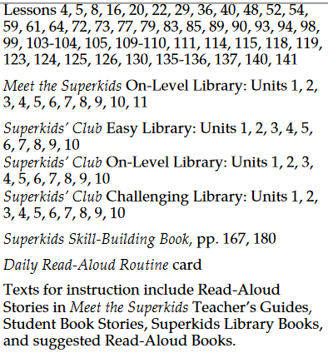  Technology / Open Resources:  Reading Eggs  Read Works  Newsela | Unit 1 Model Curriculum  Unit 2 Model Curriculum  Unit 3 Model Curriculum  Unit 4 Model Curriculum  Unit 5 Model Curriculum
NJSLSA.R2. Determine central ideas or themes of a text and analyze their development; summarize the key supporting details and ideas. | RL.K.2. With prompting and support, retell familiar stories, including key details (e.g., who, what, where, when, why, how). | Unit 1 Comprehension  Unit 3 Comprehension  Unit 5 Text Reading and Comprehension | Text (Units / Pages)  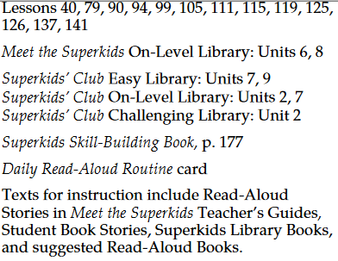  Technology / Open Resources:  Reading Eggs  Read Works  Newsela
NJSLSA.R3. Analyze how and why individuals, events, and ideas develop and interact over the course of a text. | RL.K.3. With prompting and support, identify characters, settings, and major events in a story. | Unit 1 Comprehension  Unit 3 Comprehension | Text (Units / Pages)  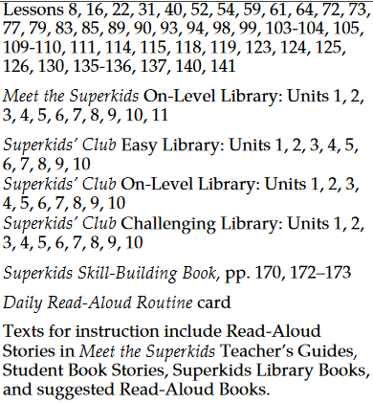  Technology / Open Resources  Reading Eggs  Read Works  Newsela

Grade: K | Unit: Literature |  | Pacing: 10 days
Craft and Structure

Critical Skills (Anchor Standards) | NJ Learning Standards (Progress Indicators): | Samples / Exemplars | Resources: | Assessments / Rubrics
NJSLSA.R4. Interpret words and phrases as they are used in a text, including determining technical, connotative, and figurative meanings, and analyze how specific word choices shape meaning or tone. | RL.K.4. Ask and answer questions about unknown words in a text. |  | Text (Units / Pages)  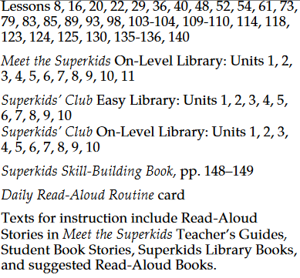  Technology / Open Resources  Reading Eggs  Read Works  Newsela
NJSLSA.R5. Analyze the structure of texts, including how specific sentences, paragraphs, and larger portions of the text (e.g., a section, chapter, scene, or stanza) relate to each other and the whole. | RL.K.5. Recognize common types of texts (e.g., storybooks, poems). |  | Text (Units / Pages)  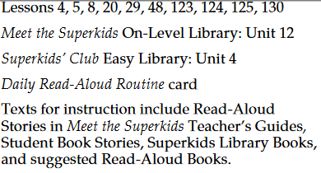  Technology / Open Resources
NJSLSA.R6. Assess how point of view or purpose shapes the content and style of a text. | RL.K.6. With prompting and support, name the author and illustrator of a story and define the role of each in telling the story. |  | Text (Units / Pages)  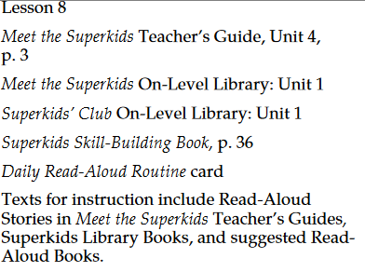  Technology / Open Resources  Reading Eggs  Read Works  Newsela

Grade: K | Unit: Literature Text |  | Pacing: 10 days
Integration of Knowledge and Ideas

Critical Skills (Anchor Standards) | NJ Learning Standards (Progress Indicators): | Samples / Exemplars | Resources: | Assessments / Rubrics
NJSLSA.R7. Integrate and evaluate content presented in diverse media and formats, including visually and quantitatively, as well as in words. | RL.K.7. With prompting and support, describe the relationship between illustrations and the story in which they appear (e.g., what moment in a story an illustration depicts). |  | Text (Units / Pages)  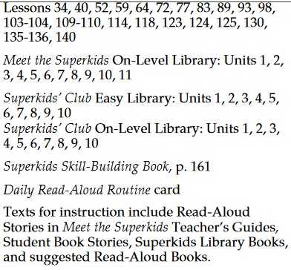  Technology / Open Resources  Reading Eggs  Read Works  Newsela
NJSLSA.R8. Delineate and evaluate the argument and specific claims in a text, including the validity of the reasoning as well as the relevance and sufficiency of the evidence. | RL.K.8. (Not applicable to literature.) |  | Text (Units / Pages)  Technology / Open Resources  Reading Eggs  Read Works  Newsela
NJSLSA.R9. Analyze and reflect on how two or more texts address similar themes or topics in order to build knowledge or to compare the approaches the authors take. | RL.K.9. With prompting and support, compare and contrast the adventures and experiences of characters in familiar stories. | Unit 5 Text Reading and Comprehension | Text (Units / Pages)  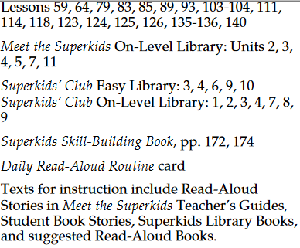  Technology / Open Resources  Reading Eggs  Read Works  Newsela

Grade: K | Unit: Literature |  | Pacing: 15 days
Range of Reading and Level of Text Complexity

Critical Skills (Anchor Standards) | NJ Learning Standards (Progress Indicators): | Samples / Exemplars | Resources: | Assessments / Rubrics
NJSLSA.R10. Read and comprehend complex literary and informational texts independently and proficiently with scaffolding as needed. | RL.K.10. Actively engage in group reading activities with purpose and understanding. | Unit 1 Comprehension  Unit 3 Comprehension | Text (Units / Pages)  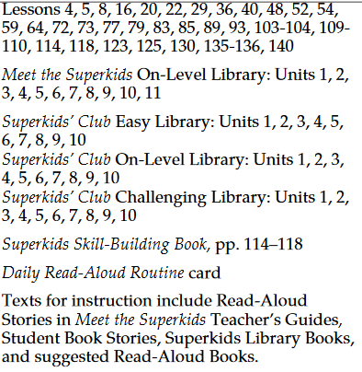  Technology / Open Resources  Reading Eggs  Read Works  Newsela

Grade: K | Unit: Informational Text
Key Ideas and Details
Critical Skills (Anchor Standards) | NJ Learning Standards (Progress Indicators): | Samples / Exemplars | Resources: | Assessments / Rubrics
NJSLSA.R1. Read closely to determine what the text says explicitly and to make logical inferences and relevant connections from it; cite specific textual evidence when writing or speaking to support conclusions drawn from the text. | RI.K.1. With prompting and support, ask and answer questions about key details in a text. | Unit 1 Comprehension  Unit 2 Oral Language | Text (Units / Pages)  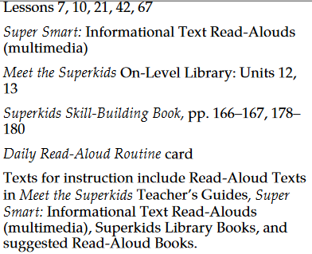  Technology / Open Resources  Reading Eggs  Read Works  Newsela
NJSLSA.R2. Determine central ideas or themes of a text and analyze their development; summarize the key supporting details and ideas. | RI.K.2. With prompting and support, identify the main topic and retell key details of a text. | Unit 1 Comprehension  Unit 3 Comprehension | Text (Units / Pages)  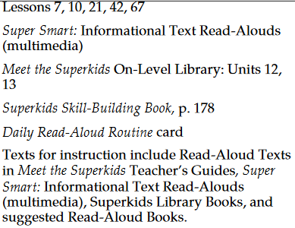  Technology / Open Resources  Reading Eggs  Read Works  Newsela
NJSLSA.R3. Analyze how and why individuals, events, and ideas develop and interact over the course of a text. | RI.K.3. With prompting and support, describe the connection between two individuals, events, ideas, or pieces of information in a text. | Unit 5 Text Reading and Comprehension | Text (Units / Pages)  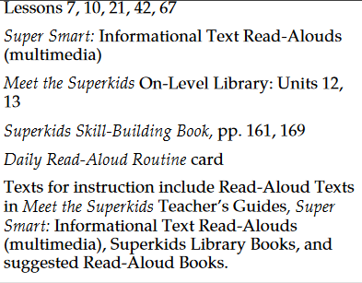  Technology / Open Resources  Reading Eggs  Read Works  Newsela

Grade: K | Unit: Informational Text |  | Pacing: 10 days
Craft and Structure

Critical Skills (Anchor Standards) | NJ Learning Standards (Progress Indicators): | Samples / Exemplars | Resources: | Assessments / Rubrics
NJSLSA.R4. Interpret words and phrases as they are used in a text, including determining technical, connotative, and figurative meanings, and analyze how specific word choices shape meaning or tone. | RI.K.4. With prompting and support, ask and answer questions about unknown words in a text. | Unit 5 Text Reading and Comprehension | Text (Units / Pages)  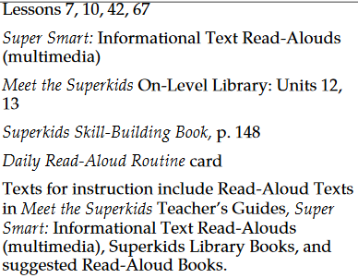  Technology / Open Resources  Reading Eggs  Read Works  Newsela
NJSLSA.R5. Analyze the structure of texts, including how specific sentences, paragraphs, and larger portions of the text (e.g., a section, chapter, scene, or stanza) relate to each other and the whole. | RI.K.5. Identify the front cover, back cover, and title page of a book. | Unit 1 Print Concepts | Text (Units / Pages)  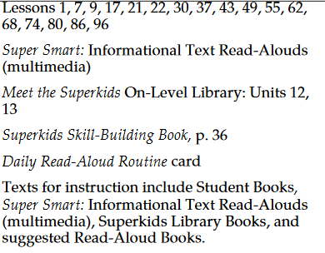  Technology / Open Resources
NJSLSA.R6. Assess how point of view or purpose shapes the content and style of a text. | RI.K.6. Name the author and illustrator of a text and define the role of each in presenting the ideas or information in a text. |  | Text (Units / Pages)  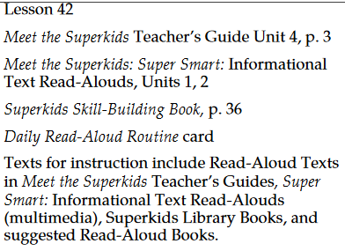  Technology / Open Resources  Reading Eggs  Read Works  Newsela

Grade: K | Unit: Informational Text
Integration of Knowledge and Ideas

Critical Skills (Anchor Standards) | NJ Learning Standards (Progress Indicators): | Samples / Exemplars | Resources: | Assessments / Rubrics
NJSLSA.R7. Integrate and evaluate content presented in diverse media and formats, including visually and quantitatively, as well as in words. | RI.K.7. With prompting and support, describe the relationship between illustrations and the text in which they appear (e.g., what person, place, thing, or idea in the text an illustration depicts). |  | Text (Units / Pages)  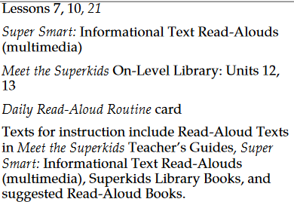  Technology / Open Resources  Reading Eggs  Read Works  Newsela
NJSLSA.R8. Delineate and evaluate the argument and specific claims in a text, including the validity of the reasoning as well as the relevance and sufficiency of the evidence. | RI.K.8. With prompting and support, identify the reasons an author gives to support points in a text. |  | Text (Units / Pages)  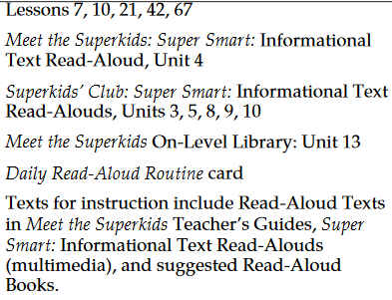  Technology / Open Resources  Reading Eggs  Read Works  Newsela
NJSLSA.R9. Analyze and reflect on how two or more texts address similar themes or topics in order to build knowledge or to compare the approaches the authors take. | RI.K.9. With prompting and support, identify basic similarities in and differences between two texts on the same topic (e.g., in illustrations, descriptions, or procedures). | Unit 5 Text Reading and Comprehension | Text (Units / Pages)  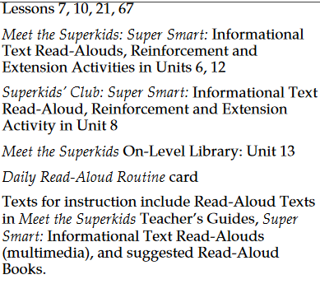  Technology / Open Resources  Reading Eggs  Read Works  Newsela

Grade: K | Unit: Informational Text |  | Pacing: 10 days
Range of Reading and Level of Text Complexity

Critical Skills (Anchor Standards) | NJ Learning Standards (Progress Indicators): | Samples / Exemplars | Resources: | Assessments / Rubrics
NJSLSA.R10. Read and comprehend complex literary and informational texts independently and proficiently with scaffolding as needed. | RI.K.10. Actively engage in group reading activities with purpose and understanding. | Unit 1 Comprehension  Unit 3 Comprehension | Text (Units / Pages)  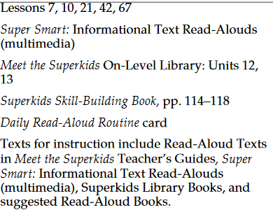  Technology / Open Resources  Reading Eggs  Read Works  Newsela

Grade: K | Unit: Reading Foundation Skills |  | Pacing: 10 days
Print Concepts
Critical Skills (Anchor Standards) | NJ Learning Standards (Progress Indicators): | Samples / Exemplars | Resources: | Assessments / Rubrics
 | RF.K.1. Demonstrate understanding of the organization and basic features of print. |  | Text (Units / Pages)  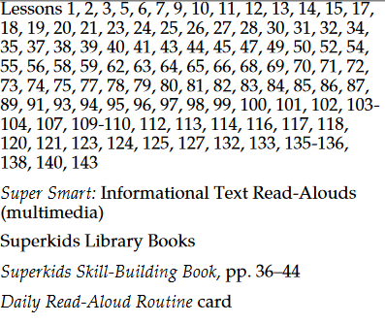  Technology/Open Resources  Reading Eggs  Read Works  Newsela
 | A. Follow words from left to right, top to bottom, and page by page. | Unit 2 Print Concepts  Unit 3 Print Concepts
 | B. Recognize that spoken words are represented in written language by specific sequences of letters. | Unit 2 Print Concepts  Unit 3 Print Concepts
 | C. Understand that words are separated by spaces in print. | Unit 2 Print Concepts  Unit 3 Print Concepts
 | D. Recognize and name all upper- and lowercase letters of the alphabet. | Unit 5 Letter Sound Identification

Grade: K | Unit: Reading Foundation Skills |  | Pacing: 15 days
Phonological Awareness

Critical Skills (Anchor Standards) | NJ Learning Standards (Progress Indicators): | Samples / Exemplars | Resources: | Assessments / Rubrics
 | RF.K.2. Demonstrate understanding of spoken words, syllables, and sounds (phonemes). |  | Text (Units / Pages)  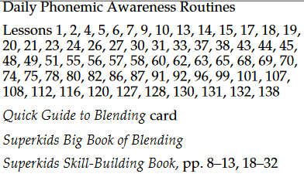  Technology / Open Resources  Reading Eggs  Read Works  Newsela
 | A. Recognize and produce rhyming words. | Unit 1 Phonemic Awareness  Unit 3 Phonemic Awareness
 | B. Count, pronounce, blend, and segment syllables in spoken words. | Unit 1 Phonemic Awareness  Unit 3 Phonemic Awareness
 | C. Blend and segment onsets and rimes of single-syllable spoken words. | Unit 3 Phonemic Awareness  Unit 5 Phonemic Awareness and Word Reading
 | D. Isolate and pronounce the initial, medial vowel, and final sounds (phonemes) in three-phoneme (consonant-vowel-consonant, or CVC) words. (This does not include CVCs ending with /l/, /r/, or /x/.) | Unit 5 Phonemic Awareness and Word Reading
 | E. Add or substitute individual sounds (phonemes) in simple, one-syllable words to make new words. | Unit 5 Phonemic Awareness and Word Reading

Grade: K | Unit: Reading Foundation Skills |  | Pacing: 10 days
Phonics and Word Recognition

Critical Skills (Anchor Standards) | NJ Learning Standards (Progress Indicators): | Samples / Exemplars | Resources: | Assessments / Rubrics
 | RF.K.3. Know and apply grade-level phonics and word analysis skills in decoding and encoding words. |  | Text (Units / Pages)  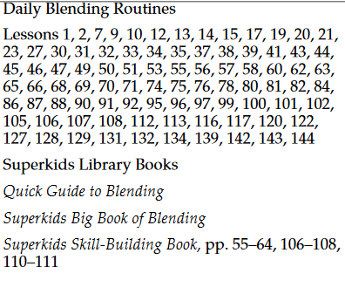  Technology / Open Resources  Reading Eggs  Read Works  Newsela
 | A. Demonstrate basic knowledge of one-to-one letter-sound correspondences by producing many of the most frequently used sounds of each consonant. | Unit 2 Letter and Sound Identification  Unit 3 Letter and Sound Recognition  Unit 5 Letter Sound Identification
 | B. Associate the long and short sounds with the common spellings (graphemes) for the five major vowels.
 | C. Read high-frequency and sight words with automaticity. | Unit 3 Phonemic Awareness
 | D. Distinguish between similarly spelled words by identifying the sounds of the letters that differ (e.g., nap and tap; cat and cot).

Grade: K | Unit: Reading Foundation Skills |  | Pacing: 10 days
Fluency

Critical Skills (Anchor Standards) | NJ Learning Standards (Progress Indicators): | Samples / Exemplars | Resources: | Assessments / Rubrics
 | RF.K.4. Read emergent text with one-to-one correspondence to develop fluency and comprehension skills. | Unit 5 Text Reading and Comprehension | Text (Units / Pages)  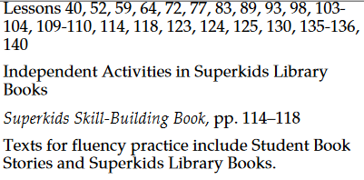  Technology / Open Resources  Reading Eggs  Read Works  Newsela
 | A. Read emergent-readers with purpose and understanding.
 | B. Read grade level text for purpose and understanding.

Grade: K | Unit: Writing |  | Pacing: 10 days
Text Types and Purposes

Critical Skills (Anchor Standards) | NJ Learning Standards (Progress Indicators): | Samples / Exemplars | Resources: | Assessments / Rubrics
NJSLSA.W1. Write arguments to support claims in an analysis of substantive topics or texts, using valid reasoning and relevant and sufficient evidence. | W.K.1. Use a combination of drawing, dictating, and writing to compose opinion pieces in which they tell a reader the topic or the name of the book they are writing about and state an opinion or preference about the topic or book (e.g., My favorite book is...). | Unit 1 Writing  Unit 3 Writing  Unit 5 Writing | Text (Units / Pages)  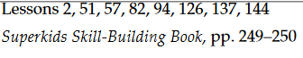  Technology / Open Resources
NJSLSA.W2. Write informative/explanatory texts to examine and convey complex ideas and information clearly and accurately through the effective selection, organization, and analysis of content. | W.K.2. Use a combination of drawing, dictating, and writing to compose informative/explanatory texts in which they name what they are writing about and supply some information about the topic. | Unit 2 Writing  Unit 3 Writing  Unit 5 Writing | Text (Units / Pages)  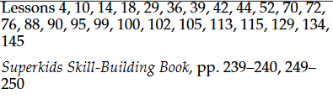  Technology / Open Resources
NJSLSA.W3. Write narratives to develop real or imagined experiences or events using effective technique, well-chosen details, and well-structured event sequences. | W.K.3. Use a combination of drawing, dictating, and writing to narrate a single event or several loosely linked events, tell about the events in the order in which they occurred, and provide a reaction to what happened. | Unit 2 Writing  Unit 5 Writing | Text (Units / Pages)  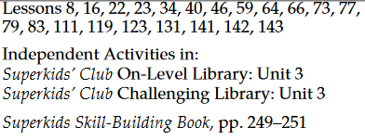  Technology / Open Resources

Grade: K | Unit: Writing |  | Pacing: 10 days
Production and Distribution of Writing

Critical Skills (Anchor Standards) | NJ Learning Standards (Progress Indicators): | Samples / Exemplars | Resources: | Assessments / Rubrics
NJSLSA.W4. Produce clear and coherent writing in which the development, organization, and style are appropriate to task, purpose, and audience. | W.K.4. (Begins in grade 3) |  | Text (Units / Pages)  Begins in grade 3  Technology / Open Resources
NJSLSA.W5. Develop and strengthen writing as needed by planning, revising, editing, rewriting, or trying a new approach. | W.K.5. With guidance and support from adults, strengthen writing through response and self-reflection using questions and suggestions from peers (e.g., adding details). | Unit 2 Writing  Unit 5 Writing | Text (Units / Pages)  Technology / Open Resources
NJSLSA.W6. Use technology, including the Internet, to produce and publish writing and to interact and collaborate with others. | W.K.6. With guidance and support from adults, explore a variety of digital tools to produce and publish writing, including in collaboration with peers. |  | Text (Units / Pages)  Technology / Open Resources

Grade: K | Unit: Writing |  |  |  | Pacing: 15 days
Research to Build and Present Knowledge

Critical Skills (Anchor Standards) |  | NJ Learning Standards (Progress Indicators): |  | Samples / Exemplars | Resources: | Assessments / Rubrics
NJSLSA.W7. Conduct short as well as more sustained research projects, utilizing an inquiry-based research process, based on focused questions, demonstrating understanding of the subject under investigation. | W.K.7. Participate in shared research and writing projects (e.g., explore a number of books by a favorite author and express opinions about them). |  | Unit 3 Writing |  | Text (Units / Pages)  Technology / Open Resources
NJSLSA.W8. Gather relevant information from multiple print and digital sources, assess the credibility and accuracy of each source, and integrate the information while avoiding plagiarism. | W.K.8. With guidance and support from adults, recall information from experiences or gather information from provided sources to answer a question. |  |  |  | Text (Units / Pages)  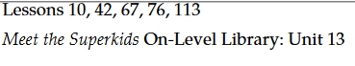  Technology / Open Resources
NJSLSA.W9. Draw evidence from literary or informational texts to support analysis, reflection, and research. | W.K.9. (Begins in grade 4) |  |  |  | Text (Units / Pages)  Begins in grade 4  Technology / Open Resources

Grade: K | Unit: Writing |  | Pacing: 10 days
Range of Writing

Critical Skills (Anchor Standards) | NJ Learning Standards (Progress Indicators): | Samples / Exemplars | Resources: | Assessments / Rubrics
NJSLSA.W10. Write routinely over extended time frames (time for research, reflection, and revision) and shorter time frames (a single sitting or a day or two) for a range of tasks, purposes, and audiences. | W.K.10. (Begins in grade 3) |  | Text (Units / Pages)  Begins in grade 3  Technology / Open Resources

Grade: K | Unit: Speaking and Listening |  | Pacing: 15 days
Comprehension and Collaboration
Critical Skills (Anchor Standards) | NJ Learning Standards (Progress Indicators): | Samples / Exemplars | Resources: | Assessments / Rubrics
NJSLSA.SL1. Prepare for and participate effectively in a range of conversations and collaborations with diverse partners, building on others’ ideas and expressing their own clearly and persuasively. | SL.K.1. Participate in collaborative conversations with diverse partners about kindergarten topics and texts with peers and adults in small and larger groups. |  | Text (Units / Pages)  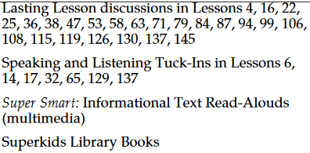  Technology / Open Resources
 | - Follow agreed-upon norms for discussions (e.g., listening to others with care and taking turns speaking about the topics and texts under discussion). | Unit 1 Oral Language  Unit 2 Oral Language
 | - Continue a conversation through multiple exchanges. | Unit 1 Oral Language  Unit 2 Oral Language
NJSLSA.SL2. Integrate and evaluate information presented in diverse media and formats, including visually, quantitatively, and orally. | SL.K.2. Confirm understanding of a text read aloud or information presented orally or through other media by asking and answering questions about key details and requesting clarification if something is not understood. | Unit 1 Comprehension  Unit 1 Oral Language  Unit 2 Oral Language | Texts (Units/Pages)  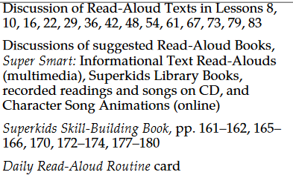  Technology/Open Resources
NJSLSA.SL3. Evaluate a speaker’s point of view, reasoning, and use of evidence and rhetoric. | SL.K.3. Ask and answer questions in order to seek help, get information, or clarify something that is not understood. | Unit 2 Oral Language  Unit 5 Text Reading and Comprehension | Texts (units/pages)  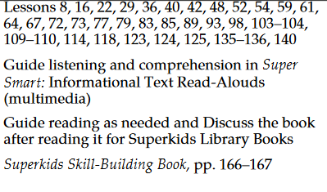  Technology/Open Resources

Grade: K |  | Unit: Speaking and Listening |  |  |  | Pacing: 10 days
Presentation of Knowledge and Ideas
Critical Skills (Anchor Standards) |  | NJ Learning Standards (Progress Indicators): | Samples / Exemplars |  |  | Resources: |  | Assessments / Rubrics
NJSLSA.SL4. Present information, findings, and supporting evidence such that listeners can follow the line of reasoning and the organization, development, and style are appropriate to task, purpose, and audience. |  | SL.K.4. Describe familiar people, places, things, and events and, with prompting and support, provide additional detail. | Unit 1 Oral Language  Unit 2 Oral Language |  |  | Text (Units / Pages)  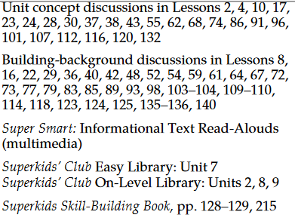  Technology / Open Resources
NJSLSA.SL5. Make strategic use of digital media and visual displays of data to express information and enhance understanding of presentations. |  | SL.K.5. Add drawings or other visual displays to descriptions as desired to provide additional detail. | Unit 3 Writing |  |  | Text (Units / Pages)  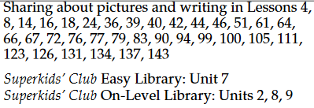  Technology / Open Resources
NJSLSA.SL6. Adapt speech to a variety of contexts and communicative tasks, demonstrating command of formal English when indicated or appropriate. |  | SL.K.6. Speak audibly and express thoughts, feelings, and ideas clearly. | Unit 2 Oral Language |  |  | Text (Units / Pages)  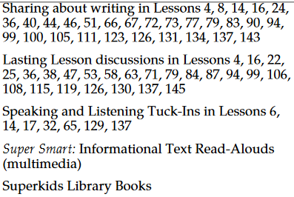  Technology / Open Resources
Grade: 1 | Unit: Language |  |  |  | Pacing: 15 days
Conventions of Standard English

Critical Skills (Anchor Standards) | NJ Learning Standards (Progress Indicators): |  |  | Samples / Exemplars | Resources: |  | Assessments / Rubrics
NJSLSA.L1. Demonstrate command of the conventions of standard English grammar and usage when writing or speaking. | L.K.1. Demonstrate command of the conventions of standard English grammar and usage when writing or speaking. |  |  |  | Text (Units / Pages)  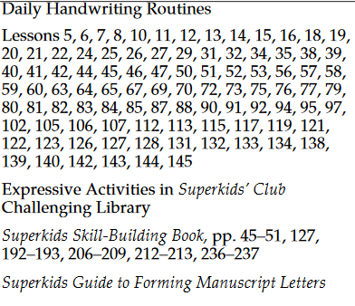  Technology / Open Resources
 | A. Print many upper- and lowercase letters. |  |  | Unit 3 Writing
 | B. Use frequently occurring nouns and verbs. |  |  | Unit 1 Oral Language  Unit 2 Oral Language
 | C. Form regular plural nouns orally by adding /s/ or /es/ (e.g., dog, dogs; wish, wishes).
 | D. Understand and use question words (interrogatives) (e.g., who, what, where, when, why, how). |  |  | Unit 1 Oral Language
 | E. Use the most frequently occurring prepositions (e.g., to, from, in, out, on, off, for, of, by, with). |  |  | Unit 1 Oral Language  Unit 2 Oral Language
 | F. Produce and expand complete sentences in shared language activities.
NJSLSA.L2. Demonstrate command of the conventions of standard English capitalization, punctuation, and spelling when writing. | L.K.2. Demonstrate command of the conventions of standard English capitalization, punctuation, and spelling when writing. |  |  |  | Texts (units/pages)  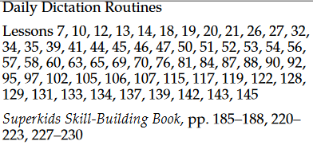
 | A. Capitalize the first word in a sentence and the pronoun I.
 | - Capitalize the first word in a sentence and the pronoun I.
 | - Recognize and name end punctuation.
 | - Write a letter or letters for most consonant and short-vowel sounds (phonemes).
 | - Spell simple words phonetically, drawing on knowledge of sound-letter relationships.

Grade: 1 | Unit: Language |  | Pacing: 15 days
Vocabulary Acquisition and Usage
Critical Skills (Anchor Standards) | NJ Learning Standards (Progress Indicators): | Samples / Exemplars | Resources: | Assessments / Rubrics
NJSLSA.L4. Determine or clarify the meaning of unknown and multiple-meaning words and phrases by using context clues, analyzing meaningful word parts, and consulting general and specialized reference materials, as appropriate. | L.K.4. Determine or clarify the meaning of unknown and multiple-meaning words and phrases based on kindergarten reading and content. |  | Text (Units / Pages)  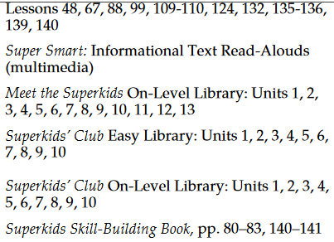  Technology / Open Resources
 | A. Identify new meanings for familiar words and apply them accurately (e.g., knowing duck is a bird and learning the verb to duck).
 | B. Use the most frequently occurring affixes (e.g., -ed, -s, -ing) as a clue to the meaning of an unknown word.
NJSLSA.L5. Demonstrate understanding of word relationships and nuances in word meanings. | L.K.5. With guidance and support from adults, explore word relationships and nuances in word meanings. |  | Texts (Units/Pages)  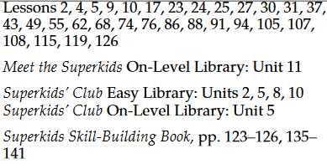  Technology/Open Resources
 | A. Sort common objects into categories (e.g., shapes, foods) to gain a sense of the concepts the categories represent.
 | B. Demonstrate understanding of frequently occurring verbs and adjectives by relating them to their opposites (antonyms).
 | C. Identify real-life connections between words and their use (e.g., note places at school that are colorful).
 | D. Distinguish shades of meaning among verbs describing the same general action (e.g., walk, march, strut, prance) by acting out the meanings. | Unit 2 Oral Language
NJSLSA.L6. Acquire and use accurately a range of general academic and domain-specific words and phrases sufficient for reading, writing, speaking, and listening at the college and career readiness level; demonstrate independence in gathering vocabulary knowledge when encountering an unknown term important to comprehension or expression. | L.K.6. Use words and phrases acquired through conversations, reading and being read to, and responding to texts. | Unit 1 Oral Language  Unit 2 Oral Language | Texts (Units/Pages)  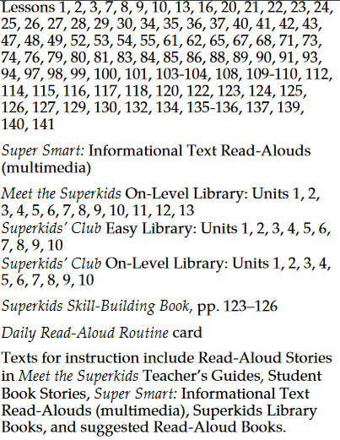

Assessments | Formative, summative, alternative assessments, performance assessments, project assessments, performance tasks, exit tickets, observations, MAP, benchmarks, Reading Eggs
21st Century Skills and Career Integration | Informational sources, text features
Technology Integration | Digital tools; online series, Reading Eggs, Reading A-Z, Newsela, Read Works
Interdisciplinary Connections | Social Studies and Science- Informational Text
Core Instructional and Supplemental Materials | Core Instruction: Project Read, Orton Gilligham, Super Kids Series  Supplemental: picture books, fictional and non-fictional books, videos
Modifications/Accommodations | ELL: Alternate responses, extended time, teacher modeling, simplified directions, vocabulary banks, manipulatives, nonverbal responses, sentence frames, prompts, partner talk  Special Education: Enlarged graph paper, small group instruction, highlighted  instructions/keywords and/or computation signs, hands on activities, visual cues, number line, modified assessment, models  G&T: Enrichment activities, centers, projects, flexible grouping, interest centers, learning log, extension activities, small group  504/Students at Risk: Enlarged graph paper, small group instruction, highlighted  instructions/keywords and/or computation signs, hands on activities, visual cues, number line, modified assessment, models

