Grade: 4 | Unit: Literature |  | Pacing: 15 days
Key Ideas and Details

Critical Skills (Anchor Standards) | NJ Learning Standards (Progress Indicators): | Samples / Exemplars | Resources: | Assessments / Rubrics
NJSLSA.R1. Read closely to determine what the text says explicitly and to make logical inferences and relevant connections from it; cite specific textual evidence when writing or speaking to support conclusions drawn from the text. | RL.4.1. Refer to details and examples in a text and make relevant connections when explaining what the text says explicitly and when drawing inferences from the text. | Charlotte’s Web  Corn  Penguins | Text (Units / Pages)  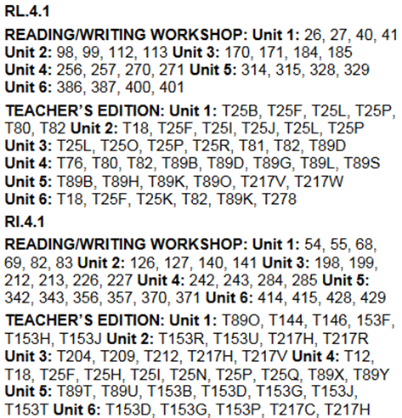  Technology / Open Resources  Making Inferences  Center Activities(for all RL standards)
NJSLSA.R2. Determine central ideas or themes of a text and analyze their development; summarize the key supporting details and ideas. | RL.4.2. Determine a theme of a story, drama, or poem from details in the text; summarize the text. | Charlotte’s Web  Corn  Penguins | Text (Units / Pages)  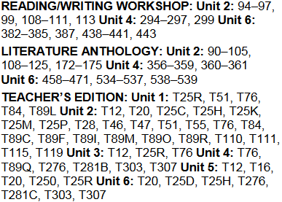  Technology / Open Resources
NJSLSA.R3. Analyze how and why individuals, events, and ideas develop and interact over the course of a text | RL.4.3. Describe in depth a character, setting, or event in a story or drama, drawing on specific details in the text (e.g., a character’s thoughts, words, or actions). | Charlotte’s Web  Corn | Text (Units / Pages)  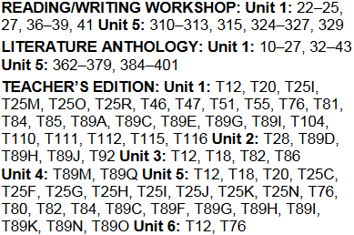  Technology / Open Resources  Character Maps

Grade: 4 | Unit: Literature |  | Pacing: 10 days
Craft and Structure

Critical Skills (Anchor Standards) | NJ Learning Standards (Progress Indicators): | Samples / Exemplars | Resources: | Assessments / Rubrics
NJSLSA.R4. Interpret words and phrases as they are used in a text, including determining technical, connotative, and figurative meanings, and analyze how specific word choices shape meaning or tone. | RL.4.4. Determine the meaning of words and phrases as they are used in a text, including those that allude to significant characters found in literature. | Corn  Penguins | Text (Units / Pages)  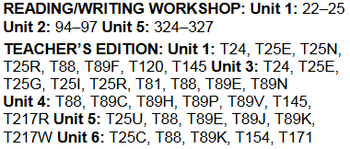  Technology / Open Resources
NJSLSA.R5. Analyze the structure of texts, including how specific sentences, paragraphs, and larger portions of the text (e.g., a section, chapter, scene, or stanza) relate to each other and the whole. | RL.4.5. Explain major differences between poems, drama, and prose, and refer to the structural elements of poems (e.g., verse, rhythm, meter) and drama (e.g., casts of characters, settings, descriptions, dialogue, stage directions) when writing or speaking about a text. | Charlotte’s Web  Corn | Text (Units / Pages)  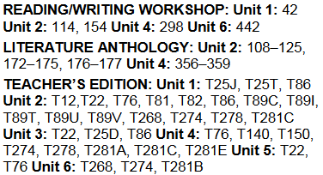  Technology / Open Resources
NJSLSA.R6. Assess how point of view or purpose shapes the content and style of a text | RL.4.6. Compare and contrast the point of view from which different stories are narrated, including the difference between first- and third-person narrations | Charlotte’s Web  Penguins | Text (Units / Pages)  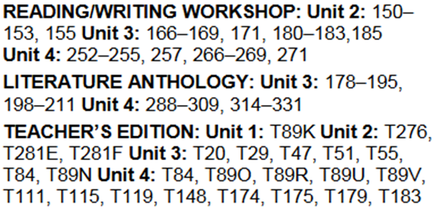  Technology / Open Resources  Read Works  Newsela

Grade: 4 | Unit: Literature Text |  | Pacing: 10 days
Integration of Knowledge and Ideas

Critical Skills (Anchor Standards) | NJ Learning Standards (Progress Indicators): | Samples / Exemplars | Resources: | Assessments / Rubrics
NJSLSA.R7. Integrate and evaluate content presented in diverse media and formats, including visually and quantitatively, as well as in words. | RL.4.7. Make connections between specific descriptions and directions in a text and a visual or oral representation of the text | Sample: RL.4.7 | Text (Units / Pages)  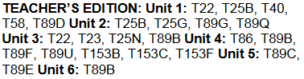  Technology / Open Resources
NJSLSA.R8. Delineate and evaluate the argument and specific claims in a text, including the validity of the reasoning as well as the relevance and sufficiency of the evidence. | RL.4.8. (Not applicable to literature) |  | Text (Units / Pages)  Technology / Open Resources
NJSLSA.R9. Analyze and reflect on how two or more texts address similar themes or topics in order to build knowledge or to compare the approaches the authors take. | RL.4.9. Compare, contrast and reflect on (e.g. practical knowledge, historical/cultural context, and background knowledge) stories in the same genre (e.g., mysteries and adventure stories) on their approaches to similar themes and topics. | Penguins | Text (Units / Pages)  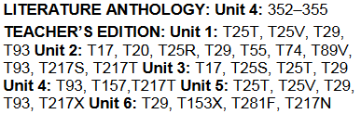  Technology / Open Resources  Read Works  Newsela

Grade: 4 | Unit: Literature |  | Pacing: 15 days
Range of Reading and Level of Text Complexity

Critical Skills (Anchor Standards) | NJ Learning Standards (Progress Indicators): | Samples / Exemplars | Resources: | Assessments / Rubrics
NJSLSA.R10. Read and comprehend complex literary and informational texts independently and proficiently with scaffolding as needed. | RL.4.10. By the end of the year, read and comprehend literature, including stories, dramas, and poems at grade level text-complexity or above, with scaffolding as needed. |  | Text (Units / Pages)  Taught throughout the year  Technology / Open Resources  Read Works  Newsela

Grade: 4 | Unit: Informational Text |  | Pacing: 15 days
Key Ideas and Details

Critical Skills (Anchor Standards) | NJ Learning Standards (Progress Indicators): | Samples / Exemplars | Resources: | Assessments / Rubrics
NJSLSA.R1. Read closely to determine what the text says explicitly and to make logical inferences and relevant connections from it; cite specific textual evidence when writing or speaking to support conclusions drawn from the text. | RI.4.1. Refer to details and examples in a text and make relevant connections when explaining what the text says explicitly and when drawing inferences from the text. | Cowboys  Penguins | Text (Units / Pages)  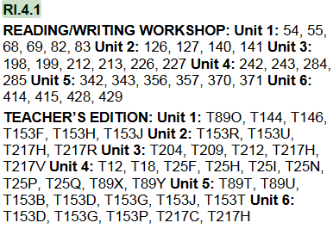  Technology / Open Resources  Read Works  Newsela
NJSLSA.R2. Determine central ideas or themes of a text and analyze their development; summarize the key supporting details and ideas. | RI.4.2. Determine the main idea of a text and explain how it is supported by key details; summarize the text. | Cowboys  Penguins | Text (Units / Pages)  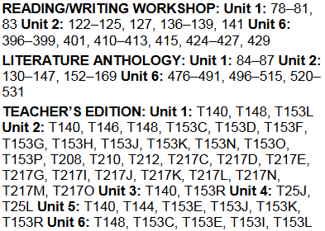  Technology / Open Resources  Main Idea
NJSLSA.R3. Analyze how and why individuals, events, and ideas develop and interact over the course of a text | RI.4.3. Explain events, procedures, ideas, or concepts in a historical, scientific, or technical text, including what happened and why, based on specific information in the text. | Cowboys | Text (Units / Pages)  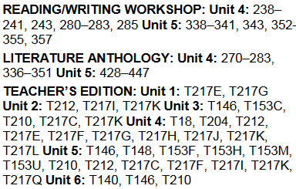  Technology / Open Resources  Read Works  Newsela

Grade: 4 | Unit: Informational Text |  | Pacing: 15 days
Craft and Structure

Critical Skills (Anchor Standards) | NJ Learning Standards (Progress Indicators): | Samples / Exemplars | Resources: | Assessments / Rubrics
NJSLSA.R4. Interpret words and phrases as they are used in a text, including determining technical, connotative, and figurative meanings, and analyze how specific word choices shape meaning or tone. | RI.4.4. Determine the meaning of general academic and domain-specific words or phrases in a text relevant to a grade 4 topic or subject area. | Cowboys  Penguins | Text (Units / Pages)  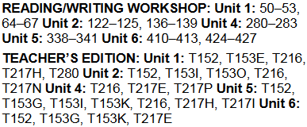  Technology / Open Resources  Read Works  Newsela
NJSLSA.R5. Analyze the structure of texts, including how specific sentences, paragraphs, and larger portions of the text (e.g., a section, chapter, scene, or stanza) relate to each other and the whole. | RI.4.5. Describe the overall structure (e.g., chronology, comparison, cause/effect, problem/solution) of events, ideas, concepts, or information in a text or part of a text. | Penguins | Text (Units / Pages)  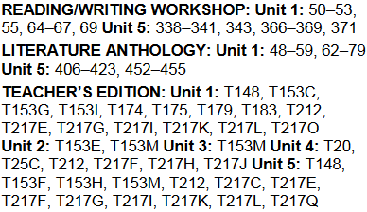  Technology / Open Resources  Read Works  Newsela
NJSLSA.R6. Assess how point of view or purpose shapes the content and style of a text | RI.4.6. Compare and contrast a firsthand and secondhand account of the same event or topic; describe the differences in focus and the information provided. | Penguins | Text (Units / Pages)  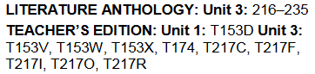  Technology / Open Resources  Read Works  Newsela

Grade: 4 | Unit: Informational Text |  | Pacing: 10 days
Integration of Knowledge and Ideas

Critical Skills (Anchor Standards) | NJ Learning Standards (Progress Indicators): | Samples / Exemplars | Resources: | Assessments / Rubrics
NJSLSA.R7. Integrate and evaluate content presented in diverse media and formats, including visually and quantitatively, as well as in words. | RI.4.7. Interpret information presented visually, orally, or quantitatively (e.g., in charts, graphs, diagrams, time lines, animations, or interactive elements on Web pages) and explain how the information contributes to an understanding of the text in which it appears. | Penguins | Text (Units / Pages)  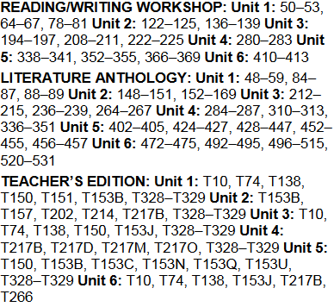  Technology / Open Resources
NJSLSA.R8. Delineate and evaluate the argument and specific claims in a text, including the validity of the reasoning as well as the relevance and sufficiency of the evidence. | RI.4.8. Explain how an author uses reasons and evidence to support particular points in a text. | Computer Games | Text (Units / Pages)  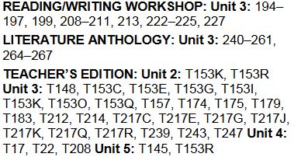  Technology / Open Resources
NJSLSA.R9. Analyze and reflect on how two or more texts address similar themes or topics in order to build knowledge or to compare the approaches the authors take. | RI.4.9. Integrate and reflect on (e.g. practical knowledge, historical/cultural context, and background knowledge) information from two texts on the same topic in order to write or speak about the subject knowledgeably. | Computer Games | Text (Units / Pages)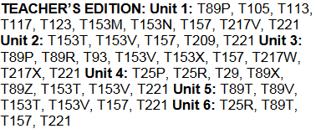  Technology / Open Resources  Read Works  Newsela

Grade: 4 | Unit: Informational Text |  | Pacing: 15 days
Range of Reading and Level of Text Complexity

Critical Skills (Anchor Standards) | NJ Learning Standards (Progress Indicators): | Samples / Exemplars | Resources: | Assessments / Rubrics
NJSLSA.R10. Read and comprehend complex literary and informational texts independently and proficiently with scaffolding as needed. | RI.4.10. By the end of year, read and comprehend literary nonfiction at grade level text-complexity or above, with scaffolding as needed. |  | Text (Units / Pages)  Taught throughout the year  Technology / Open Resources

Grade: 4 | Unit: Reading Foundation Skills |  | Pacing: 10 days
Phonological Awareness

Critical Skills (Anchor Standards) | NJ Learning Standards (Progress Indicators): | Samples / Exemplars | Resources: | Assessments / Rubrics
 | RF.4.3. Know and apply grade-level phonics and word analysis skills in decoding and encoding words.  - Use combined knowledge of all letter-sound correspondences, syllabication patterns, and morphology (e.g., roots and affixes) to read accurately unfamiliar multisyllabic words in context and out of context. |  | Text (Units / Pages)  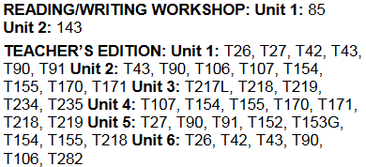  Technology / Open Resources  Center Activities

Grade: 4 | Unit: Reading Foundation Skills |  | Pacing: 10 days
Fluency

Critical Skills (Anchor Standards) | NJ Learning Standards (Progress Indicators): | Samples / Exemplars | Resources: | Assessments / Rubrics
 | RF.4.4. Read with sufficient accuracy and fluency to support comprehension. |  | Text (Units / Pages)  Practice Book Pages, weekly  Technology / Open Resources  RazKids-Fluency Recording  Fluency Passages
 | RF.4.4.A: Read grade-level text with purpose and understanding. |  | Text (Units / Pages)  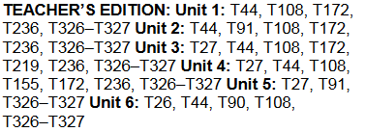  Technology / Open Resources  RazKids-Fluency Recording
 | RF.4.4.B: Read grade-level prose and poetry orally with accuracy, appropriate rate, and expression. |  | Text (Units / Pages)  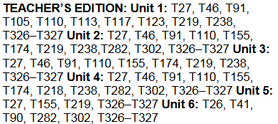  Technology / Open Resources  RazKids-Fluency Recording
 | RF.4.4.C: Use context to confirm or self-correct word recognition and understanding, rereading as necessary. |  | Text (Units / Pages)  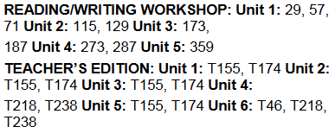  Technology / Open Resources  RazKids-Fluency Recording

Grade: 4 | Unit: Writing |  | Pacing: 15 days
Text Types and Purposes

Critical Skills (Anchor Standards) | NJ Learning Standards (Progress Indicators): | Samples / Exemplars | Resources: | Assessments / Rubrics
NJSLSA.W1. Write arguments to support claims in an analysis of substantive topics or texts, using valid reasoning and relevant and sufficient evidence. | W4.1.:Write opinion pieces on topics or texts, supporting a point of view with reasons and information | Charlotte's Web  Opinion Writing prompt and rubric at the end of the document. Covers all standards W.1 | Text (Units / Pages)  Technology / Open Resources
 | W4.1A: Introduce a topic or text clearly, state an opinion, and create an organizational structure in which related ideas are grouped to support the writer’s purpose. |  | Text (Units / Pages)  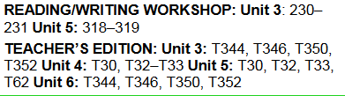  Technology / Open Resources  Study Island Writing Lessons
 | W4.1B: Provide reasons that are supported by facts from texts and/or other sources. |  | Text (Units / Pages)  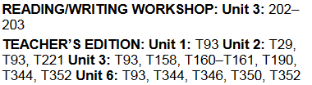  Technology / Open Resources  Study Island Writing Lessons
 | W4.1C: Link opinion and reasons using words and phrases (e.g., for instance, in order to, in addition).
 | W4.1D: Provide a conclusion related to the opinion presented. |  | Text (Units / Pages)  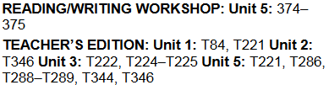  Technology / Open Resources  Study Island Writing Lessons
NJSLSA.W2. Write informative/explanatory texts to examine and convey complex ideas and information clearly and accurately through the effective selection, organization, and analysis of content. | W.4.2  Write informative/explanatory texts to examine a topic and convey ideas and information clearly. | Cowboys  Penguins  Computer Games | Text (Units / Pages)  Technology / Open Resources
 | W.4.2A: Introduce a topic clearly and group related information in paragraphs and sections; include formatting (e.g., headings), illustrations, and multimedia when useful to aiding comprehension. | Cowboys  Penguins  Computer Games | Text (Units / Pages)  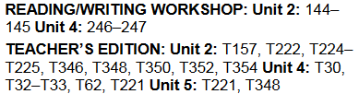  Technology / Open Resources  Study Island Writing Lessons
 | W.4.2B: Develop the topic with facts, definitions, concrete details, text evidence, or other information and examples related to the topic. | Cowboys  Penguins  Computer Games | Text (Units / Pages)  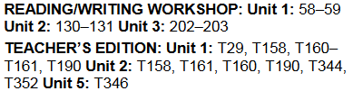  Technology / Open Resources  Study Island Writing Lessons
 | W.4.2C: Link ideas within paragraphs and sections of information using words and phrases (e.g., another, for example, also, because). | Penguins  Computer Games | 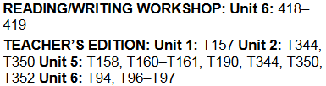
 | W.4.2D: Use precise language and domain-specific vocabulary to inform about or explain the topic. | Penguins  Computer Games | Text (Units / Pages)  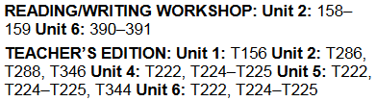  Technology / Open Resources  Study Island Writing Lessons
 | W.4.2E: Provide a conclusion related to the information or explanation presented | Cowboys  Penguins  Computer Games | Text (Units / Pages)  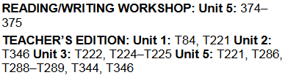  Technology / Open Resources  Study Island Writing Lessons
NJSLSA.W3. Write narratives to develop real or imagined experiences or events using effective technique, well-chosen details, and well-structured event sequences. | Write narratives to develop real or imagined experiences or events using narrative technique, descriptive details, and clear event sequences. | Corn | Text (Units / Pages)  Technology / Open Resources  Narrative Plans
 | W.4.3A: Orient the reader by establishing a situation and introducing a narrator and/or characters; organize an event sequence that unfolds naturally. | Corn | Text (Units / Pages)  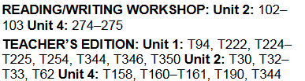  Technology / Open Resources  Study Island Writing Lessons
 | W.4.3B: Use dialogue and description to develop experiences and events or show the responses of characters to situations. | Corn | Text (Units / Pages)  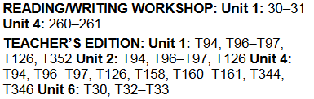  Technology / Open Resources  Study Island Writing Lessons
 | W.4.3C: Use a variety of transitional words and phrases to manage the sequence of events. | Corn | Text (Units / Pages)  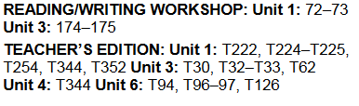  Technology / Open Resources  Study Island Writing Lessons
 | W.4.3D: Use concrete words and phrases and sensory details to convey experiences and events precisely. | Corn | Text (Units / Pages)  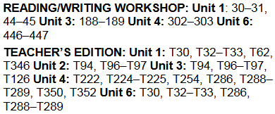  Technology / Open Resources  Study Island Writing Lessons
 | W.4.3E: Provide a conclusion that follows from the narrated experiences or events. | Corn | Text (Units / Pages)  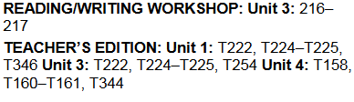  Technology / Open Resources  Study Island Writing Lessons
NJSLSA.W4. Produce clear and coherent writing in which the development, organization, and style are appropriate to task, purpose, and audience. | Produce clear and coherent writing in which the development and organization are appropriate to task, purpose, and audience. (Grade-specific expectations for writing types are defined in standards 1–3 above.) |  | Text (Units / Pages)  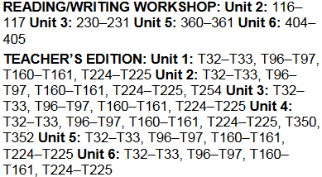  Technology / Open Resources

Grade: 4 | Unit: Writing |  | Pacing: 15 days
Critical Skills (Anchor Standards) | NJ Learning Standards (Progress Indicators): | Samples / Exemplars | Resources: | Assessments / Rubrics
NJSLSA.W5. Develop and strengthen writing as needed by planning, revising, editing, rewriting, or trying a new approach. | With guidance and support from peers and adults, develop and strengthen writing as needed by planning, revising, and editing. |  | Text (Units / Pages)  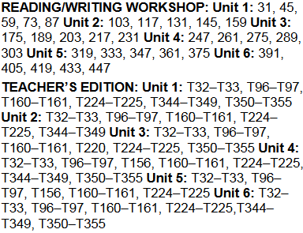  Technology / Open Resources
NJSLSA.W6. Use technology, including the Internet, to produce and publish writing and to interact and collaborate with others. | With some guidance and support from adults, use technology, including the Internet, to produce and publish writing as well as to interact and collaborate with others; demonstrate sufficient command of keyboarding skills to type a minimum of one page in a single sitting. |  | Text (Units / Pages)  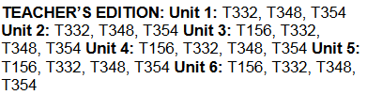  Technology / Open Resources  Microsoft Office  Sway  Animoto
NJSLSA.W7. Conduct short as well as more sustained research projects, utilizing an inquiry-based research process, based on focused questions, demonstrating understanding of the subject under investigation | Conduct short research projects that build knowledge through investigation of different aspects of a topic. |  | Text (Units / Pages)  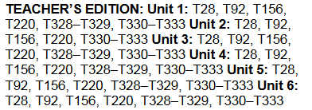  Technology / Open Resources
NJSLSA.W8. Gather relevant information from multiple print and digital sources, assess the credibility and accuracy of each source, and integrate the information while avoiding plagiarism. | Recall relevant information from experiences or gather relevant information from print and digital sources; take notes and categorize information, and provide a list of sources. | W.4.8 SI  Recalling Information | Text (Units / Pages)  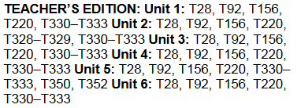  Technology / Open Resources
NJSLSA.W9. Draw evidence from literary or informational texts to support analysis, reflection, and research. | Draw evidence from literary or informational texts to support analysis, reflection, and research.
 | W.4.9A: Apply grade 4 Reading standards to literature (e.g., “Describe in depth a character, setting, or event in a story or drama, drawing on specific details in the text [e.g., a character’s thoughts, words, or actions].”). |  | Text (Units / Pages)  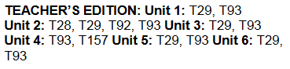  Technology / Open Resources
 | W.4.9B: Apply grade 4 Reading standards to informational texts (e.g., “Explain how an author uses reasons and evidence to support particular points in a text”). |  | Text (Units / Pages)  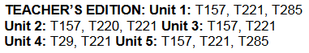  Technology / Open Resources
NJSLSA.W10. Write routinely over extended time frames (time for research, reflection, and revision) and shorter time frames (a single sitting or a day or two) for a range of tasks, purposes, and audiences. | W.4.10. Write routinely over extended time frames (time for research, reflection, metacognition/self-correction and revision) and shorter time frames (a single sitting or a day or two) for a range of discipline-specific tasks, purposes, and audiences. |  | Text (Units/Pages)  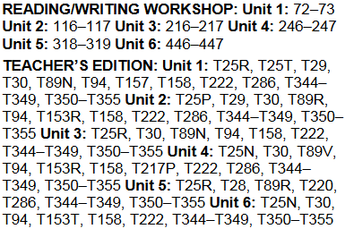  Technology/Open Resources  Study Island: Create a written assignment

Grade: 4 | Unit: Speaking and Listening |  | Pacing: 10 days
Critical Skills (Anchor Standards) | NJ Learning Standards (Progress Indicators): | Samples / Exemplars | Resources: | Assessments / Rubrics
NJSLSA.SL1. Prepare for and participate effectively in a range of conversations and collaborations with diverse partners, building on others’ ideas and expressing their own clearly and persuasively. | SL.4.1. Engage effectively in a range of collaborative discussions (one-on-one, in groups, and teacher-led) with diverse partners on grade 4 topics and texts, building on others’ ideas and expressing their own clearly. |  | Text (Units / Pages)  Technology / Open Resources
 | SL.4.1A: Explicitly draw on previously read text or material and other information known about the topic to explore ideas under discussion. |  | Text (Units / Pages)  Technology / Open Resources
 | SL.4.1B: Follow agreed-upon rules for discussions and carry out assigned roles. |  | Text (Units / Pages)  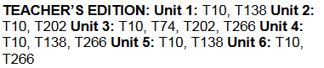  Technology / Open Resources
 | SL.4.1C: Pose and respond to specific questions to clarify or follow up on information, and make comments that contribute to the discussion and link to the remarks of others. |  | Text (Units / Pages)  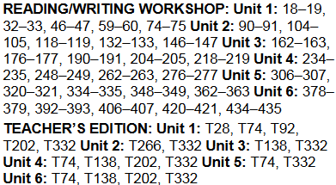  Technology / Open Resources  Text Talks
 | SL.4.1D: Review the key ideas expressed and explain their own ideas and understanding in light of the discussion. |  | Text (Units / Pages)  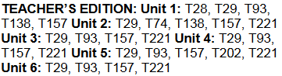  Technology / Open Resources
NJSLSA.SL2. Integrate and evaluate information presented in diverse media and formats, including visually, quantitatively, and orally. | SL.4.2. Paraphrase portions of a text read aloud or information presented in diverse media and formats (e.g. Visually, quantitatively, and orally). |  | Text (Units / Pages)  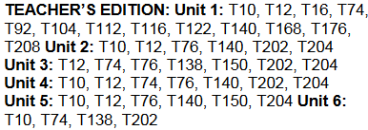  Technology / Open Resources
NJSLSA.SL3. Evaluate a speaker’s point of view, reasoning, and use of evidence and rhetoric. | SL.4.3. Identify the reasons and evidence a speaker provides to support particular points. |  | Text (Units / Pages)  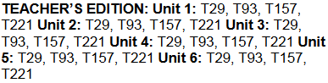  Technology / Open Resources
NJSLSA.SL4. Present information, findings, and supporting evidence such that listeners can follow the line of reasoning and the organization, development, and style are appropriate to task, purpose, and audience. | SL.4.4. Report on a topic or text, tell a story, or recount an experience in an organized manner, using appropriate facts and relevant, descriptive details to support main ideas or themes; speak clearly at an understandable pace. |  | Text (Units / Pages)  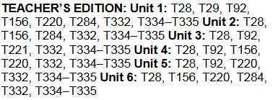  Technology / Open Resources
NJSLSA.SL5. Make strategic use of digital media and visual displays of data to express information and enhance understanding of presentations. | SL.4.5. Add audio recordings and visual displays to presentations when appropriate to enhance the development of main ideas or themes. |  | 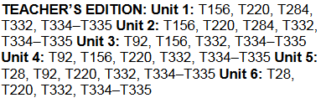
NJSLSA.SL6. Adapt speech to a variety of contexts and communicative tasks, demonstrating command of formal English when indicated or appropriate. | SL.4.6. Differentiate between contexts that call for formal English (e.g., presenting ideas) and situations where informal discourse is appropriate (e.g., small-group discussion); use formal English when appropriate to task and situation. |  | Text (Units / Pages)  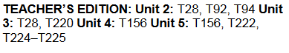  Technology / Open Resources

Grade: 4 | Unit: Language |  | Pacing: 15 days
Critical Skills (Anchor Standards) | NJ Learning Standards (Progress Indicators): | Samples / Exemplars | Resources: | Assessments / Rubrics
NJSLSA.L1. Demonstrate command of the conventions of standard English grammar and usage when writing or speaking. | L4.1: Demonstrate command of the conventions of standard English grammar and usage when writing or speaking. |  | 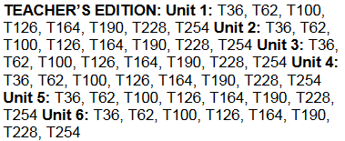  Technology/Open Resources  Center Activities (for all Language standards)
 | L4.1A: Use relative pronouns (who, whose, whom, which, that) and relative adverbs (where, when, why). | Pronouns | Text (Units / Pages)  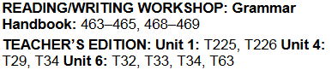  Technology / Open Resources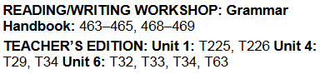
 | L4.1B: Form and use the progressive (e.g., I was walking; I am walking; I will be walking) verb tenses. | Verbs SI | Text (Units / Pages)  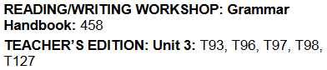  Technology / Open Resources
 | L4.1C: Use modal auxiliaries (e.g., can, may, must) to convey various conditions. | Auxiliaries | Text (Units / Pages)  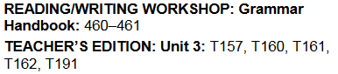  Technology / Open Resources
 | L4.1D: Order adjectives within sentences according to conventional patterns (e.g., a small red bag rather than a red small bag). | Adjectives | Text (Units / Pages)  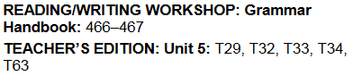  Technology / Open Resources
 | L4.1E: Form and use prepositional phrases. | Prepositions | Text (Units / Pages)  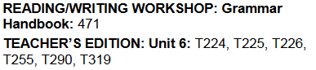  Technology / Open Resources
 | L4.1F: Produce complete sentences, recognizing and correcting inappropriate fragments and run-ons. | Fragments and run ons | Text (Units / Pages)  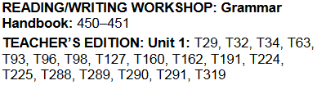  Technology / Open Resources
 | L4.1G: Correctly use frequently confused words (e.g., to, too, two; there, their). | Confused Words | Text (Units / Pages)  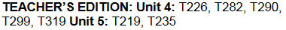  Technology / Open Resources  Commonly Confused Words
NJSLSA.L2. Demonstrate command of the conventions of standard English capitalization, punctuation, and spelling when writing. | L.4.2. Demonstrate command of the conventions of standard English capitalization, punctuation, and spelling when writing. |  | Text (Units / Pages)  Technology / Open Resources  Study Island  Spelling Practice
 | L4.2A: Use correct capitalization. | Capitalization | Text (Units / Pages)  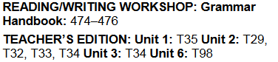  Technology / Open Resources
 | L4.2B: Use commas and quotation marks to mark direct speech and quotations from a text. |  | 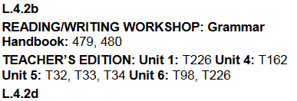
 | L4.2C: Use a comma before a coordinating conjunction in a compound sentence. |  | Text (Units / Pages)  Technology / Open Resources
 | L4.2D: Spell grade-appropriate words correctly, consulting references as needed |  | Texts (Units/Topics)  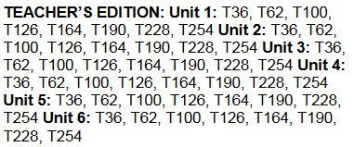
NJSLSA.L3. Apply knowledge of language to understand how language functions in different contexts, to make effective choices for meaning or style, and to comprehend more fully when reading or listening. | L.4.3. Use knowledge of language and its conventions when writing, speaking, reading, or listening.
 | L4.3A: Choose words and phrases to convey ideas precisely. |  | Texts (Units/Topics)  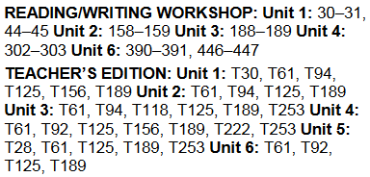
 | L4.3B: Choose punctuation for effect. |  | Texts (Units/Pages)  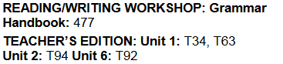
 | L4.3C: Differentiate between contexts that call for formal English (e.g., presenting ideas) and situations where informal discourse is appropriate (e.g., small-group discussion). |  | Texts (Units/Topics)  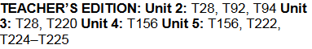
NJSLSA.L4. Determine or clarify the meaning of unknown and multiple-meaning words and phrases by using context clues, analyzing meaningful word parts, and consulting general and specialized reference materials, as appropriate. | L.4.4. Determine or clarify the meaning of unknown and multiple-meaning words and phrases based on grade 4 reading and content, choosing flexibly from a range of strategies. |  | Texts (Units/Topics)  Technology/Open Resources  Context Clues Resources
 | L4.4A: Use context (e.g., definitions, examples, or restatements in text) as a clue to the meaning of a word or phrase. |  | Texts (units/pages)  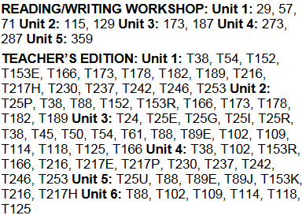
 | L4.4B: Use common, grade-appropriate Greek and Latin affixes and roots as clues to the meaning of a word (e.g., telegraph, photograph, autograph). |  | Texts (Units/Topics)  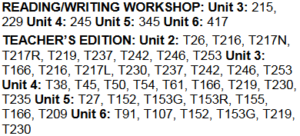
 | L4.4C: Consult reference materials (e.g., dictionaries, glossaries, thesauruses), both print and digital, to find the pronunciation and determine or clarify the precise meaning of key words and phrases. |  | Texts (Units/Pages)  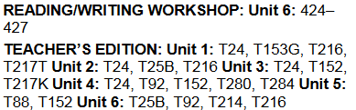
NJSLSA.L5. Demonstrate understanding of word relationships and nuances in word meanings. | L.4.5. Demonstrate understanding of figurative language, word relationships, and nuances in word meanings.
 | L4.5A: Explain the meaning of simple similes and metaphors (e.g., as pretty as a picture) in context. |  | Texts (units/pages)  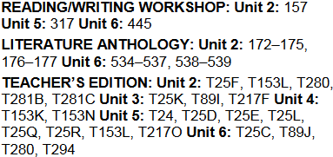
 | L4.5B: Recognize and explain the meaning of common idioms, adages, and proverbs. |  | Texts (Units/Pages)  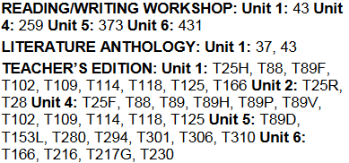
 | L4.5A: Demonstrate understanding of words by relating them to their opposites (antonyms) and to words with similar but not identical meanings (synonyms). |  | Text (Units / Pages)  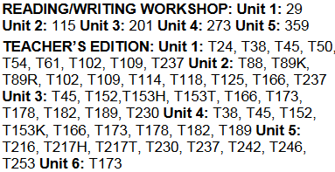  Technology / Open Resources
NJSLSA.L6. Acquire and use accurately a range of general academic and domain-specific words and phrases sufficient for reading, writing, speaking, and listening at the college and career readiness level; demonstrate independence in gathering vocabulary knowledge when encountering an unknown term important to comprehension or expression. | L.4.6. Acquire and use accurately grade-appropriate general academic and domain-specific words and phrases, including those that signal precise actions, emotions, or states of being (e.g., quizzed, whined, stammered) and that are basic to a particular topic (e.g., wildlife, conservation, and endangered when discussing animal preservation). |  | Text (Units / Pages)  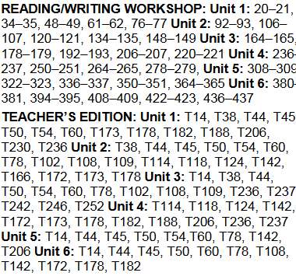  Technology / Open Resources

Assessments | Formative, summative, alternative assessments, performance assessments, project assessments, performance tasks, exit tickets, observations, MAP, benchmarks, Study Island
21st Century Skills and Career Integration | Informational sources, text features
Technology Integration | Digital tools; online series, Study Island, Reading A-Z, Newsela, Read Works
Interdisciplinary Connections | Social Studies and Science- Informational Text
Core Instructional and Supplemental Materials | Core Instruction: Project Read, Orton Gilling ham, Reading Wonders Series  Supplemental: picture books, fictional and non-fictional books, videos
Modifications/Accommodations | ELL: Alternate responses, extended time, teacher modeling, simplified directions, vocabulary banks, manipulatives, nonverbal responses, sentence frames, prompts, partner talk  Special Education: Enlarged graph paper, small group instruction, highlighted  instructions/keywords and/or computation signs, hands on activities, visual cues, number line, modified assessment, models  G&T: Enrichment activities, centers, projects, flexible grouping, interest centers, learning log, extension activities, small group  504/Students at Risk: Enlarged graph paper, small group instruction, highlighted  instructions/keywords and/or computation signs, hands on activities, visual cues, number line, modified assessment, models

