Grade: 3 | Unit: Literature Reading Wonders |  | Pacing: 15 days
Key Ideas and Details

Critical Skills (Anchor Standards) | NJ Learning Standards (Progress Indicators): | Samples / Exemplars | Resources: | Assessments / Rubrics
NJSLSA.R1. Read closely to determine what the text says explicitly and to make logical inferences and relevant connections from it; cite specific textual evidence when writing or speaking to support conclusions drawn from the text. | RL.3.1. Ask and answer questions, and make relevant connections to demonstrate understanding of a text, referring explicitly to the text as the basis for the answers. | Sam competed in the skateboarding contest on Saturday at Wilkerson Park. The contest started at 10 am. Sam had practiced very hard for many days. He knew he was ready. He did his best tricks. At noon, they announced the winner. It was Sam!  Questions  Who won the skateboarding contest?  What did Sam win?  Where was the skateboarding contest?  How did Sam win?  When did Sam win the contest?  Why did Sam win? | Text (Units / Pages)  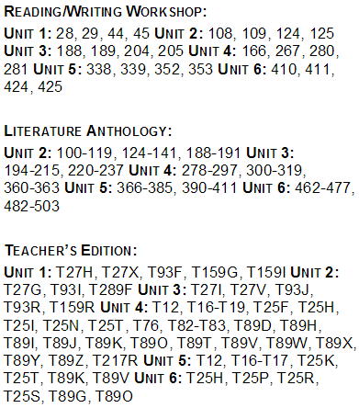  Technology / Open Resources  Student Activities for Literary Text  Read Works  Newsela  Study Island 2a: Asking and Answering Questions  http://www.education.com/common-core/CCSS.ELA-LITERACY.RL.3.1/worksheets/ | NJ Model Curriculum Assessments:  Unit 1  Unit 2  Unit 3  Unit 4  Unit 5
NJSLSA.R2. Determine central ideas or themes of a text and analyze their development; summarize the key supporting details and ideas | RL.3.2. Recount stories, including fables, folktales, and myths from diverse cultures; determine the central message/theme, lesson, or moral and explain how it is revealed through key details in the text. | There once lived a tortoise and a hare. The hare bragged that he was so fast he could beat anyone. The tortoise said he would race him. The hare started out way ahead. He thought it would take the tortoise a long time to catch up with him. He decided to take a little nap. The tortoise did not stop. He kept moving, slowly but surely. When the hare woke up, he saw that the tortoise was about to cross the finish line. He tried to catch up, but the tortoise beat him.  Question: What is the theme in this story?  Answer: Slow and steady wins the race. | Text (Units / Pages)  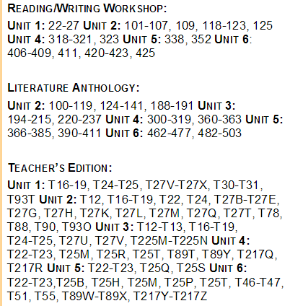  Technology / Open Resources  Study Island 2c: Lessons and Morals  http://www.education.com/common-core/CCSS.ELA-LITERACY.RL.3.2/worksheets/  Read Works  Newsela
NJSLSA.R3. Analyze how and why individuals, events, and ideas develop and interact over the course of a text. | RL.3.3. Describe the characters in a story (e.g., their traits, motivations, or feelings) and explain how their actions contribute to the plot. | A character is a person, animal, or object that an author uses in telling a story. Characters can be real or make-believe. Just like you, characters have problems, wants, feelings, and thoughts. To learn about the characters in a story, pay attention to what they say and do. | Text (Units / Pages)  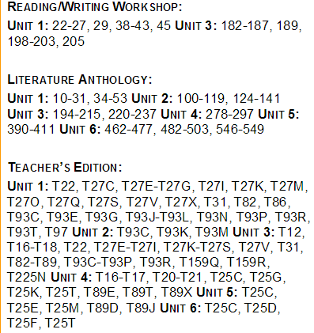  Technology / Open Resources  Study Island 2d: Characters  http://www.k12reader.com/subject/reading-skills/characters/  Read Works  Newsela

Grade: 3 | Unit: Literature: Reading Wonders |  | Pacing: 10 days
Craft and Structure

Critical Skills (Anchor Standards) | NJ Learning Standards (Progress Indicators): | Samples / Exemplars | Resources: | Assessments / Rubrics
NJSLSA.R4. Interpret words and phrases as they are used in a text, including determining technical, connotative, and figurative meanings, and analyze how specific word choices shape meaning or tone. | RL.3.4. Determine the meaning of words and phrases as they are used in a text, distinguishing literal from nonliteral language | An idiom is something authors use in their writing to make it more exciting. It is a word or saying many people in a certain place or area say.  There is one important thing to remember about idioms: They do not mean what they say.  The literal meaning (what is really said) is different from the intended meaning (what is meant).  For example:  Someone might say to you, "Break a leg!" This does not mean they want you to really break your leg. It is a saying some people say instead of "Good luck." | Text (Units / Pages)  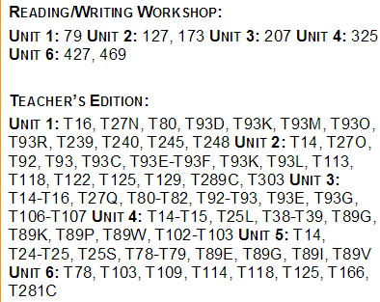  Technology / Open Resources  Study Island lesson 2h: Distinguishing Figurative Language  http://www.education.com/common-core/CCSS.ELA-LITERACY.RL.3.4/worksheets/  Read Works  Newsela
NJSLSA.R5. Analyze the structure of texts, including how specific sentences, paragraphs, and larger portions of the text (e.g., a section, chapter, scene, or stanza) relate to each other and the whole. | RL.3.5. Refer to parts of stories, dramas, and poems when writing or speaking about a text, using terms such as chapter, scene, and stanza; describe how each successive part builds on earlier sections. | Plays or dramas are stories told by characters talking to each other. Not all stories are written for people to read. Some stories are written for people to watch. Just like stories, plays have a plot, tell a story, and have characters. As the characters talk, the story moves on into different scenes and acts.  Poetry has a special structure because it is not written in sentences and paragraphs. It is written in lines and stanzas. The lines and stanzas give the poetry a different look.  A line is a small chuck of a poem. It is one group of words that reads from left to right. It looks like one row in a poem.  A stanza is a big chunk of a poem. It is one group of lines. Stanzas are separated by spaces between lines. | Text (Units / Pages)  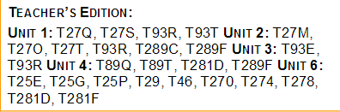  Technology / Open Resources  Study Island Lesson 2i: Structures of Texts  http://www.education.com/common-core/CCSS.ELA-LITERACY.RL.3.5/worksheets/  Read Works  Newsela
NJSLSA.R6. Assess how point of view or purpose shapes the content and style of a text. | RL.3.6. Distinguish their own point of view from that of the narrator or those of the characters. | Questions for students:  Which two statements describe the point of view of the passage?  Which sentence from the passage helps show who the narrator is?  Which two sentences from the piece best reveal the author's point of view? | Text (Units / Pages)  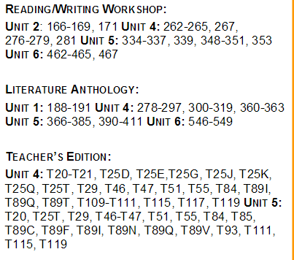  Technology / Open Resources  Study Island lesson 2j: Point of View  http://www.k12reader.com/subject/reading-skills/point-of-view/  Read Works  Newsela

Grade: 3 | Unit: Literature: Reading Wonders |  | Pacing: 10 days
Integration of Knowledge and Ideas

Critical Skills (Anchor Standards) | NJ Learning Standards (Progress Indicators): | Samples / Exemplars | Resources: | Assessments / Rubrics
NJSLSA.R7. Integrate and evaluate content presented in diverse media and formats, including visually and quantitatively, as well as in words. | RL.3.7. Explain how specific aspects of a text’s illustrations contribute to what is conveyed by the words in a story (e.g., create mood, emphasize aspects of a character or setting). | Why was this picture chosen to illustrate the story?  What do you think of when you see it?  Does it make the story better? Does it make the story worse?  What colors are there in the picture? Do the colors show that the story is a happy story or a sad story? How do the colors make you feel? Are they bright and cheerful or dark and gloomy?  Have you seen the picture before somewhere else? If you have, what do you remember about it?  Which parts from the story are illustrated?  How detailed is the picture compared to the story? Did the artist leave out anything the author tried to make important? | Text (Units / Pages)  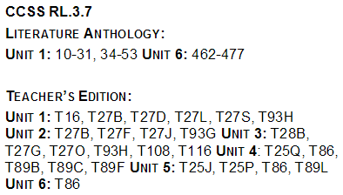  Technology / Open Resources  Study Island lesson 2k: Illustrations  Read Works  Newsela
NJSLSA.R8. Delineate and evaluate the argument and specific claims in a text, including the validity of the reasoning as well as the relevance and sufficiency of the evidence. | RL.3.8. (Not applicable to literature) |  | Text (Units / Pages)  Technology / Open Resources
NJSLSA.R9. Analyze and reflect on how two or more texts address similar themes or topics in order to build knowledge or to compare the approaches the authors take. | RL.3.9. Compare, contrast and reflect on (e.g. practical knowledge, historical/cultural context, and background knowledge) the central message/theme, lesson, and/ or moral, settings, and plots of stories written by the same author about the same or similar characters (e.g., in books from a series). | Friar Woods is a nice, quiet place. Some might call it a "neighborhood." All the animals talk to each other. They work together, and they play together. They also protect each other from harm. Leo the Lion is known as the fighter. He will fight any intruder that comes into Friar Woods without an invitation. He works really hard during the day and sleeps soundly at night. Otto the Owl hoots when danger is near. Otto sleeps all day and is up all night. Friar Woods is always under a watchful eye. The animals take care of each other and live in harmony.  1. What is similar about Leo and Otto (compare)?  2. How are Leo and Otto different (contrast)? | Text (Units / Pages)  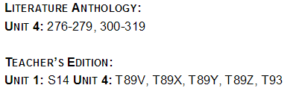  Technology / Open Resources  Study Island 2l: Compare and Contrast  http://www.education.com/common-core/CCSS.ELA-LITERACY.RL.3.9/lesson-plans/  Read Works  Newsela

Grade: | Unit: Literature: Reading Wonders |  | Pacing: 15 days
Range of Reading and Level of Text Complexity
Critical Skills (Anchor Standards) | NJ Learning Standards (Progress Indicators): | Samples / Exemplars | Resources: | Assessments / Rubrics
NJSLSA.R10. Read and comprehend complex literary and informational texts independently and proficiently with scaffolding as needed. | RL.3.10. By the end of the year, read and comprehend literature, including stories, dramas, and poems at grade level text-complexity or above, with scaffolding as needed. |  | Text (Units / Pages)  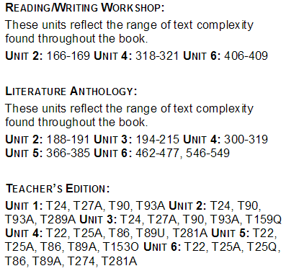  Technology / Open Resources  http://www.education.com/common-core/CCSS.ELA-LITERACY.RL.3.10/worksheets/

Grade: 3 | Unit: Informational Text: Reading Wonders |  | Pacing: 15 days
Key Ideas and Details

Critical Skills (Anchor Standards) | NJ Learning Standards (Progress Indicators): | Samples / Exemplars | Resources: | Assessments / Rubrics
NJSLSA.R1. Read closely to determine what the text says explicitly and to make logical inferences and relevant connections from it; cite specific textual evidence when writing or speaking to support conclusions drawn from the text. | RI.3.1. Ask and answer questions, and make relevant connections to demonstrate understanding of a text, referring explicitly to the text as the basis for the answers. |  | Text (Units / Pages)  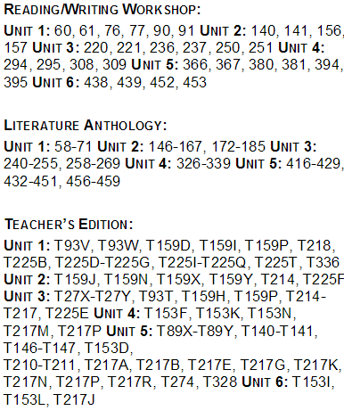  Technology / Open Resources  Center Activities for Informational Reading  http://www.education.com/common-core/CCSS.ELA-LITERACY.RI.3.1/worksheets/
NJSLSA.R2. Determine central ideas or themes of a text and analyze their development; summarize the key supporting details and ideas. | RI.3.2. Determine the main idea of a text; recount the key details and explain how they support the main idea. | When you are looking for the main idea, ask yourself . . . Why did the author write this story?  What is the story mostly about?  When you think you know what the main idea is, ask yourself . . .  Do all of the sentences in the passage support this idea?  If the answer to this question is yes, then you have found the main idea! | Text (Units / Pages)  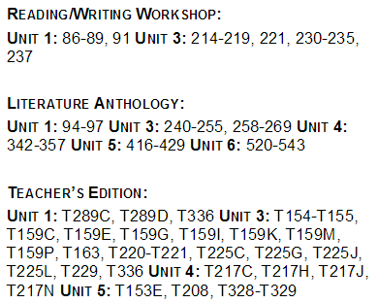  Technology / Open Resources  Study Island lesson 3a: Main Ideas and Supporting Details  http://www.education.com/common-core/CCSS.ELA-LITERACY.RI.3.2/worksheets/
NJSLSA.R3. Analyze how and why individuals, events, and ideas develop and interact over the course of a text. | RI.3.3. Describe the relationship between a series of historical events, scientific ideas or concepts, or steps in technical procedures in a text, using language that pertains to time, sequence, and cause/effect. | Beach Fun Sunscreen  Directions: Use all year round. Put a large amount on your uncovered skin before going out in the sun. Make sure to spread this sunscreen evenly. Put on the sunscreen again after swimming or sweating.  Caution: For use on skin only. Do not get it in the eyes. If it gets in the eyes, rinse with water. If rash appears, stop use.  When should you put on Beach Fun Sunscreen? | Text (Units / Pages)  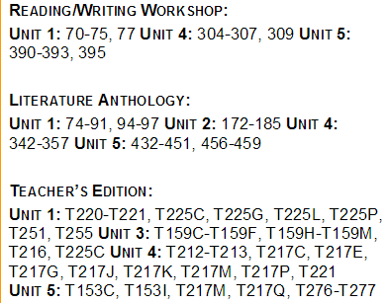  Technology / Open Resources  Study Island 3b: Events, Ideas, and Procedures  http://www.education.com/common-core/CCSS.ELA-LITERACY.RI.3.2/worksheets/

Grade: 3 | Unit: Informational Text: Reading Wonders |  | Pacing: 10 days
Craft and Structure

Critical Skills (Anchor Standards) | NJ Learning Standards (Progress Indicators): | Samples / Exemplars | Resources: | Assessments / Rubrics
NJSLSA.R4. Interpret words and phrases as they are used in a text, including determining technical, connotative, and figurative meanings, and analyze how specific word choices shape meaning or tone. | RI.3.4. Determine the meaning of general academic and domain-specific words and phrases in a text relevant to a grade 3 topic or subject area. | Academic language is used in your school books, in your teacher's instructions, and on your tests. This language is how you learn the basics of social studies, language arts, math, science, and other subjects. The more academic language you know, the better you will do in school! | Text (Units / Pages)  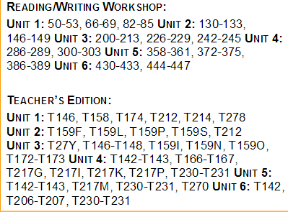  Technology / Open Resources  Study Island 3c: Academic Language  http://www.education.com/common-core/CCSS.ELA-LITERACY.RI.3.4/worksheets/
NJSLSA.R5. Analyze the structure of texts, including how specific sentences, paragraphs, and larger portions of the text (e.g., a section, chapter, scene, or stanza) relate to each other and the whole. | RI.3.5. Use text features and search tools (e.g., key words, sidebars, hyperlinks) to locate information relevant to a given topic efficiently. | Why did the author hyperlink the text in the sentences below?  The Eiffel Tower is named after Gustave Eiffel. He is the engineer who designed and built the tower. | Text (Units / Pages)  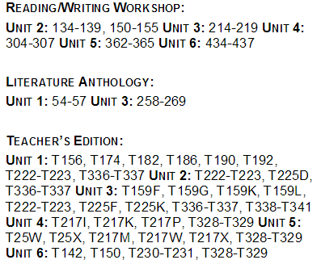  Technology / Open Resources  https://www.lernerbooks.com/pages/teaching-text-features.aspx  Study Island lesson: 3d Text Features
NJSLSA.R6. Assess how point of view or purpose shapes the content and style of a text. | RI.3.6. Distinguish their own point of view from that of the author of a text. |  | Text (Units / Pages)  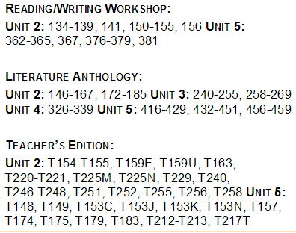  Technology / Open Resources  http://www.k12reader.com/subject/reading-skills/point-of-view/  Study Island 3e: Author's Point of View

Grade: 3 | Unit: Informational Text: Reading Wonders |  | Pacing: 15 days
Integration of Knowledge and Ideas

Critical Skills (Anchor Standards) | NJ Learning Standards (Progress Indicators): | Samples / Exemplars | Resources: | Assessments / Rubrics
NJSLSA.R7. Integrate and evaluate content presented in diverse media and formats, including visually and quantitatively, as well as in words. | RI.3.7. Use information gained from text features (e.g., illustrations, maps, photographs) and the words in a text to demonstrate understanding of the text (e.g., where, when, why, and how key events occur). |  | Text (Units / Pages)  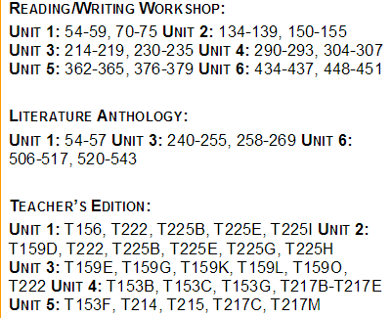  Technology / Open Resources  Study Island 3f: Maps, Charts, and Photographs  http://www.education.com/common-core/CCSS.ELA-LITERACY.RI.3.7/worksheets/
NJSLSA.R8. Delineate and evaluate the argument and specific claims in a text, including the validity of the reasoning as well as the relevance and sufficiency of the evidence. | RI.3.8. Describe the logical connection between particular sentences and paragraphs in a text (e.g., comparison, cause/effect, first/second/third in a sequence) to support specific points the author makes in a text. |  | Text (Units / Pages)  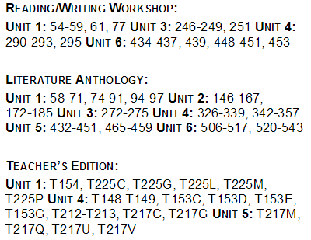  Technology / Open Resources
NJSLSA.R9. Analyze and reflect on how two or more texts address similar themes or topics in order to build knowledge or to compare the approaches the authors take. | RI.3.9. Compare, contrast and reflect on (e.g. practical knowledge, historical/cultural context, and background knowledge) the most important points and key details presented in two texts on the same topic. |  | Text (Units / Pages)  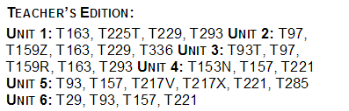  Technology / Open Resources

Grade: 3 | Unit: Informational Text: Reading Wonders |  | Pacing: 10 days
Range of Reading and Level of Text Complexity

Critical Skills (Anchor Standards) | NJ Learning Standards (Progress Indicators): | Samples / Exemplars | Resources: | Assessments / Rubrics
NJSLSA.R10. Read and comprehend complex literary and informational texts independently and proficiently with scaffolding as needed. | RI.3.10. By the end of the year, read and comprehend literary nonfiction at grade level text-complexity or above, with scaffolding as needed. |  | Text (Units / Pages)  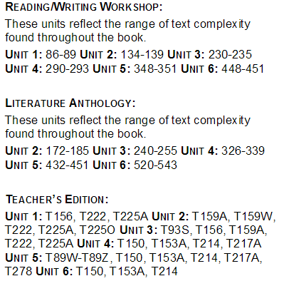  Technology / Open Resources

Grade: 3 | Unit: Reading Foundation Skills: Reading Wonders |  | Pacing: 10 days
Phonics and Word Recognition
Critical Skills (Anchor Standards) | NJ Learning Standards (Progress Indicators): | Samples / Exemplars | Resources: | Assessments / Rubrics
NJSLSA.R4. Interpret words and phrases as they are used in a text, including determining technical, connotative, and figurative meanings, and analyze how specific word choices shape meaning or tone. | RF.3.3. Know and apply grade-level phonics and word analysis skills in decoding and encoding words. |  | Text (Units / Pages)  Technology / Open Resources  Activities for Reading Foundation Skills
 | A. Identify and know the meaning of the most common prefixes and derivational suffixes. |  | Text (Units / Pages)  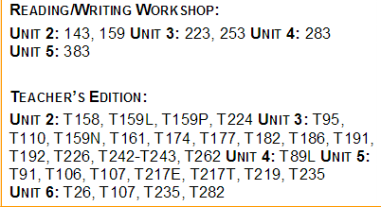  Technology / Open Resources
 | B. Decode words with common Latin suffixes. |  | Text (Units / Pages)  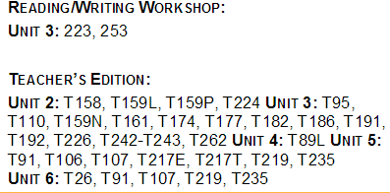  Technology / Open Resources
 | C. Decode multisyllable words. |  | Text (Units / Pages)  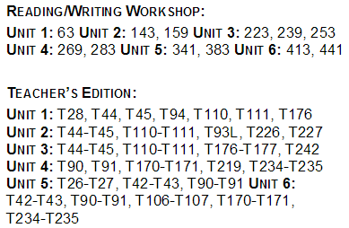  Technology / Open Resources
 | D. Read grade-appropriate irregularly spelled words. |  | Text (Units / Pages)  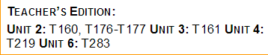  Technology / Open Resources

Grade: | Unit: Reading Foundation Skills: Reading Wonders |  | Pacing: 10 days
Fluency

Critical Skills (Anchor Standards) | NJ Learning Standards (Progress Indicators): | Samples / Exemplars | Resources: | Assessments / Rubrics
NJSLSA.R10. Read and comprehend complex literary and informational texts independently and proficiently with scaffolding as needed. | RF.3.4. Read with sufficient accuracy and fluency to support comprehension. |  | Text (Units / Pages)  Technology / Open Resources
 | - Read grade-level text with purpose and understanding |  | Text (Units / Pages)  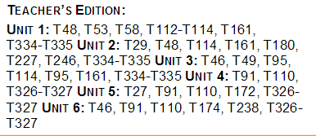  Technology / Open Resources
 | B. Read grade-level prose and poetry orally with accuracy, appropriate rate, and expression. |  | Text (Units / Pages)  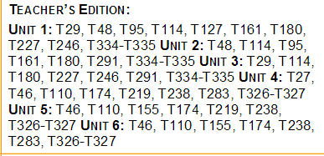  Technology / Open Resources
 | C. Use context to confirm or self-correct word recognition and understanding, rereading as necessary. |  | Text (Units / Pages)  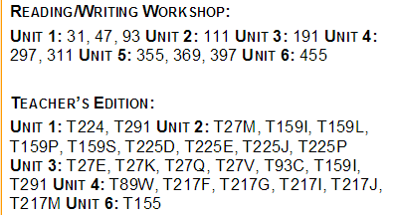  Technology / Open Resources

Grade: 3 | Unit: Writing: Reading Wonders |  | Pacing: 10 days
Text Types and Purposes

Critical Skills (Anchor Standards) | NJ Learning Standards (Progress Indicators): | Samples / Exemplars | Resources: | Assessments / Rubrics
NJSLSA.W1. Write arguments to support claims in an analysis of substantive topics or texts, using valid reasoning and relevant and sufficient evidence. | W.3.1. Write opinion pieces on topics or texts, supporting a point of view with reasons |  | Text (Units / Pages)  Technology / Open Resources  Writing Mini Lessons
 | A. Introduce the topic or text they are writing about, state an opinion, and create an organizational structure that lists reasons. |  | Text (Units / Pages)  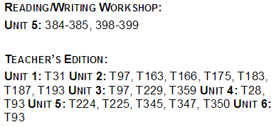  Technology / Open Resources
 | B. Provide reasons that support the opinion. |  | Text (Units / Pages)  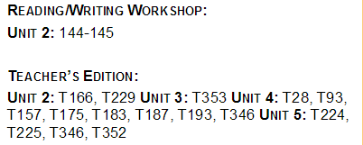  Technology / Open Resources
 | C. Use linking words and phrases (e.g., because, therefore, since, for example) to connect opinion and reasons. |  | Text (Units / Pages)  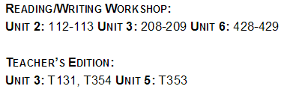  Technology / Open Resources
 | D. Provide a conclusion. |  | Text (Units / Pages)  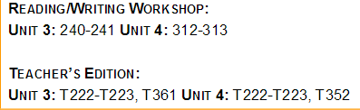  Technology / Open Resources
NJSLSA.W2. Write informative/explanatory texts to examine and convey complex ideas and information clearly and accurately through the effective selection, organization, and analysis of content. | W.3.2. Write informative /explanatory texts to examine a topic and convey ideas and information clearly. |  | Text (Units / Pages)  Technology / Open Resources
 | A. Introduce a topic and group related information together; include text features (e.g.: illustrations, diagrams, captions) when useful to support comprehension. |  | Text (Units / Pages)  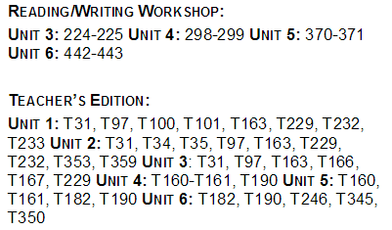  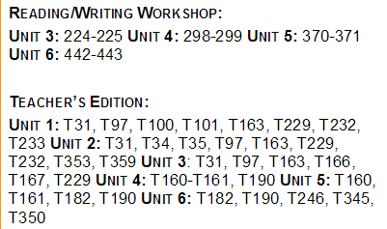  Technology / Open Resources
 | B. Develop the topic with facts, definitions, and details. |  | Text (Units / Pages)  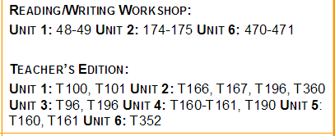  Technology / Open Resources
 | C. Use linking words and phrases (e.g., also, another, and, more, but) to connect ideas within categories of information. |  | Text (Units / Pages)  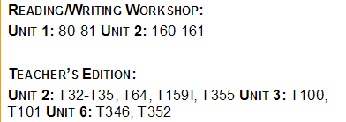  Technology / Open Resources
 | D. Provide a conclusion. |  | Text (Units / Pages)  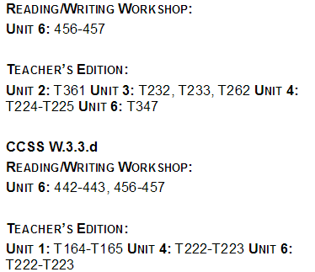  Technology / Open Resources
NJSLSA.W3. Write narratives to develop real or imagined experiences or events using effective technique, well-chosen details, and well-structured event sequences. | W.3.3. Write narratives to develop real or imagined experiences or events using narrative technique, descriptive details, and clear event sequences. |  | Text (Units / Pages)  Technology / Open Resources
 | - Establish a situation and introduce a narrator and/or characters; organize an event sequence that unfolds naturally. |  | Text (Units / Pages)  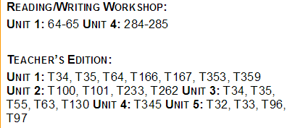  Technology / Open Resources
 | - Use dialogue and descriptions of actions, thoughts, and feelings to develop experiences and events or show the response of characters to situations. |  | Text (Units / Pages)  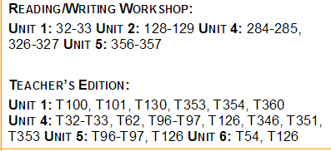  Technology / Open Resources
 | - Use temporal words and phrases to signal event order. |  | -
 | - Provide a sense of closure. |  | Text (Units / Pages)  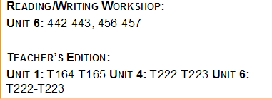  Technology / Open Resources

Grade: 3 | Unit: Writing: Reading Wonders |  | Pacing: 10 days
Production and Distribution of Writing

Critical Skills (Anchor Standards) | NJ Learning Standards (Progress Indicators): | Samples / Exemplars | Resources: | Assessments / Rubrics
NJSLSA.W4. Produce clear and coherent writing in which the development, organization, and style are appropriate to task, purpose, and audience. | W.3.4. With guidance and support from adults, produce writing in which the development and organization are appropriate to task and purpose. (Grade-specific expectations for writing types are defined in standards 1–3 above.) |  | Text (Units / Pages)  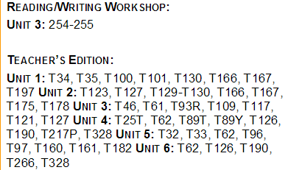  Technology / Open Resources
NJSLSA.W5. Develop and strengthen writing as needed by planning, revising, editing, rewriting, or trying a new approach. | W.3.5. With guidance and support from peers and adults, develop and strengthen writing as needed by planning, revising, and editing. |  | Text (Units / Pages)  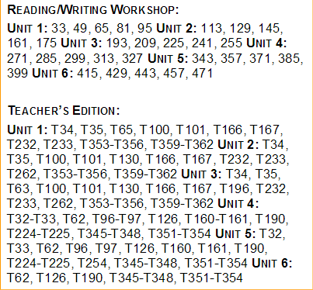  Technology / Open Resources
NJSLSA.W6. Use technology, including the Internet, to produce and publish writing and to interact and collaborate with others. | W.3.6. With guidance and support from adults, use technology to produce and publish writing as well as to interact and collaborate with others. |  | Text (Units / Pages)  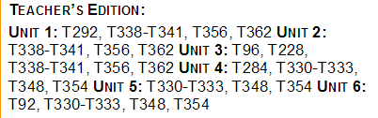  Technology / Open Resources

Grade: 3 | Unit: Writing: Reading Wonders |  | Pacing: 10 days
Research to Build and Present Knowledge

Critical Skills (Anchor Standards) | NJ Learning Standards (Progress Indicators): | Samples / Exemplars | Resources: | Assessments / Rubrics
NJSLSA.W7. Conduct short as well as more sustained research projects, utilizing an inquiry-based research process, based on focused questions, demonstrating understanding of the subject under investigation. | W.3.7. Conduct short research projects that build knowledge about a topic. |  | Text (Units / Pages)  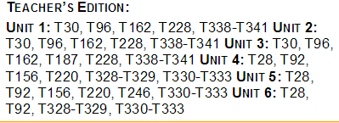  Technology / Open Resources
NJSLSA.W8. Gather relevant information from multiple print and digital sources, assess the credibility and accuracy of each source, and integrate the information while avoiding plagiarism. | W.3.8. Recall information from experiences or gather information from print and digital sources; take brief notes on sources and sort evidence into provided categories. |  | Text (Units / Pages)  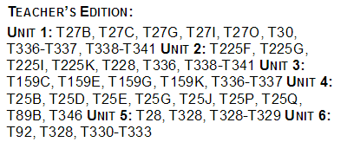  Technology / Open Resources
NJSLSA.W9. Draw evidence from literary or informational texts to support analysis, reflection, and research. | W.3.9. (Begins in grade 4) |  | Text (Units / Pages)  Technology / Open Resources

Grade: 3 | Unit: Writing: Reading Wonders |  | Pacing: 10 days
Range of Writing

Critical Skills (Anchor Standards) | NJ Learning Standards (Progress Indicators): | Samples / Exemplars | Resources: | Assessments / Rubrics
NJSLSA.W10. Write routinely over extended time frames (time for research, reflection, and revision) and shorter time frames (a single sitting or a day or two) for a range of tasks, purposes, and audiences. | W.3.10. Write routinely over extended time frames (time for research, reflection, metacognition/self-correction and revision) and shorter time frames (a single sitting or a day or two) for a range of discipline-specific tasks, purposes, and audiences. |  | Text (Units / Pages)  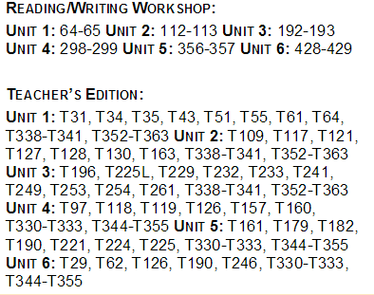  Technology / Open Resources

Grade: 3 | Unit: Speaking and Listening: Reading Wonders |  |  |  | Pacing: 10 days
Comprehension and Collaboration
Critical Skills (Anchor Standards) | NJ Learning Standards (Progress Indicators): |  |  | Samples / Exemplars | Resources: | Assessments / Rubrics
NJSLSA.SL1. Prepare for and participate effectively in a range of conversations and collaborations with diverse partners, building on others’ ideas and expressing their own clearly and persuasively. | SL.3.1. Engage effectively in a range of collaborative discussions (one-on-one, in groups, and teacher led) with diverse partners on grade 3 topics and texts, building on others’ ideas and expressing their own clearly. |  |  |  | Text (Units / Pages)  Technology / Open Resources
 | A. Explicitly draw on previously read text or material and other information known about the topic to explore ideas under discussion. |  |  |  | Text (Units / Pages)  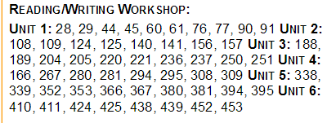  Technology / Open Resources
 | B. Follow agreed-upon norms for discussions (e.g., gaining the floor in respectful ways, listening to others with care, speaking one at a time about the topics and texts under discussion). |  |  |  | Text (Units / Pages)  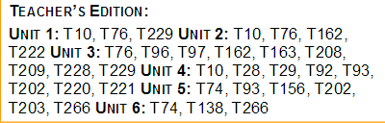  Technology / Open Resources
 | - Ask questions to check understanding of information presented, stay on topic, and link their comments to the remarks of others. |  |  |  | Text (Units / Pages)  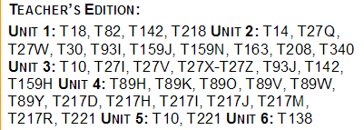  Technology / Open Resources
 | - Explain their own ideas and understanding in light of the discussion. |  |  |  | Text (Units / Pages)  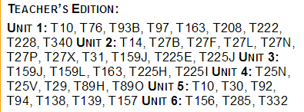  Technology / Open Resources
NJSLSA.SL2. Integrate and evaluate information presented in diverse media and formats, including visually, quantitatively, and orally. | SL.3.2. Determine the main ideas and supporting details of a text read aloud or information presented in diverse media and formats, including visually, quantitatively, and orally. |  |  |  | Text (Units / Pages)  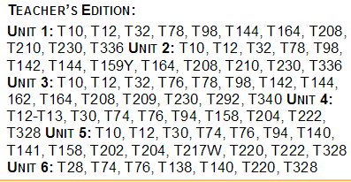  Technology / Open Resources
NJSLSA.SL3. Evaluate a speaker’s point of view, reasoning, and use of evidence and rhetoric. | SL.3.3. Ask and answer questions about information from a speaker, offering appropriate elaboration and detail. |  |  |  | Text (Units / Pages)  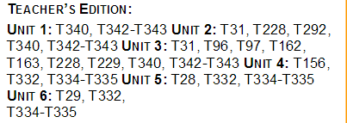  Technology / Open Resources
Grade 3 |  | Unit: Speaking and Listening: Reading Wonders |  |  | Pacing: 10 days
Presentation of Knowledge and Ideas
Critical Skills (Anchor Standards) |  | NJ Learning Standards (Progress Indicators): | Samples / Exemplars |  | Resources: | Assessments / Rubrics
NJSLSA.SL4. Present information, findings, and supporting evidence such that listeners can follow the line of reasoning and the organization, development, and style are appropriate to task, purpose, and audience. |  | SL.3.4. Report on a topic or text, tell a story, or recount an experience with appropriate facts and relevant, descriptive details, speaking clearly at an understandable pace. |  |  | Text (Units / Pages)  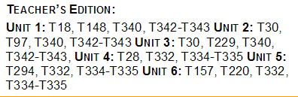  Technology / Open Resources
NJSLSA.SL5. Make strategic use of digital media and visual displays of data to express information and enhance understanding of presentations. |  | SL.3.5. Use multimedia to demonstrate fluid reading at an understandable pace; add visual displays when appropriate to emphasize or enhance certain facts or details. |  |  | Text (Units / Pages)  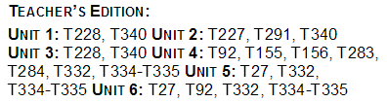  Technology / Open Resources
NJSLSA.SL6. Adapt speech to a variety of contexts and communicative tasks, demonstrating command of formal English when indicated or appropriate. |  | SL.3.6. Speak in complete sentences when appropriate to task and situation in order to provide requested detail or clarification. |  |  | Text (Units / Pages)  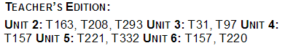  Technology / Open Resources

Grade: 3 | Unit: Language: Reading Wonders |  | Pacing: 10 days
Conventions of Standard English
Critical Skills (Anchor Standards) | NJ Learning Standards (Progress Indicators): | Samples / Exemplars | Resources: | Assessments / Rubrics
NJSLSA.L1. Demonstrate command of the conventions of standard English grammar and usage when writing or speaking. | L.3.1. Demonstrate command of the conventions of standard English grammar and usage when writing or speaking. |  | Text (Units / Pages)  Technology / Open Resources  Student Activities for Language
 | - Explain the function of nouns, pronouns, verbs, adjectives, and adverbs in general and their functions in particular sentences. |  | Text (Units / Pages)  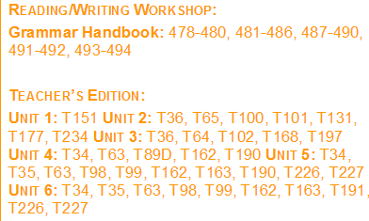  Technology / Open Resources
 | - Form and use regular and irregular plural nouns. |  | Text (Units / Pages)  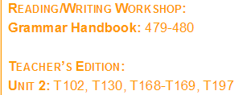  Technology / Open Resources
 | - Use abstract nouns (e.g., childhood). |  | Text (Units / Pages)  Technology / Open Resources
 | - Form and use regular and irregular verbs |  | Text (Units / Pages)  Technology / Open Resources
 | - Form and use the simple (e.g., I walked; I walk; I will walk) verb tenses. |  | Text (Units / Pages)  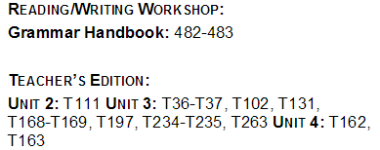  Technology / Open Resources
 | - Ensure subject-verb and pronoun-antecedent agreement. |  | Text (Units / Pages)  Technology / Open Resources
 | - Form and use comparative and superlative adjectives and adverbs, and choose between them depending on what is to be modified. |  | Text (Units / Pages)  Technology / Open Resources
 | - Use coordinating and subordinating conjunctions. |  | Text (Units / Pages)  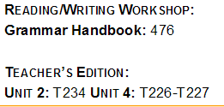  Technology / Open Resources
 | - Produce simple, compound, and complex sentences. |  | Text (Units / Pages)  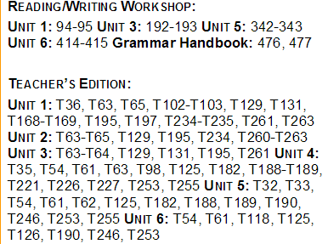  Technology / Open Resources
NJSLSA.L2. Demonstrate command of the conventions of standard English capitalization, punctuation, and spelling when writing. | L.3.2. Demonstrate command of the conventions of standard English capitalization, punctuation, and spelling when writing. |  | Text (Units / Pages)  Technology / Open Resources
 | - Capitalize appropriate words in titles |  | Text (Units / Pages)  Technology / Open Resources
 | - Use commas in addresses. |  | Text (Units / Pages)  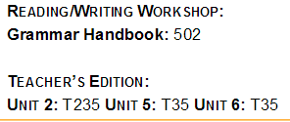  Technology / Open Resources
 | - Use commas and quotation marks in dialogue. |  | Text (Units / Pages)  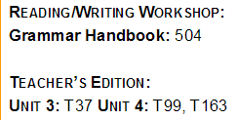  Technology / Open Resources
 | - Form and use possessives. |  | Text (Units / Pages)  Technology / Open Resources
 | - Use conventional spelling for high-frequency and other studied words and for adding suffixes to base words (e.g., sitting, smiled, cries, happiness). |  | Text (Units / Pages)  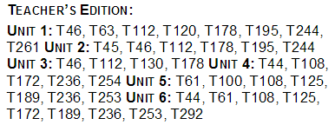  Technology / Open Resources
 | - Use spelling patterns and generalizations (e.g., word families, position-based spellings, syllable patterns, ending rules, meaningful word parts) in writing words. |  | Text (Units / Pages)  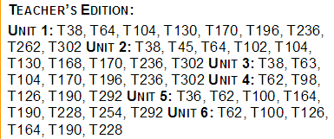  Technology / Open Resources
 | - Consult reference materials, including beginning dictionaries, as needed to check and correct spellings. |  | Text (Units / Pages)  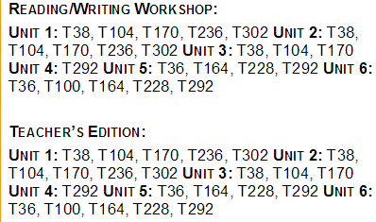  Technology / Open Resources

Grade: 3 | Unit: Language: Reading Wonders |  | Pacing: 10 days
Knowledge of Language
Critical Skills (Anchor Standards) | NJ Learning Standards (Progress Indicators): | Samples / Exemplars | Resources: | Assessments / Rubrics
NJSLSA.L3. Apply knowledge of language to understand how language functions in different contexts, to make effective choices for meaning or style, and to comprehend more fully when reading or listening. | L.3.3. Use knowledge of language and its conventions when writing, speaking, reading, or listening. |  | Text (Units / Pages)  Technology / Open Resources
 | - Choose words and phrases for effect. |  | Text (Units / Pages)  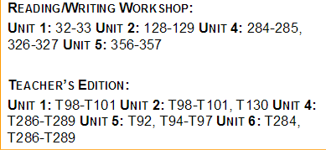  Technology / Open Resources
 | - Recognize and observe differences between the conventions of spoken and written standard English. |  | Text (Units / Pages)  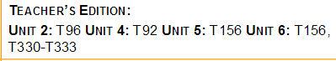  Technology / Open Resources

Grade: 3 | Unit: Language: Reading Wonders |  | Pacing: 10 days
Vocabulary Acquisition and Use
Critical Skills (Anchor Standards) | NJ Learning Standards (Progress Indicators): | Samples / Exemplars | Resources: | Assessments / Rubrics
NJSLSA.L4. Determine or clarify the meaning of unknown and multiple-meaning words and phrases by using context clues, analyzing meaningful word parts, and consulting general and specialized reference materials, as appropriate. | L.3.4. Determine or clarify the meaning of unknown and multiple-meaning word and phrases based on grade 3 reading and content, choosing flexibly from a range of strategies. |  | Text (Units / Pages)  Technology / Open Resources
 | - Use sentence-level context as a clue to the meaning of a word or phrase. |  | Text (Units / Pages)  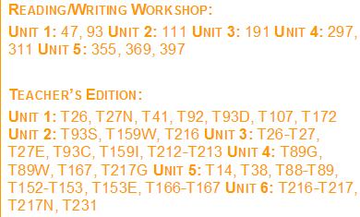  Technology / Open Resources
 | - Determine the meaning of the new word formed when a known affix is added to a known word (e.g., agreeable/disagreeable, comfortable/uncomfortable, care/careless, heat/preheat). |  | Text (Units / Pages)  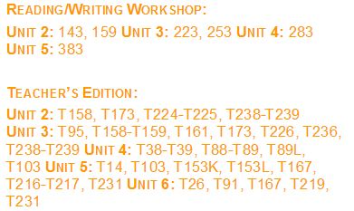  Technology / Open Resources
 | - Use a known root word as a clue to the meaning of an unknown word with the same root (e.g., company, companion). |  | Text (Units / Pages)  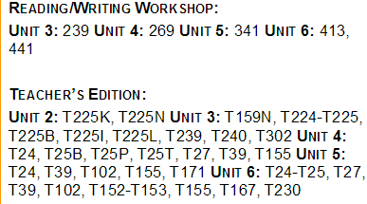  Technology / Open Resources
 | - Use glossaries or beginning dictionaries, both print and digital, to determine or clarify the precise meaning of key words and phrases. |  | Text (Units / Pages)  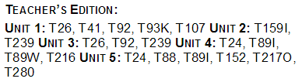  Technology / Open Resources
NJSLSA.L5. Demonstrate understanding of word relationships and nuances in word meanings. | L.3.5. Demonstrate understanding of figurative language, word relationships and nuances in word meanings. |  | Text (Units / Pages)  Technology / Open Resources
 | - Distinguish the literal and nonliteral meanings of words and phrases in context (e.g., take steps). |  | Text (Units / Pages)  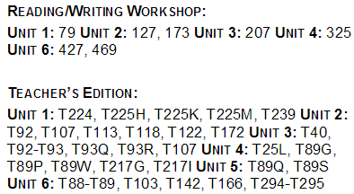  Technology / Open Resources
 | - Identify real-life connections between words and their use (e.g., describe people who are friendly or helpful). |  | Text (Units / Pages)  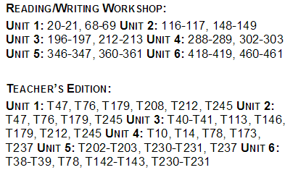  Technology / Open Resources
 | - Distinguish shades of meaning among related words that describe states of mind or degrees of certainty (e.g., knew, believed, suspected, heard, wondered). |  | Text (Units / Pages)  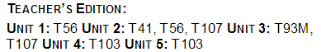  Technology / Open Resources
NJSLSA.L6. Acquire and use accurately a range of general academic and domain-specific words and phrases sufficient for reading, writing, speaking, and listening at the college and career readiness level; demonstrate independence in gathering vocabulary knowledge when encountering an unknown term important to comprehension or expression. | L.3.6. Acquire and use accurately grade-appropriate conversational, general academic, and domain-specific words and phrases, including those that signal spatial and temporal relationships (e.g., After dinner that night we went looking for them). |  | Text (Units / Pages)  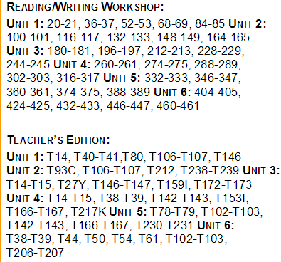  Technology / Open Resources

Assessments | Formative, summative, alternative assessments, performance assessments, project assessments, performance tasks, exit tickets, observations, MAP, benchmarks, Study Island
21st Century Skills and Career Integration | Informational sources, text features
Technology Integration | Digital tools; online series, Study Island, Reading A-Z, Newsela, Read Works
Interdisciplinary Connections | Social Studies and Science- Informational Text
Core Instructional and Supplemental Materials | Core Instruction: Project Read, Orton Gilligham, Reading Wonders Series  Supplemental: picture books, fictional and non-fictional books, videos
Modifications/Accommodations | ELL: Alternate responses, extended time, teacher modeling, simplified directions, vocabulary banks, manipulatives, nonverbal responses, sentence frames, prompts, partner talk  Special Education: Enlarged graph paper, small group instruction, highlighted  instructions/keywords and/or computation signs, hands on activities, visual cues, number line, modified assessment, models  G&T: Enrichment activities, centers, projects, flexible grouping, interest centers, learning log, extension activities, small group  504/Students at Risk: Enlarged graph paper, small group instruction, highlighted  instructions/keywords and/or computation signs, hands on activities, visual cues, number line, modified assessment, models

