Grade: 2 | Unit: Reading Literature Texts |  |  |  |  | Pacing: 15 days
Key Idea and Details

Critical Skills (Anchor Standards) | NJ Learning Standards (Progress Indicators): |  | Samples / Exemplars |  |  |  | Resources: |  | Assessments / Rubrics
NJSLSA.R1. Read closely to determine what the text says explicitly and to make logical inferences and relevant connections from it; cite specific textual evidence when writing or speaking to support conclusions drawn from the text. | RL.2.1. Ask and answer such questions as who, what, where, when, why, and how to demonstrate understanding of key details in a text. |  | Just in Case  One Night's Sleep & Circadian Rhythms |  |  |  | Text (Units / Pages)  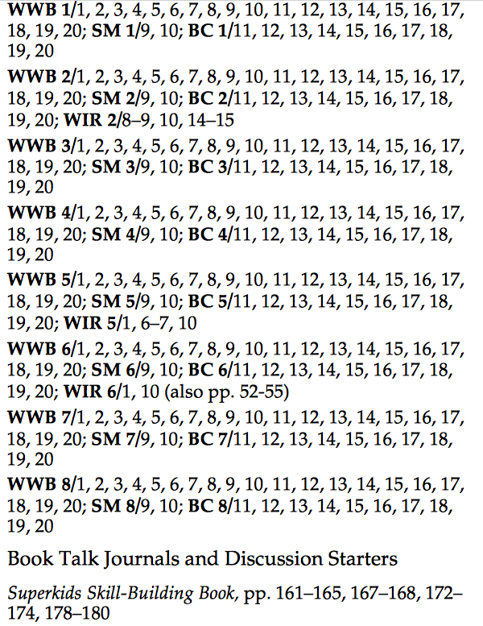  Technology / Open Resources  Student Center Activities for Literature  RL.2.1  Reading and Writing Project  Read Works  Newsela  Jennifer Serravallo Reading Blog  National Writing Project  Sight Words  Linda Hoyt  Read Write Think  Lester Laminack Blog  Seymour Simon |  | NJ Unit 1 Assessment  NJ Unit 2 Assessment  NJ Unit 3 Assessment  NJ Unit 4 Assessment  NJ Unit 5 Assessment
NJSLSA.R2. Determine central ideas or themes of a text and analyze their development; summarize the key supporting details and ideas. |  | RL.2.2. Recount stories, including fables and folktales from diverse cultures, and determine their central message/theme, lesson, or moral. |  | The Ugly Duckling & The Frog Prince | Text (Units / Pages)  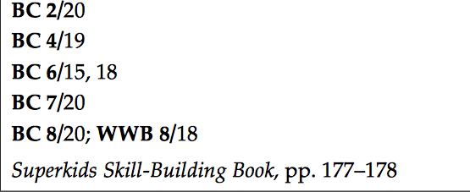  Technology / Open Resources
NJSLSA.R3. Analyze how and why individuals, events, and ideas develop and interact over the course of a text. |  | RL.2.3. Describe how characters in a story respond to major events and challenges using key details. |  | How to be Happy  The Ugly Duckling & The Frog Prince | Text (Units / Pages)  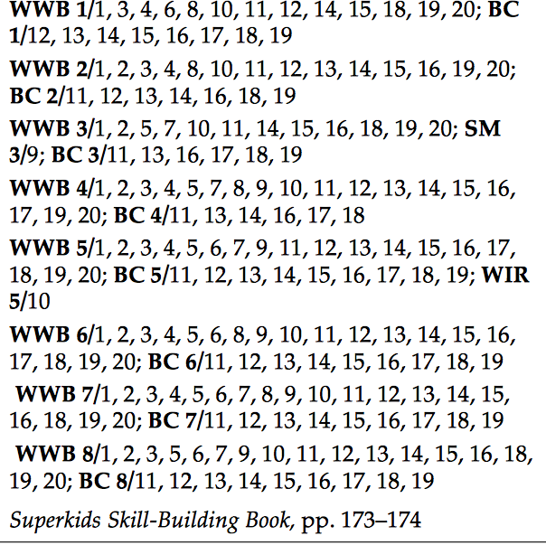  Technology / Open Resources  Read Works  Newsela

Grade: 2 | Unit: Reading Literature Texts |  | Pacing: 10 days
Craft and Structure

Critical Skills (Anchor Standards) | NJ Learning Standards (Progress Indicators): | Samples / Exemplars |  | Resources: | Assessments / Rubrics
NJSLSA.R4. Interpret words and phrases as they are used in a text, including determining technical, connotative, and figurative meanings, and analyze how specific word choices shape meaning or tone. | RL.2.4. Describe how words and phrases (e.g., regular beats, alliteration, rhymes, repeated lines) supply rhythm and meaning in a story, poem, or song. | RL 2.4  Better Lesson |  | Text (Units / Pages)  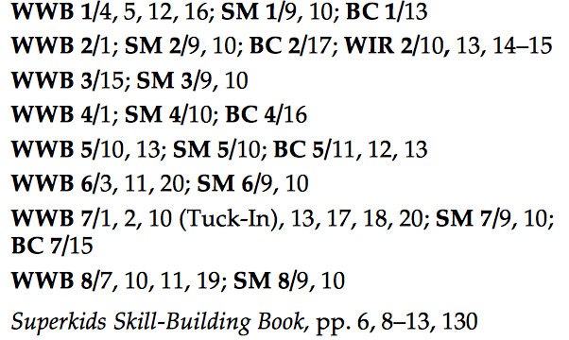  Technology / Open Resources
NJSLSA.R5. Analyze the structure of texts, including how specific sentences, paragraphs, and larger portions of the text (e.g., a section, chapter, scene, or stanza) relate to each other and the whole. | RL.2.5. Describe the overall structure of a story, including describing how the beginning introduces the story and the ending concludes the action identifying how each successive part builds on earlier sections. | Stone Soup  One Night's Sleep & Circadian Rhythms |  | Text (Units / Pages)  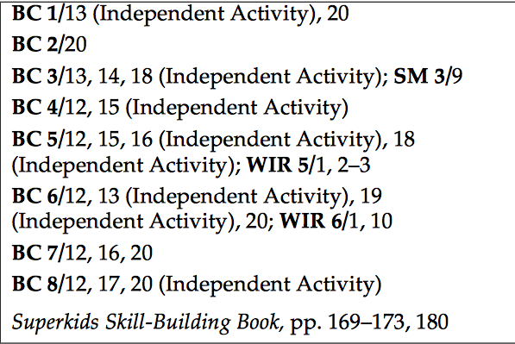  Technology / Open Resources
NJSLSA.R6. Assess how point of view or purpose shapes the content and style of a text. | RL.2.6. Acknowledge differences in the points of view of characters, including by speaking in a different voice for each character when reading dialogue aloud. |  |  | Text (Units / Pages)  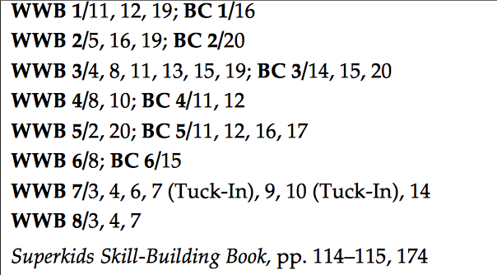  Technology / Open Resources  RL.2.6  Read Works  Newsela

Grade: 2 | Unit: Reading Literature Texts |  | Pacing: 10 days
Integration of Knowledge and Ideas

Critical Skills (Anchor Standards) | NJ Learning Standards (Progress Indicators): | Samples / Exemplars |  | Resources: | Assessments / Rubrics
NJSLSA.R7. Integrate and evaluate content presented in diverse media and formats, including visually and quantitatively, as well as in words. | RL.2.7. Use information gained from the illustrations and words in a print or digital text to demonstrate understanding of its characters, setting, or plot. | Just in Case  How to be Happy  Stone Soup |  | Text (Units / Pages)  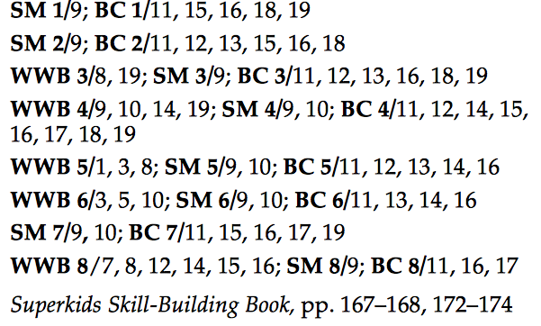  Technology / Open Resources  Read Works  Newsela
NJSLSA.R8. Delineate and evaluate the argument and specific claims in a text, including the validity of the reasoning as well as the relevance and sufficiency of the evidence. | RL.2.8. (Not applicable to literature) |  |  | Text (Units / Pages)  Technology / Open Resources
NJSLSA.R9. Analyze and reflect on how two or more texts address similar themes or topics in order to build knowledge or to compare the approaches the authors take. | RL.2.9. Compare and contrast two or more versions of the same story (e.g., Cinderella stories) by different authors or from different cultures. | Stone Soup- A Real Meal from Mexico  The Ugly Duckling & The Frog Prince | Text (Units / Pages)  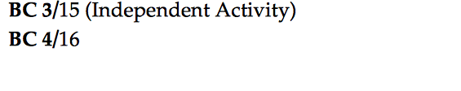  Technology / Open Resources  Read Works  Newsela

Grade:2 | Unit: Reading Literature Texts |  | Pacing: 10 days
Range of Reading and Level of Text Complexity

Critical Skills (Anchor Standards) | NJ Learning Standards (Progress Indicators): | Samples / Exemplars |  | Resources: | Assessments / Rubrics
NJSLSA.R10. Read and comprehend complex literary and informational texts independently and proficiently with scaffolding as needed. | RL.2.10. Read and comprehend literature, including stories and poetry, at grade level text complexity or above with scaffolding as needed. |  |  | Text (Units / Pages)  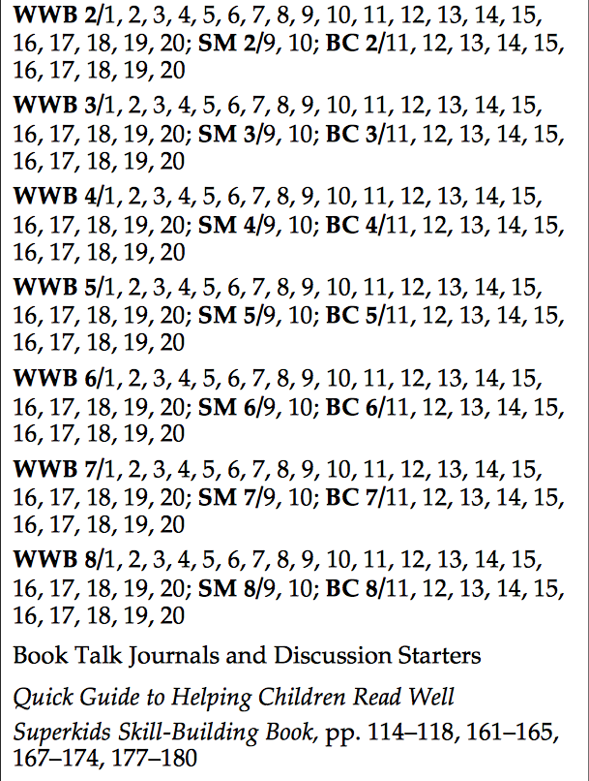  Technology / Open Resources  RL.2.10  Read Works  Newsela

Grade: 2 |  | Unit: Reading Informational Texts |  |  |  | Pacing: 10 days
Key Idea and Details

Critical Skills (Anchor Standards) |  | NJ Learning Standards (Progress Indicators): |  | Samples / Exemplars |  | Resources: |  | Assessments / Rubrics
NJSLSA.R1. Read closely to determine what the text says explicitly and to make logical inferences and relevant connections from it; cite specific textual evidence when writing or speaking to support conclusions drawn from the text. |  | RI.2.1. Ask and answer such questions as who, what, where, when, why, and how to demonstrate understanding of key details in a text. |  | Ready to Rest |  | Text (Units / Pages)  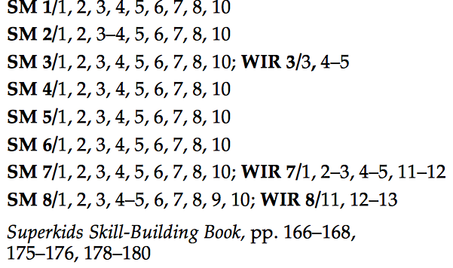  Technology / Open Resources  Student Center Activities- Reading for Information  Read Works  Newsela  RI.2.1
NJSLSA.R2. Determine central ideas or themes of a text and analyze their development; summarize the key supporting details and ideas. |  | RI.2.2. Identify the main topic of a multiparagraph text as well as the focus of specific paragraphs within the text. |  | Summer of the Shark  Ready to Rest  One Night's Sleep & Circadian Rhythms |  | Text (Units / Pages)  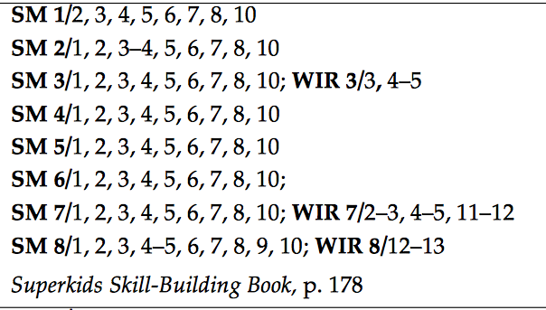  Technology / Open Resources  RI.2.2  Read Works  Newsela
NJSLSA.R3. Analyze how and why individuals, events, and ideas develop and interact over the course of a text. |  | RI.2.3. Describe the connection between a series of historical events, scientific ideas or concepts, or steps in technical procedures in a text. |  | How to be Happy  One Night's Sleep & Circadian Rhythms |  | Text (Units / Pages)  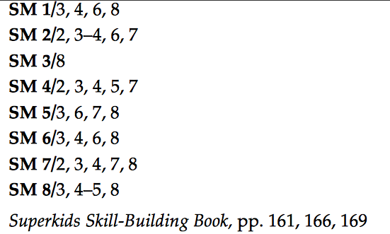  Technology / Open Resources  RI.2.3  Read Works  Newsela
Grade: 2 | Unit: Reading Informational Texts |  |  |  | Pacing: 10 days
Craft and Structure

Critical Skills (Anchor Standards) | NJ Learning Standards (Progress Indicators): |  | Samples / Exemplars |  | Resources: |  | Assessments / Rubrics
NJSLSA.R4. Interpret words and phrases as they are used in a text, including determining technical, connotative, and figurative meanings, and analyze how specific word choices shape meaning or tone. | RI.2.4. Determine the meaning of words and phrases in a text relevant to a grade 2 topic or subject area. |  | Summer of the Shark  Ready to Rest  Stone Soup-A Real Meal from Mexico |  | Text (Units / Pages)  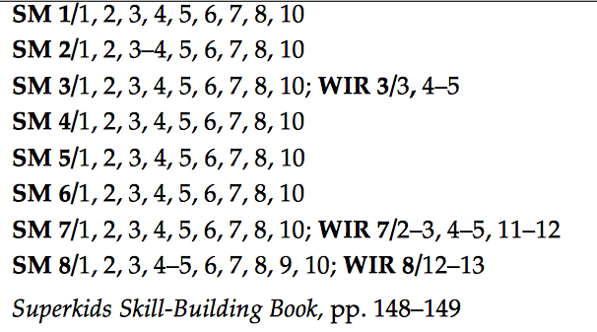  Technology / Open Resources  RI.2.4  Read Works  Newsela
NJSLSA.R5. Analyze the structure of texts, including how specific sentences, paragraphs, and larger portions of the text (e.g., a section, chapter, scene, or stanza) relate to each other and the whole. | RI.2.5. Know and use various text features (e.g., captions, bold print, subheadings, glossaries, indexes, electronic menus, icons) to locate key facts or information in a text efficiently. |  | Ready to Rest  Stone Soup- A Real Meal from Mexico |  | Text (Units / Pages)  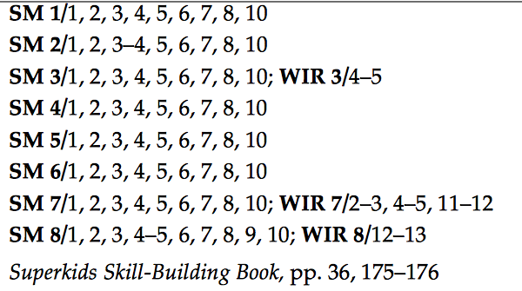  Technology / Open Resources  RI.2.5  Read Works  Newsela
NJSLSA.R6. Assess how point of view or purpose shapes the content and style of a text. | RI.2.6. Identify the main purpose of a text, including what the author wants to answer, explain, or describe. |  | One Night Sleep & Circadian Rhythms |  | Text (Units / Pages)  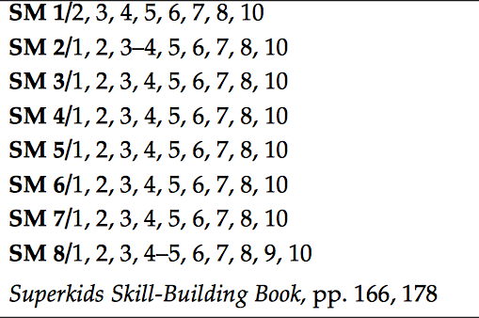  Technology / Open Resources  RI.2.6  Read Works  Newsela

Grade: 2 | Unit: Reading Informational Texts |  | Pacing: 10 days
Integration of Knowledge and Ideas

Critical Skills (Anchor Standards) | NJ Learning Standards (Progress Indicators): | Samples / Exemplars |  | Resources: | Assessments / Rubrics
NJSLSA.R7. Integrate and evaluate content presented in diverse media and formats, including visually and quantitatively, as well as in words. | RI.2.7. Explain how specific illustrations and images (e.g., a diagram showing how a machine works) contribute to and clarify a text. | Ready to Rest |  | Text (Units / Pages)  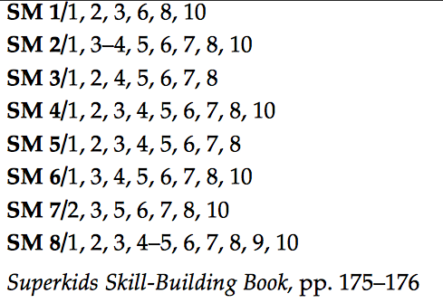  Technology / Open Resources  RI.2.7  Read Works  Newsela
NJSLSA.R8. Delineate and evaluate the argument and specific claims in a text, including the validity of the reasoning as well as the relevance and sufficiency of the evidence. | RI.2.8. Describe and identify the logical connections of how reasons support specific points the author makes in a text. | Stone Soup- A Real Meal from Mexico |  | Text (Units / Pages)  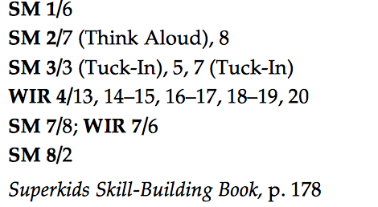  Technology / Open Resources  RI.2.8  Read Works  Newsela
NJSLSA.R9. Analyze and reflect on how two or more texts address similar themes or topics in order to build knowledge or to compare the approaches the authors take. | RI.2.9. Compare and contrast the most important points presented by two texts on the same topic. | One Night's Sleep & Circadian Rhythms |  | Text (Units / Pages)  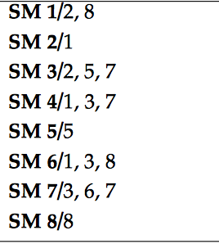  Technology / Open Resources  RI.2.9  Read Works  Newsela

Grade: 2 | Unit: Reading Informational Texts |  |  | Pacing: 10 days
Critical Skills (Anchor Standards) | NJ Learning Standards (Progress Indicators): | Samples / Exemplars | Resources: |  | Assessments / Rubrics
NJSLSA.R10. Read and comprehend complex literary and informational texts independently and proficiently with scaffolding as needed. | RI.2.10. Read and comprehend informational texts, including history/social studies, science, and technical texts, at grade level text complexity proficiently with scaffolding as needed. |  | Text (Units / Pages)  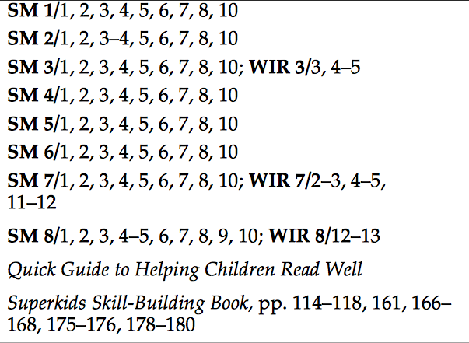  Technology / Open Resources  RI.2.10  Read Works  Newsela

Grade: 2 | Unit: Reading Foundational Skills |  | Pacing: 10 days
Phonics and Word Recognition

Critical Skills (Anchor Standards) | NJ Learning Standards (Progress Indicators): | Samples / Exemplars | Resources: | Assessments / Rubrics
 | RF.2.3. Know and apply grade-level phonics and word analysis skills in decoding words. |  | Text (Units / Pages)  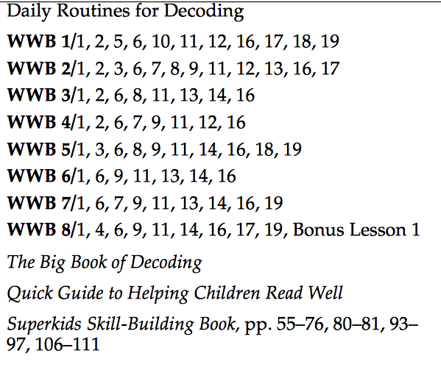  Technology / Open Resources  Student Center Activities- Reading Foundataional Skills  RF.2.3  Read Works  Newsela
 | - Know spelling-sound correspondences for common vowel teams.
 | B. Decode regularly spelled two-syllable words with long vowels.
 | C. Decode words with common prefixes and suffixes.
 | D. Identify words with inconsistent but common spelling-sound correspondences. | Stone Soup
 | E. Recognize and read grade-appropriate irregularly spelled words.

Grade: 2 |  | Unit: Reading Foundational Skills |  |  |  |  |  |  |  | Pacing: 10 days
Fluency

Critical Skills (Anchor Standards) |  | NJ Learning Standards (Progress Indicators): | Samples / Exemplars |  |  |  |  |  |  | Resources: | Assessments / Rubrics
 |  | RF.2.4. Read with sufficient accuracy and fluency to support comprehension. |  |  |  |  |  |  |  | Text (Units / Pages)  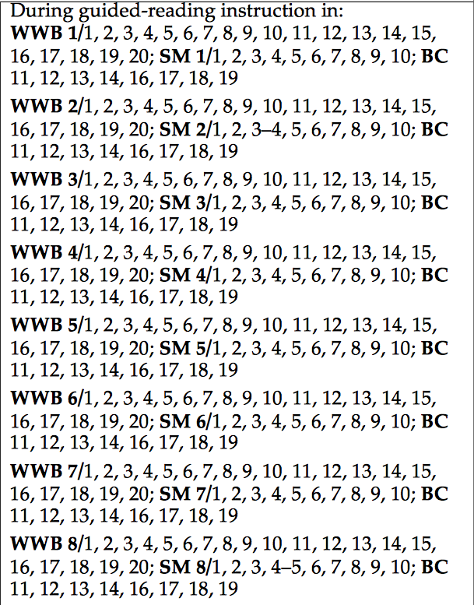  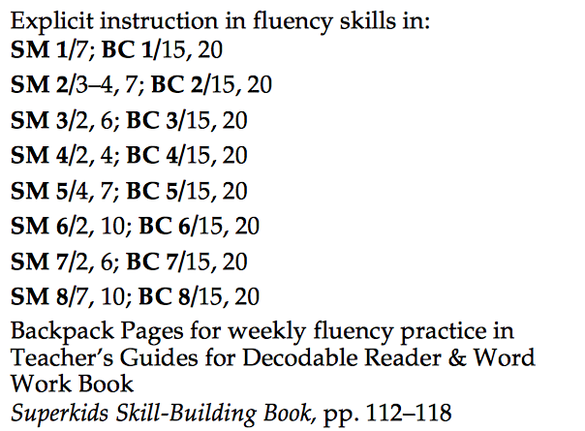  Technology / Open Resources  RF.2.4  Read Works  Newsela
 |  | A. Read grade-level text with purpose and understanding.
 |  | B. Read grade-level text orally with accuracy, appropriate rate, and expression.
 |  | C. Use context to confirm or self-correct word recognition and understanding, rereading as necessary.
Grade: 2 |  | Unit: Writing |  |  |  |  | Pacing: 10 days
Texts Types and Purposes

Critical Skills (Anchor Standards) |  | NJ Learning Standards (Progress Indicators): | Samples / Exemplars |  |  |  |  |  |  | Resources: | Assessments / Rubrics
NJSLSA.W1. Write arguments to support claims in an analysis of substantive topics or texts, using valid reasoning and relevant and sufficient evidence. |  | W.2.1. Write opinion pieces in which they introduce the topic or book they are writing about, state an opinion, supply reasons that support the opinion, use linking words (e.g., because, and, also) to connect opinion and reasons, and provide a conclusion. |  |  |  |  |  |  |  | Text (Units / Pages)  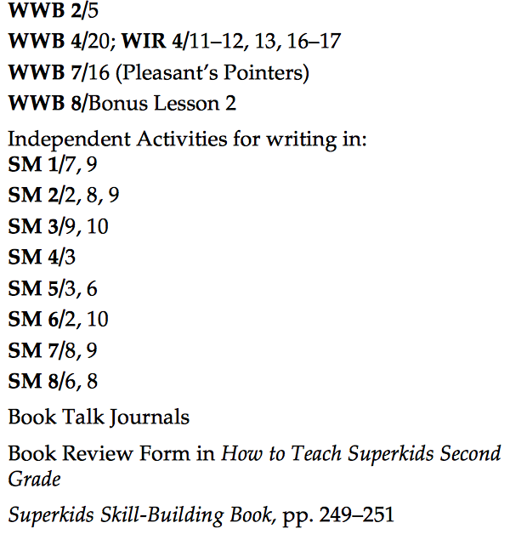  Technology / Open Resources  The Reading and Writing Project  Kathy Schrock  Two Writing Teachers  Read Write Think  National Writing Project
NJSLSA.W2. Write informative/explanatory texts to examine and convey complex ideas and information clearly and accurately through the effective selection, organization, and analysis of content. |  | W.2.2. Write informative/explanatory texts in which they introduce a topic, use evidence-based facts and definitions to develop points, and provide a conclusion. | Stone Soup- A Real Meal from Mexico |  |  |  |  |  |  | Text (Units / Pages)  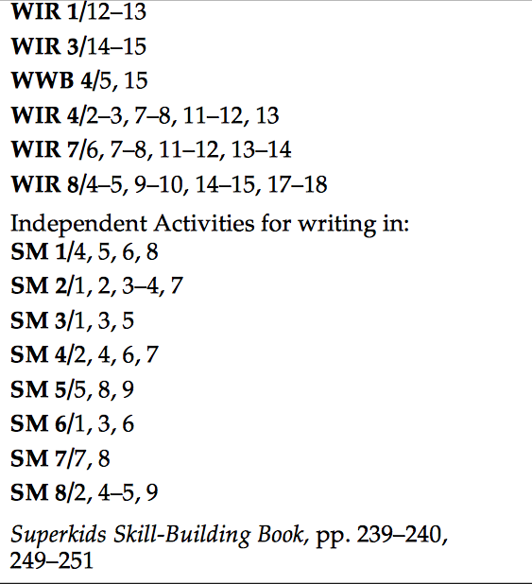  Technology / Open Resources  Read Works  Newsela
NJSLSA.W3. Write narratives to develop real or imagined experiences or events using effective technique, well-chosen details, and well-structured event sequences. |  | W.2.3. Write narratives in which they recount a well-elaborated event or short sequence of events, include details to describe actions, thoughts, and feelings, use temporal words to signal event order, and provide a sense of closure. | Summer of the Shark |  |  |  |  |  |  | Text (Units / Pages)  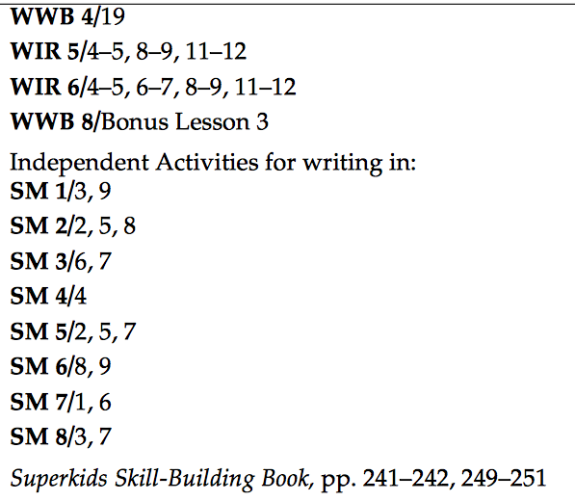  Technology / Open Resources  Read Works  Newsela
Grade: 2 | Unit: Writing |  |  |  |  | Pacing: 10 days
Product and Distribution of Writing

Critical Skills (Anchor Standards) | NJ Learning Standards (Progress Indicators): |  |  |  | Samples / Exemplars |  |  | Resources: |  |  |  |  | Assessments / Rubrics
NJSLSA.W4. Produce clear and coherent writing in which the development, organization, and style are appropriate to task, purpose, and audience. | W.2.4. (Begins in grade 3) |  |  |  |  |  |  | Text (Units / Pages)  Technology / Open Resources
NJSLSA.W5. Develop and strengthen writing as needed by planning, revising, editing, rewriting, or trying a new approach. | W.2.5. With guidance and support from adults and peers, focus on a topic and strengthen writing as needed through self-reflection, revising and editing. |  |  |  |  |  |  | Text (Units / Pages)  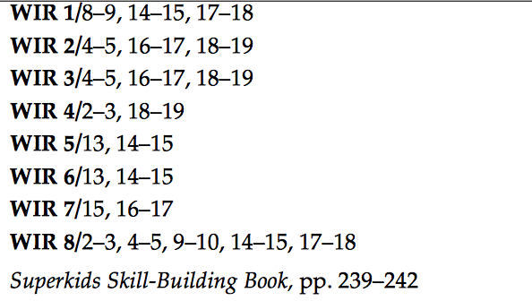  Technology / Open Resources  Read Works  Newsela
NJSLSA.W6. Use technology, including the Internet, to produce and publish writing and to interact and collaborate with others. | W.2.6. With guidance and support from adults, use a variety of digital tools to produce and publish writing, including in collaboration with peers. |  |  |  |  |  |  | Text (Units / Pages)  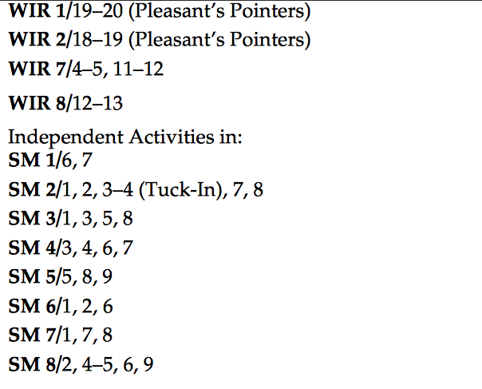  Technology / Open Resources  Read Works  Newsela
Grade: 2 |  | Unit: Writing |  |  |  |  | Pacing: 15 days
Research to Build and Present Knowledge

Critical Skills (Anchor Standards) |  | NJ Learning Standards (Progress Indicators): |  | Samples / Exemplars |  |  |  |  | Resources: |  |  | Assessments / Rubrics
NJSLSA.W7. Conduct short as well as more sustained research projects, utilizing an inquiry-based research process, based on focused questions, demonstrating understanding of the subject under investigation. |  | W.2.7. Participate in shared research and writing projects (e.g., read a number of books on a single topic to produce a report; record science observations). |  |  |  |  |  |  | Text (Units / Pages)  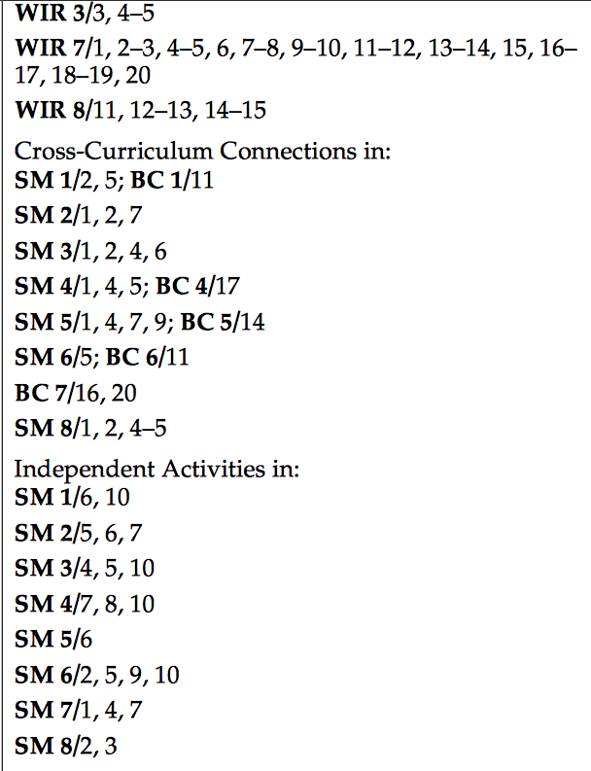  Technology / Open Resources  Read Works  Newsela
NJSLSA.W8. Gather relevant information from multiple print and digital sources, assess the credibility and accuracy of each source, and integrate the information while avoiding plagiarism. |  | W.2.8. Recall information from experiences or gather information from provided sources to answer a question. |  | The Ugly Duckling & The Frog Prince |  |  |  |  | Text (Units / Pages)  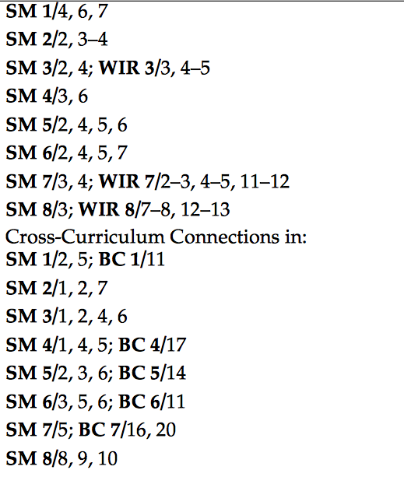  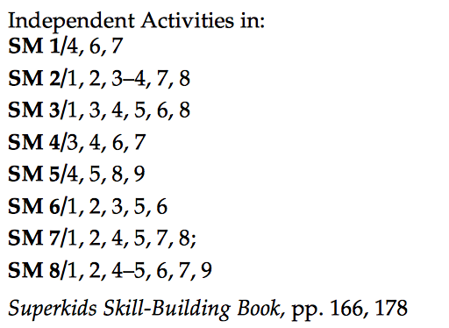  Technology / Open Resources  Read Works  Newsela
NJSLSA.W9. Draw evidence from literary or informational texts to support analysis, reflection, and research. |  | W.2.9. (Begins in grade 4) |  |  |  |  |  |  | Text (Units / Pages)  Technology / Open Resources

Grade: 2 | Unit: Writing |  | Pacing: 10 days
Range of Writing

Critical Skills (Anchor Standards) | NJ Learning Standards (Progress Indicators): | Samples / Exemplars |  | Resources: | Assessments / Rubrics
NJSLSA.W10. Write routinely over extended time frames (time for research, reflection, and revision) and shorter time frames (a single sitting or a day or two) for a range of tasks, purposes, and audiences. | W.2.10. (Begins in grade 3) |  |  | Text (Units / Pages)  Technology / Open Resources

Grade: 2 | Unit: Speaking and Listening |  | Pacing: 10 days
Comprehension and Collaboration

Critical Skills (Anchor Standards) | NJ Learning Standards (Progress Indicators): | Samples / Exemplars |  | Resources: | Assessments / Rubrics
NJSLSA.SL1. Prepare for and participate effectively in a range of conversations and collaborations with diverse partners, building on others’ ideas and expressing their own clearly and persuasively. | SL.2.1. Participate in collaborative conversations with diverse partners about grade 2 topics and texts with peers and adults in small and larger groups. |  |  | Text (Units / Pages)  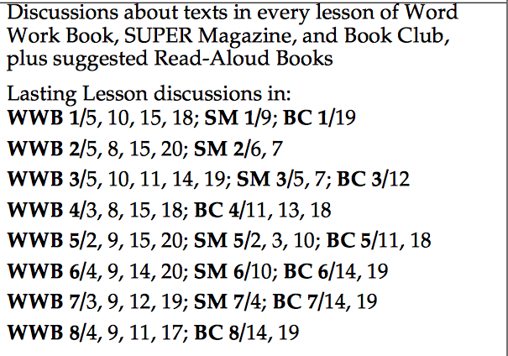  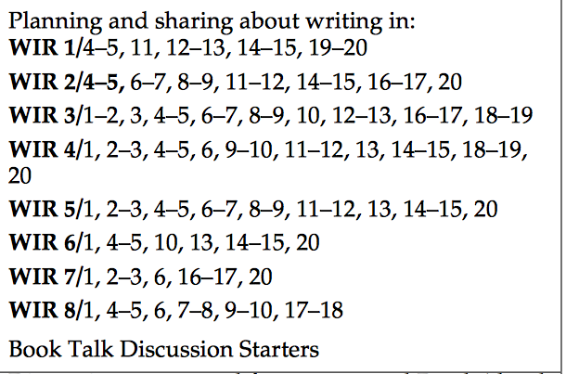  Technology / Open Resources  Reading and Writing Project  Linda Hoyt  Read Works  Newsela
 | A. Follow agreed-upon norms for discussions (e.g., gaining the floor in respectful ways, listening to others with care, speaking one at a time about the topics and texts under discussion).
 | B. Build on others' talk in conversations by linking their explicit comments to the remarks of others.
 | C. Ask for clarification and further explanation as needed about the topics and texts under discussion.
NJSLSA.SL2. Integrate and evaluate information presented in diverse media and formats, including visually, quantitatively, and orally. | SL.2.2. Recount or describe key ideas or details from a text read aloud or information presented orally or through other media. |  |  | Text (Units / Pages)  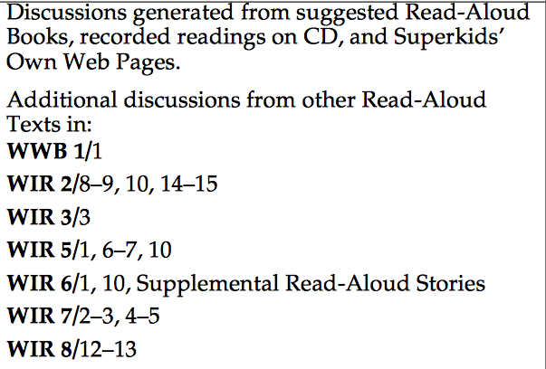  Technology / Open Resources
NJSLSA.SL3. Evaluate a speaker’s point of view, reasoning, and use of evidence and rhetoric. | SL.2.3. Ask and answer questions about what a speaker says in order to clarify comprehension, gather additional information, or deepen understanding of a topic or issue. |  |  | Text (Units / Pages)  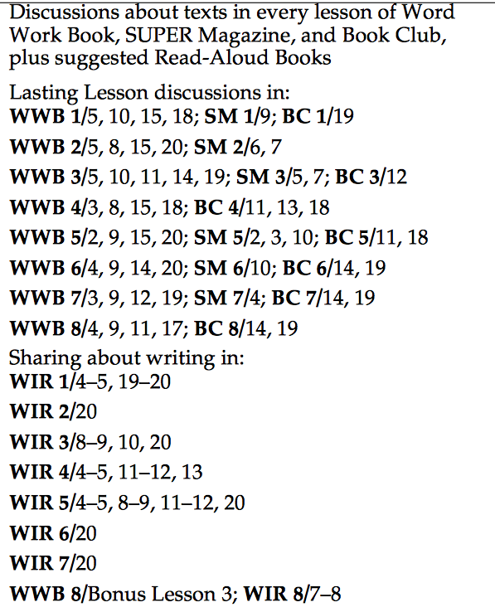  Technology / Open Resources

Grade: 2 | Unit: Speaking and Listening |  | Pacing: 10 days
Presentation of Knowledge and Ideas

Critical Skills (Anchor Standards) | NJ Learning Standards (Progress Indicators): | Samples / Exemplars | Resources: | Assessments / Rubrics
NJSLSA.SL4. Present information, findings, and supporting evidence such that listeners can follow the line of reasoning and the organization, development, and style are appropriate to task, purpose, and audience. | SL.2.4. Tell a story or recount an experience with appropriate facts and relevant, descriptive details, speaking audibly in coherent sentences. |  | Text (Units / Pages)  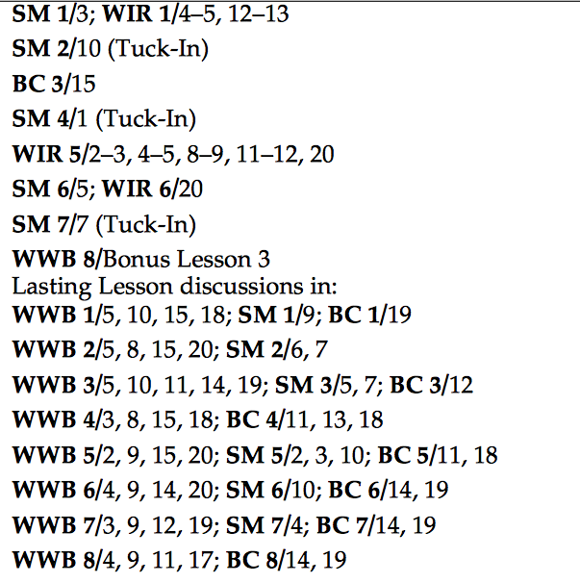  Technology / Open Resources
NJSLSA.SL5. Make strategic use of digital media and visual displays of data to express information and enhance understanding of presentations. | SL.2.5. Use multimedia; add drawings or other visual displays to stories or recounts of experiences when appropriate to clarify ideas, thoughts, and feelings. |  | Text (Units / Pages)  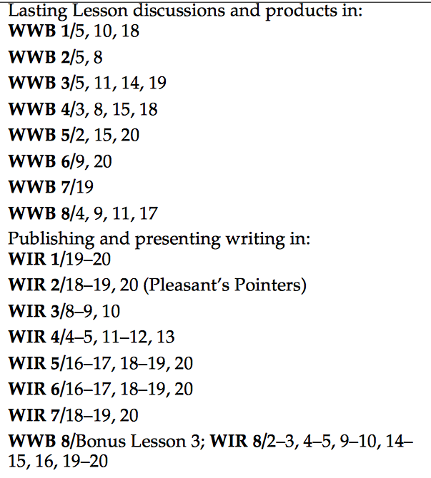  Technology / Open Resources
NJSLSA.SL6 Adapt speech to a variety of contexts and communicative tasks, demonstrating command of formal English when indicated or appropriate. | SL.2.6. Produce complete sentences when appropriate to task and situation in order to provide requested detail or clarification. |  | Text (Units / Pages)  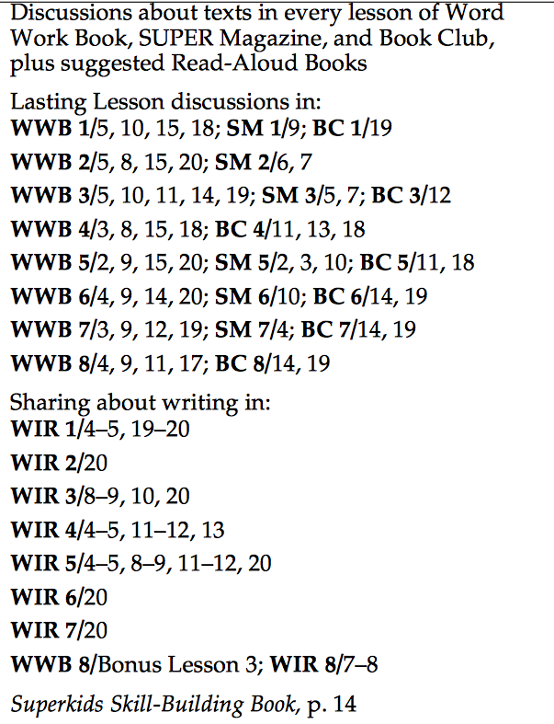  Technology / Open Resources

Grade: 2 | Unit: Language |  | Pacing: 10 days
Conventions of Standard English

Critical Skills (Anchor Standards) | NJ Learning Standards (Progress Indicators): | Samples / Exemplars | Resources: | Assessments / Rubrics
NJSLSA.L1. Demonstrate command of the conventions of standard English grammar and usage when writing or speaking. | L.2.1. Demonstrate command of the conventions of standard English grammar and usage when writing or speaking. |  | Text (Units / Pages)  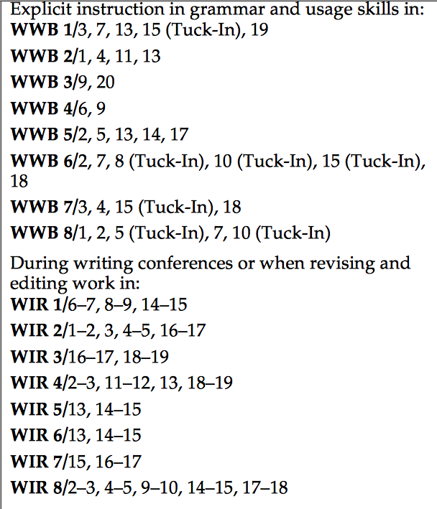  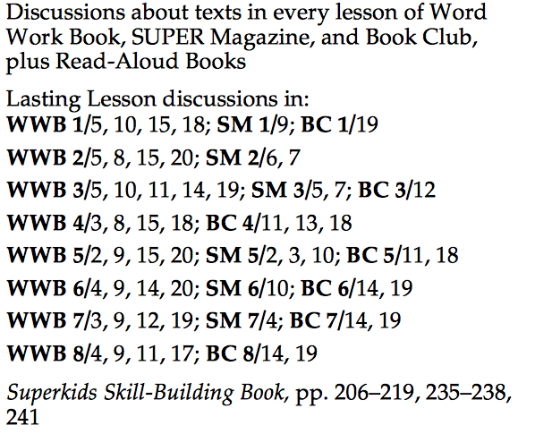  Technology / Open Resources  Reading Center Activities for Language  Reading and Writing Project  Linda Hoyt  Seymour Simon
 | A. Use collective nouns (e.g., group).
 | B. Form and use frequently occurring irregular plural nouns (e.g., feet, children, teeth, mice, fish). | Just in Case
 | C. Use reflexive pronouns (e.g., myself, ourselves).
 | D. Form and use the past tense of frequently occurring irregular verbs (e.g., sat, hid, told). | Summer of the Shark
 | E. Use adjectives and adverbs, and choose between them depending on what is to be modified.
 | F. Produce, expand, and rearrange complete simple and compound sentences (e.g., The boy watched the movie; The little boy watched the movie; The action movie was watched by the little boy).
NJSLSA.L2. Demonstrate command of the conventions of standard English capitalization, punctuation, and spelling when writing. | L.2.2. Demonstrate command of the conventions of standard English capitalization, punctuation, and spelling when writing. |  | Text (Units / Pages)  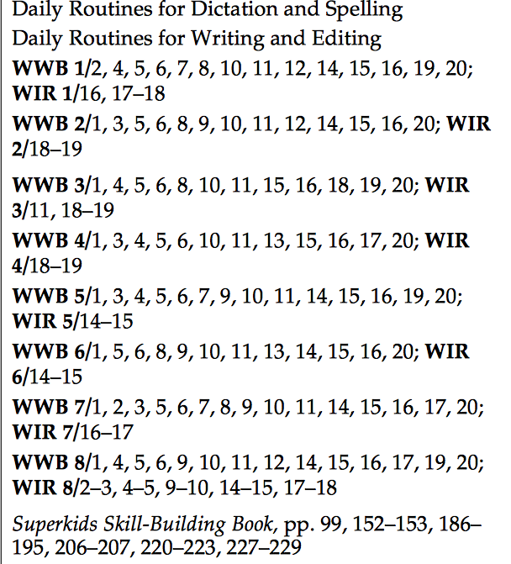  Technology / Open Resources
 | A. Capitalize holidays, product names, and geographic names. | Summer of the Shark
 | B. Use commas in greetings and closings of letters. | How to be Happy
 | C. Use an apostrophe to form contractions and frequently occurring possessives. | One Night's Sleep & Circadian Rhythms
 | D. Generalize learned spelling patterns when writing words (e.g., cage → badge; boy → boil). | Summer of the Shark
 | E. Consult print and digital resources, including beginning dictionaries, as needed to check and correct spellings.

Grade: 2 | Unit: Language |  |  |  | Pacing: 10 days
Knowledge of Language

Critical Skills (Anchor Standards) | NJ Learning Standards (Progress Indicators): | Samples / Exemplars |  |  | Resources: | Assessments / Rubrics
NJSLSA.L3. Apply knowledge of language to understand how language functions in different contexts, to make effective choices for meaning or style, and to comprehend more fully when reading or listening. | L.2.3. Use knowledge of language and its conventions when writing, speaking, reading, or listening. |  |  |  | Text (Units / Pages)  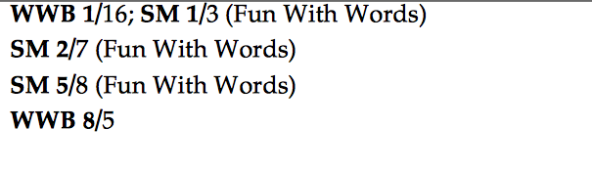  Technology / Open Resources
 | A. Compare formal and informal uses of English.
Grade: 2 | Unit: Language |  |  |  | Time: Pacing: 10 days
Vocabulary and Acquisition Use

Critical Skills (Anchor Standards) | NJ Learning Standards (Progress Indicators): |  | Samples / Exemplars | Resources: |  | Assessments / Rubrics
NJSLSA.L4. Determine or clarify the meaning of unknown and multiple-meaning words and phrases by using context clues, analyzing meaningful word parts, and consulting general and specialized reference materials, as appropriate. | L.2.4. Determine or clarify the meaning of unknown and multiple-meaning words and phrases based on grade 2 reading and content, choosing flexibly from an array of strategies. |  |  | Text (Units / Pages)  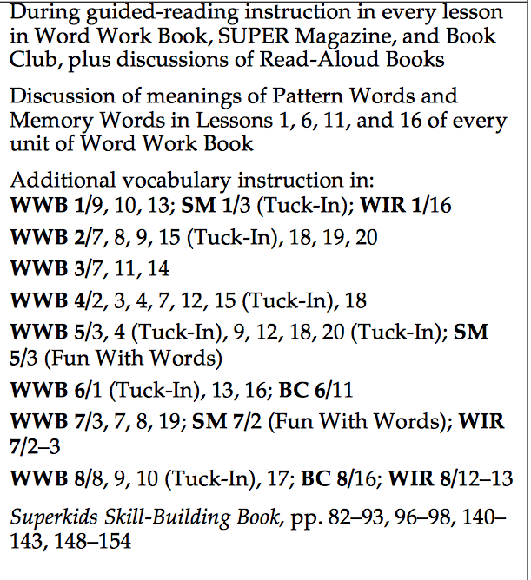  Technology / Open Resources
 | A. Use sentence-level context as a clue to the meaning of a word or phrase. |  | Summer of the Shark
 | B. Determine the meaning of the new word formed when a known prefix is added to a known word (e.g., happy/unhappy, tell/retell).
 | C. Use a known root word as a clue to the meaning of an unknown word with the same root (e.g., addition, additional).
 | D. Use knowledge of the meaning of individual words to predict the meaning of compound words (e.g., birdhouse, lighthouse, housefly; bookshelf, notebook, bookmark). |  | Summer of the Shark
 | E. Use glossaries and beginning dictionaries, both print and digital, to determine or clarify the meaning of words and phrases.
NJSLSA.L5. Demonstrate understanding of word relationships and nuances in word meanings. | L.2.5. Demonstrate understanding of figurative language, word relationships and nuances in word meanings. |  |  | Text (Units / Pages)  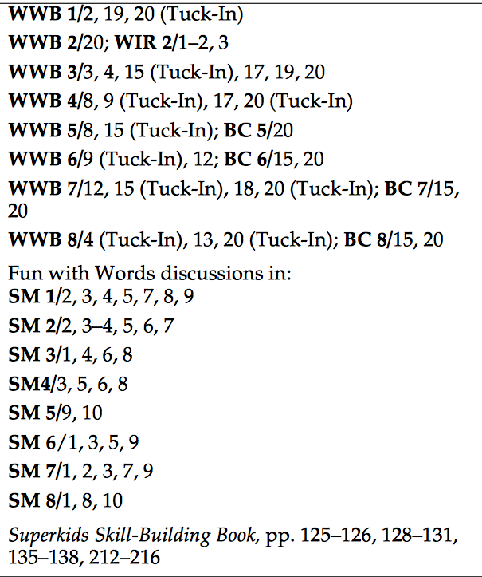  Technology / Open Resources
 | A. Identify real-life connections between words and their use (e.g., describe foods that are spicy or juicy).
 | B. Distinguish shades of meaning among closely related verbs (e.g., toss, throw, hurl) and closely related adjectives (e.g., thin, slender, skinny, scrawny).
NJSLSA.L6. Acquire and use accurately a range of general academic and domain-specific words and phrases sufficient for reading, writing, speaking, and listening at the college and career readiness level; demonstrate independence in gathering vocabulary knowledge when encountering an unknown term important to comprehension or expression. | L.2.6. Use words and phrases acquired through conversations, reading and being read to, and responding to texts, including using adjectives and adverbs to describe (e.g., When other kids are happy that makes me happy). |  |  | Text (Units / Pages)  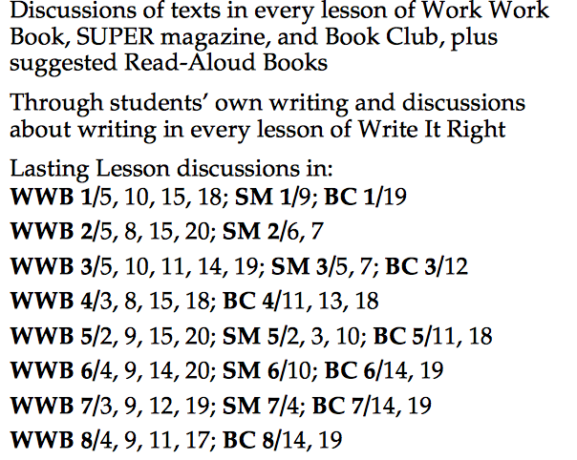  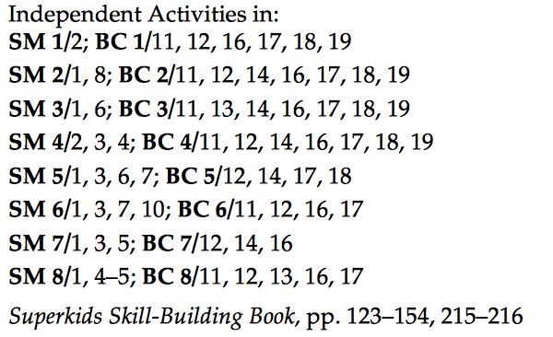  Technology / Open Resources

Assessments | Formative, summative, alternative assessments, performance assessments, project assessments, performance tasks, exit tickets, observations, MAP, benchmarks, Reading Eggs
21st Century Skills and Career Integration | Informational sources, text features
Technology Integration | Digital tools; online series, Reading Eggs, Reading A-Z, Newsela, Read Works
Interdisciplinary Connections | Social Studies and Science- Informational Text
Core Instructional and Supplemental Materials | Core Instruction: Project Read, Orton Gilligham, Super Kids Series  Supplemental: picture books, fictional and non-fictional books, videos
Modifications/Accommodations | ELL: Alternate responses, extended time, teacher modeling, simplified directions, vocabulary banks, manipulatives, nonverbal responses, sentence frames, prompts, partner talk  Special Education: Enlarged graph paper, small group instruction, highlighted  instructions/keywords and/or computation signs, hands on activities, visual cues, number line, modified assessment, models  G&T: Enrichment activities, centers, projects, flexible grouping, interest centers, learning log, extension activities, small group  504/Students at Risk: Enlarged graph paper, small group instruction, highlighted  instructions/keywords and/or computation signs, hands on activities, visual cues, number line, modified assessment, models

