­­

Port Colden Newspaper

Volume 2



The Panther Press



An Interview with Mrs. Cruts

By Tatianna Kicak

**Question 1**: Why did you want to be a teacher?

**Mrs. Cruts:** I wanted to be a teacher because I like helping kids learn.

**Question 2:** What is your favorite part of being a teacher?

**Mrs. Cruts:** My favorite part is getting to know everybody and planning stuff to do.

**Question 3:** What is your favorite subject to teach? Why?

**Mrs. Cruts:** My favorite subject to teach is reading because you can imagine different stories.

**Question 4:** What is your favorite holiday? Why?

**Mrs. Cruts:** My favorite holiday is Thanksgiving because of all the food.

**Question 5:** What is your favorite season?

**Mrs. Cruts:** Fall is my favorite season because the leaves turn different colors.

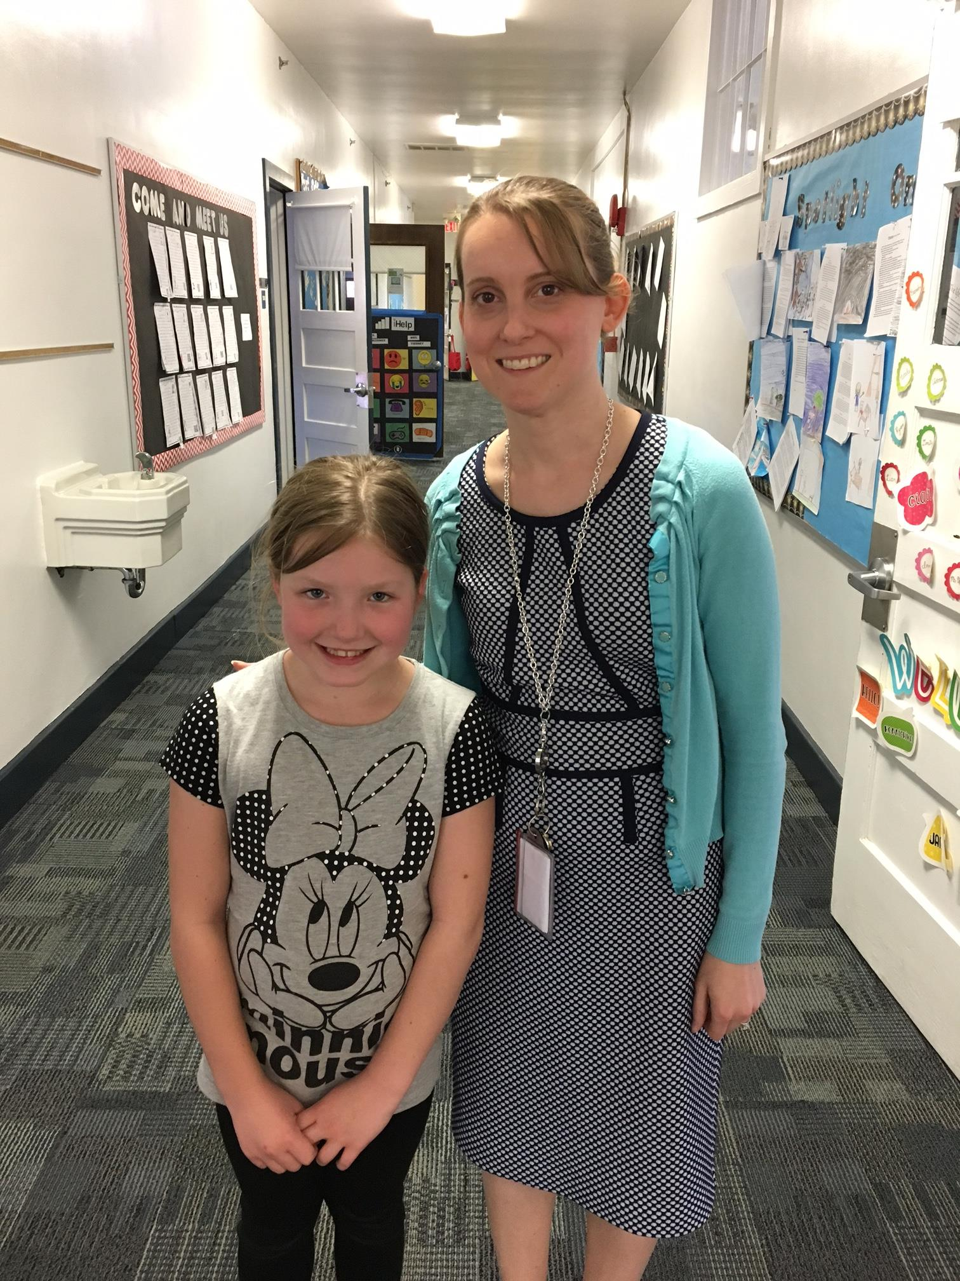

All about Mr. Neu

By Kaydence Raber & Yesenia Rudd

**Question 1**: What is it like being a principal?

**Mr. Neu:** It is the greatest job in the world because I get to help students achieve

**Question 2:** Do you go in every classroom every day?

**Mr. Neu:** Yes. It helps me connect with students and staff, and to be the most effective with teaching and learning.

**Question 3:** What is your favorite part of being a principal?

**Mr. Neu:** My favorite part is being able to aid in building an atmosphere that inspires innovative practices to assist students to be successful.

**Question 4**: What is your favorite color?

**Mr. Neu:** Blue is my favorite color because it is the color of the sky and ocean, and it represents trustworthiness.

**Question 5:** What is your favorite song?

**Mr.Neu:** I like November Rain and Huntin’, Fishin’, and Lovin’ Everyday

Top Six Video Games

By Dominic Kicak and Ivan Kovalev

In our opinion, here are the top 6 video games...

1. Mario Kart Seven/Eight - You can play offline with coms or online with people that play from around the world. You race on different maps. You also pick your character.
2. ROBLOX – There are different games you can choose to play like Phantom Forces, Survive the Distance, Naturals Disaster, and more. You can also play with people from around the world. It is based off Legos where you can build and create things.
3. Minecraft – Similar to ROBLOX, but you mine and grow food to eat for survival.  You can play with or against friends.
4. Hangman- Hangman is a game of words.  To play, you have to guess letters to guess the other player's word/phrase. If you get a letter wrong, you get a part of the hangman.  If you make the man, you lose.
5. MiP- MiP is a toy robot and an app.  You can control him, name him, and play other games with him like Stack, Cans, and more.
6. Vlogger Go Viral – You can choose a character and a name when you start the game.  In the game, you are doing a You-tube set up to get more money and more gems.  The gems are for buying stuff for your character like cow armor.  There is a tournament and when making videos in the comments there are symbols of what video you should do such as football, music, etc. For the tournament, your goal is to get first against people from around the world.  If you get first, you get a skin and money. If you do not come in first, you get money. You need money to buy upgrades for stuff in the house and you have to buy a pug who stays in the house.  When you get the pug, you get to go to the store where you have your pet pineapple.  You tap on him and he will give you gems.  In the store, you have to put stuff down in the store and people come to buy it.  You get dog coins to buy gems.

The “Soup-er Bowl”

By Dominic Kicak

In our school, we started a Soup-er Bowl. This is where you guess who will win the actual Super Bowl. It was the Falcons or the Patriots, and the students needed to bring in a soup can to vote. The most votes were for the Falcons. In the real game the Falcons were winning, but Patriots made a come back to win.  Many people were upset. We donated the cans we collected to First Presbyterian Church in Washington.

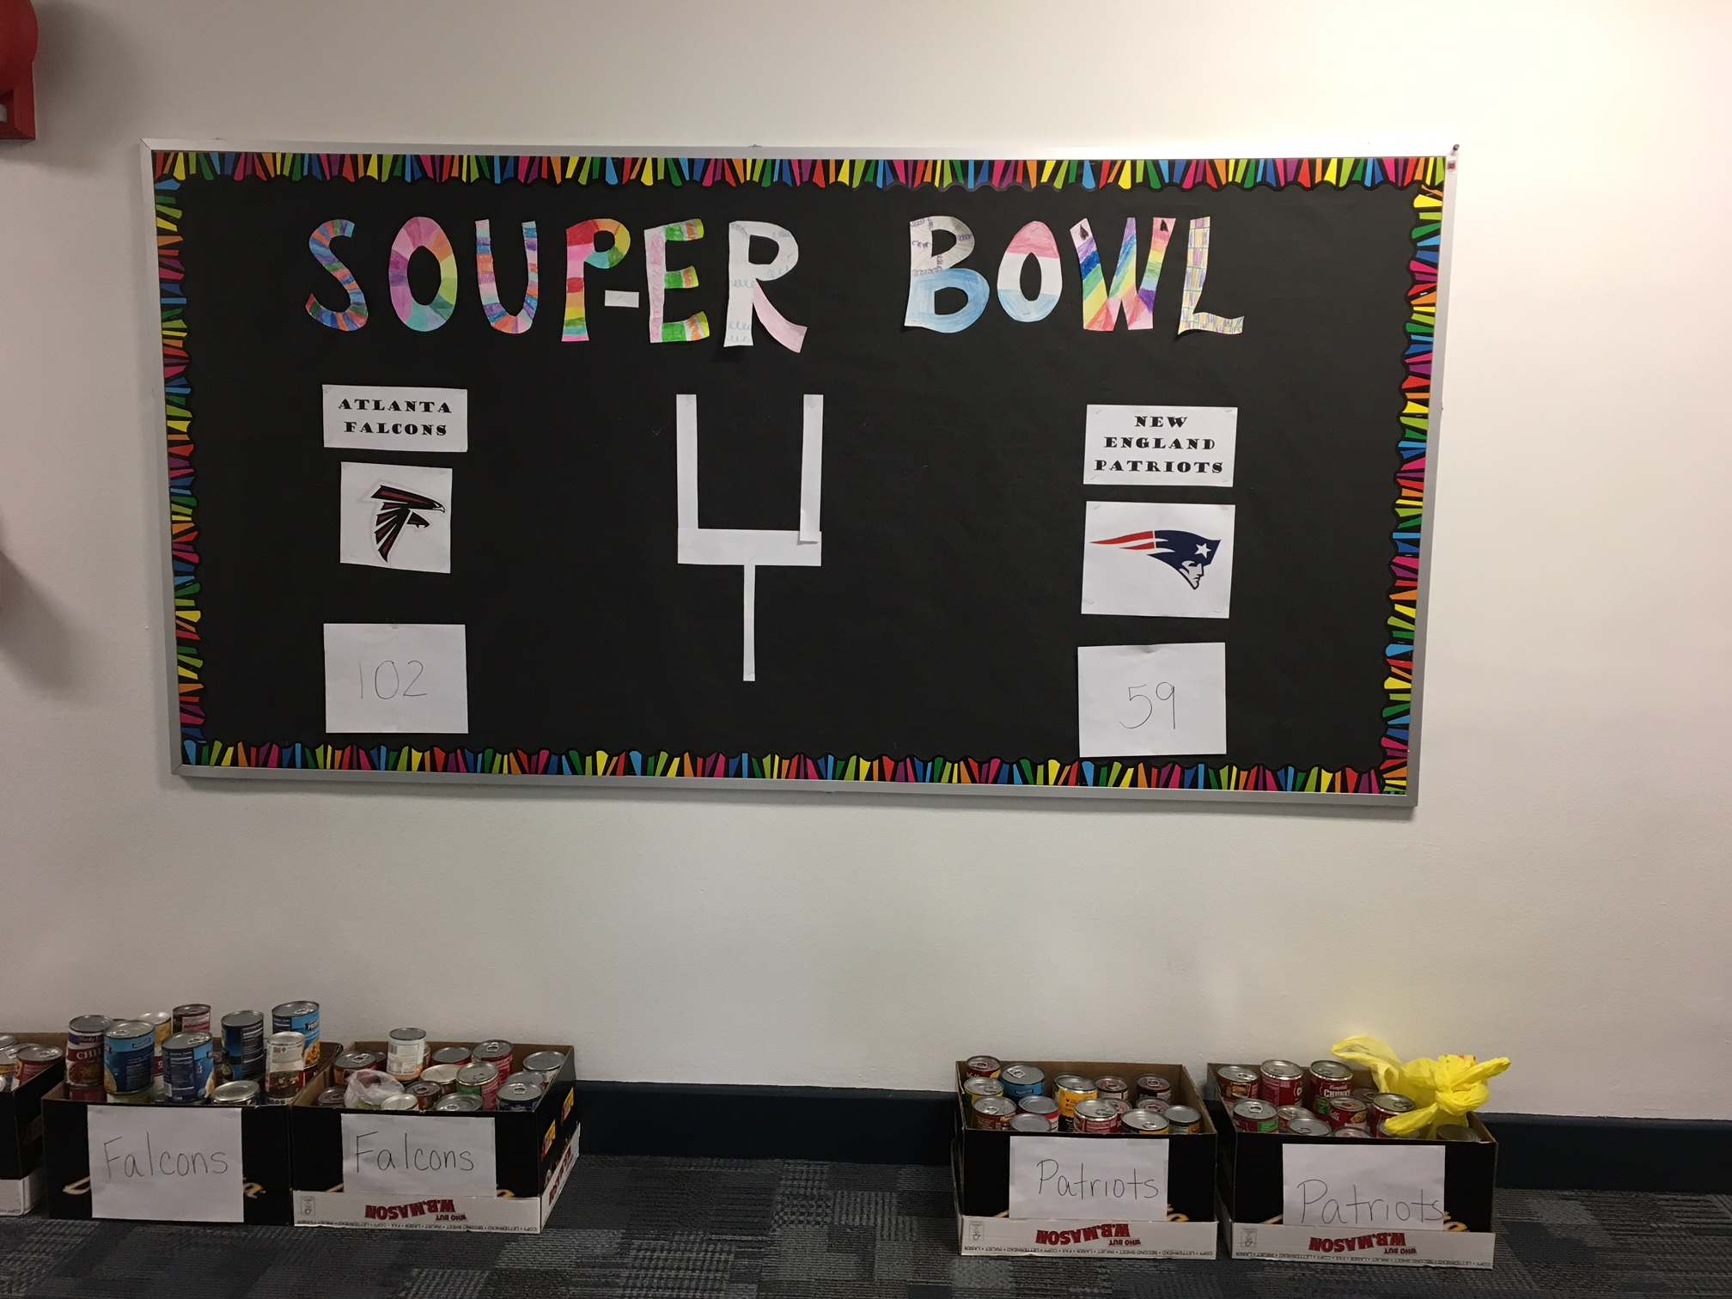

LOL!

What is black and white, and read all over?

A newspaper.

Why can’t an egg tell jokes?

Because he will crack up.

What do you call a magic owl?

Hoo-dini

What travels all around the world, but stays in one corner?

A stamp.

Survey Says….

By Nick Kicak and Victoria Arnold

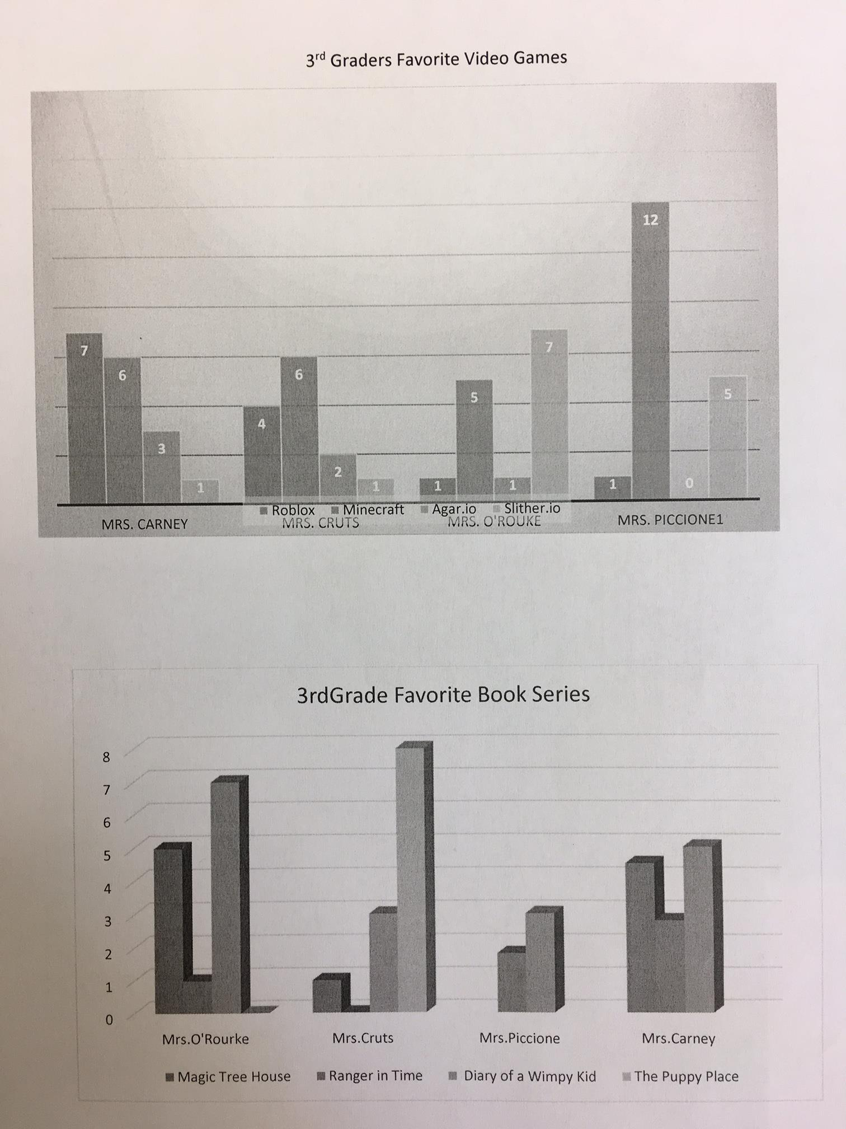

The Winter Fun

By Sofia Trawin

One day two bunnies named John and Jill were playing outside. They were having a snowball fight. They were having so much fun. The score was tied 5 to 5. Then their mom said it was time to go in for supper. They were having their favorite food, CARROT SOUP! Jill had five full bowls and John had three full bowls. They asked if they could go back outside. Their mom said “Yes, but not for too long.” When they went outside, they decided to make a snowman. After the snowman was made, they went sledding down a hill. It was 7:15 pm when their mom called them back in to warm up.

