­­

Port Colden Newspaper

Volume 3



The Panther Press

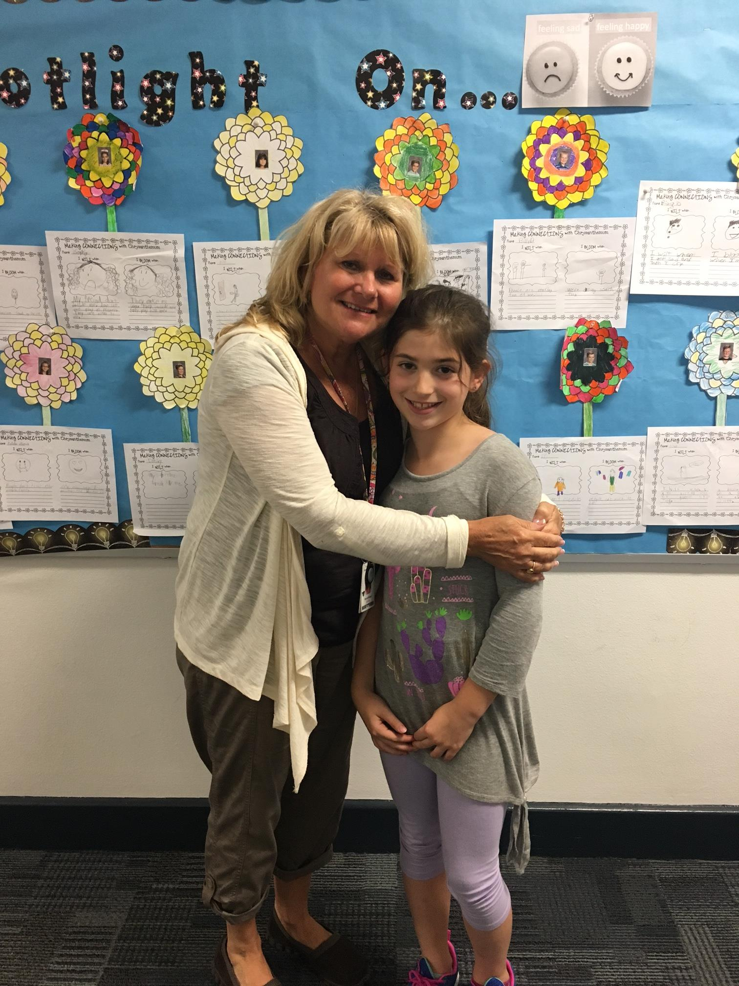

All about Mrs. Klingel

By Sofia Trawin

**Question 1**: Why do you like being a paraprofessional /teacher's aide?

**Mrs. Klingel:** I love children and enjoy helping them learn.

**Question 2:** Do you live near Port Colden?

**Mr. Klingel:** No.

**Question 3:** Why do you like being in a classroom?

**Mr. Klingel:** I enjoy watching the teachers teach, the kids learn, and helping them.

**Question 4**: What do you like to do for fun?

**Mrs. Klingel:** I like camping, walking, and spending time with my grandkids.

**Question 5:** What is your favorite vacation place?

**Mrs. Klingel:** My favorite vacation place is Myrtle Beach, South Carolina.

An Interview with Ms. Mornick

By Dominic Kicak

**Question 1**: Why did you become a janitor? Is it fun?

**Ms. Mornick:** I became a janitor so I could be at school with all of us all day long instead of part of the day.  Yes, it is fun. It can be a messy job, but I can make jokes and have fun doing it.

**Question 2:** Have you ever had a dirty day?

**Ms. Mornick:** YES!!!!!!!!!!!!!!!!!!!!!!!!!!!!!!!!!!!!!!!!!!!!!!!!!!!!!!!!!!! But I always have my rubber gloves ready for when I need them.

**Question 3:** Why do you tell jokes to the students?

**Ms. Mornick:** I like to tell jokes because I like to have fun and make people laugh.

**Question 4:** What do you like to do for fun (outside of work)?

**Ms. Mornick:** I like to do things outside like bike riding, hiking, kayaking, skiing, and camping.

**Question 5:** What will you do in your new house? What do you like best in your new home?

**Ms. Mornick:** I will decorate it and make it home sweet home. I like that I can live there forever, and I helped build my house too.

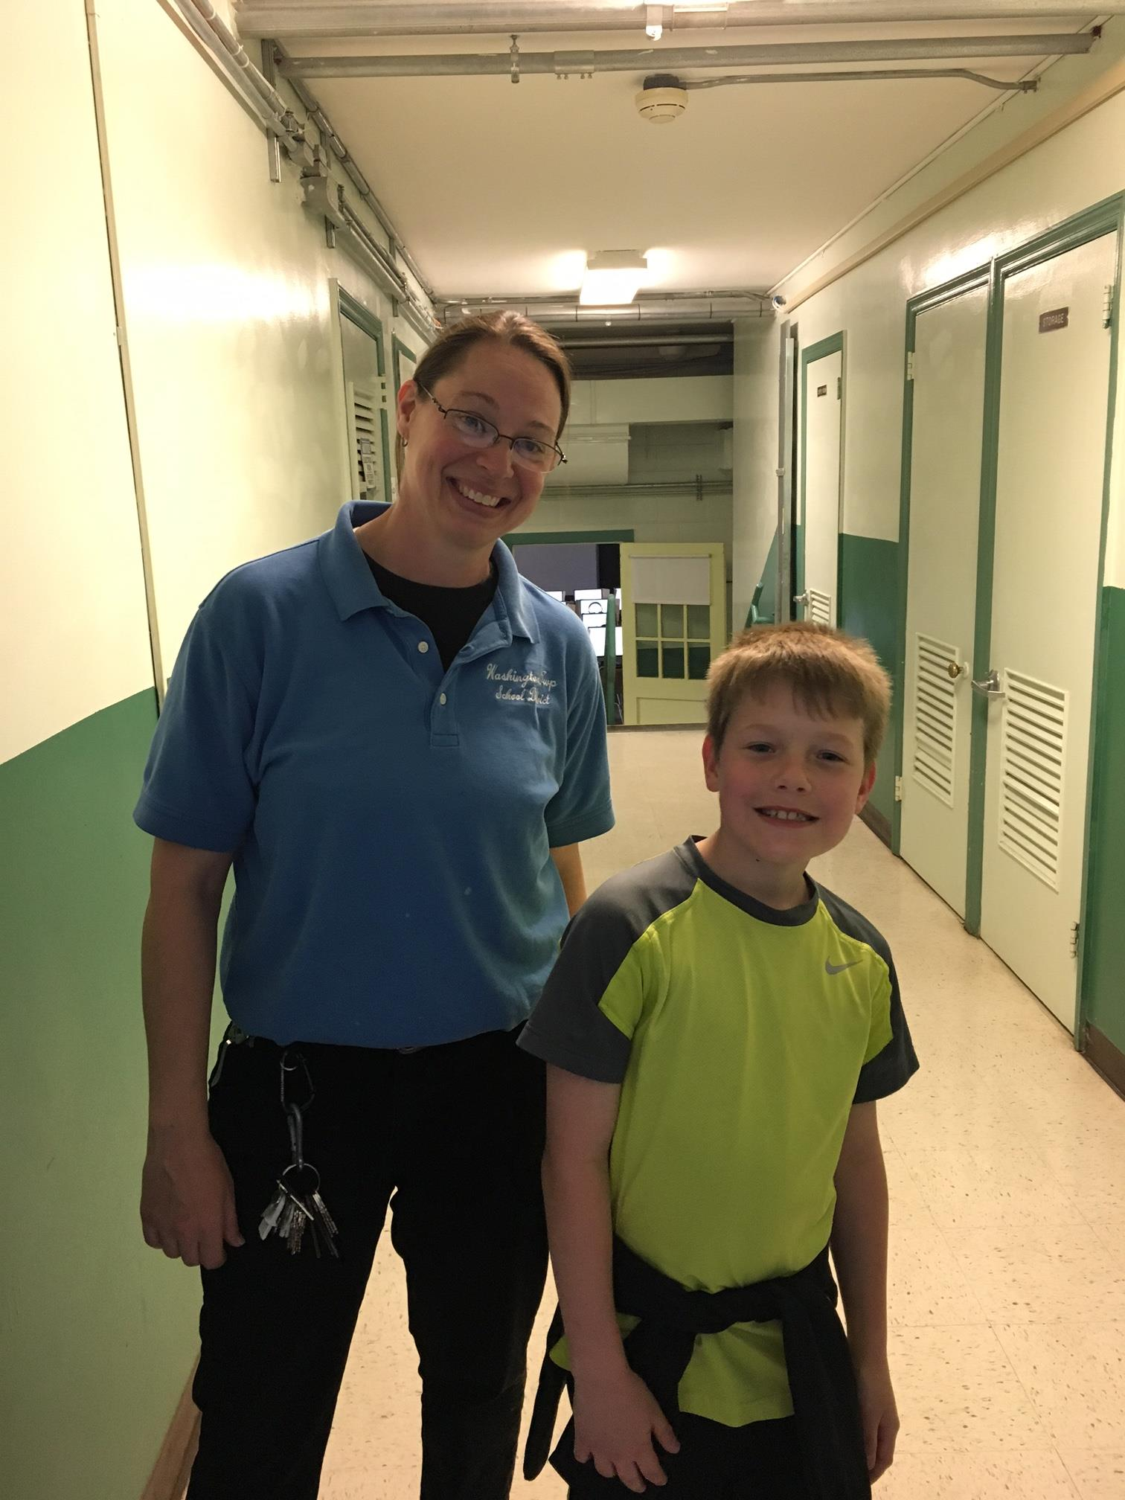

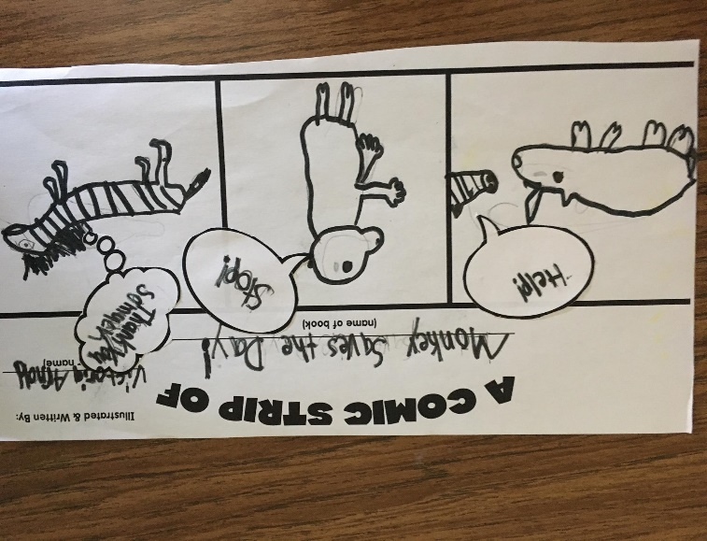

Fun Things to Do this Summer

By Dominic and Nick Kicak

* Go Camping
* Play at the Park
* Go to the Washington Pool
* Play with your Friends
* Play Outside in your Backyard
* Go to a BBQ

The Field Trip

By Nicholas Kicak and Sofia Trawin

The 3rd grade classes went to the Natural History Museum. We went to the planetarium and saw the moon and earth, and we were pretending to be in a rocket ship. We saw the Titanosaur and it was really big. It was so big it had its own room that it could not fit in. It was bigger than the room because the head came out into another room. We saw the humpback whale. We also saw Dum Dum that wanted Gum Gum and we took a picture of him. Another display was the animals in a glass box and the Indians. We saw the dinosaurs RAWRRRRRRRRRRRRRRR.  It was a great day!

The Class Play

By Dominic Kicak

In Mrs. Crut's class, we do a Class Play. We have our own characters in the play and everyone has two people to be. I am Dwarf 2 and Rat. In the play, we need to remember our lines because in the play you will not have our script at all. In addition, you will be singing songs. The name of my play is Character Matters 2.  Mrs. Kupcha's class does Character Matters 1.  You need to make your costume in my class, but maybe your teacher will give you your costume. There are many parts like king, queen, dwarfs and Snow White.  The Play is going to be on June 13, 2017 for our family.

Beauty and the Beast

Movie Review

By Victoria Arnold

 Beauty and the Beast was amazing. It had lots of singing and many cool characters. Some characters are Belle, the beast, and the teacup Chip. It had some violence, which may not be good for younger viewers. My favorite part is when Belle says, "What's your name?" to the hairbrush, but it was not a talking hairbrush. I also liked all the singing. It was a good movie!



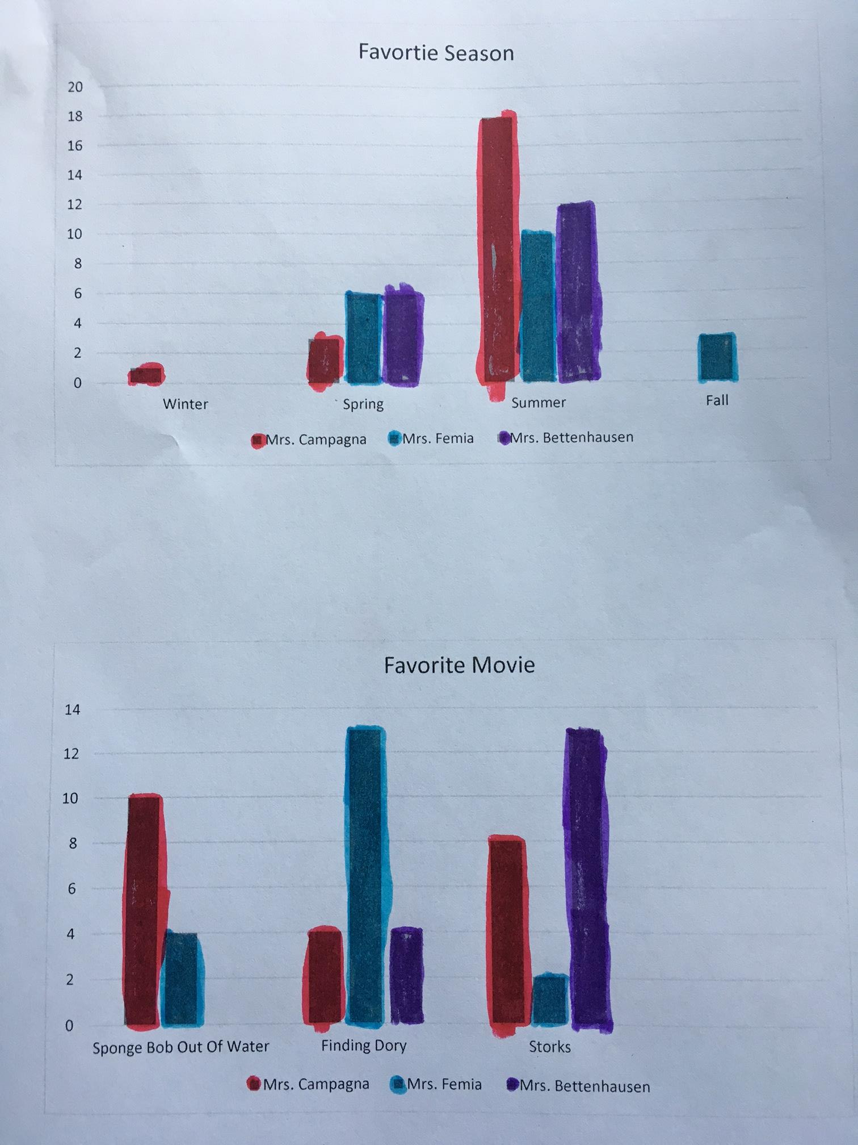

Survey Says…. 1st Grade Favorites

By Kaydence Raber and Yesenia Rudd

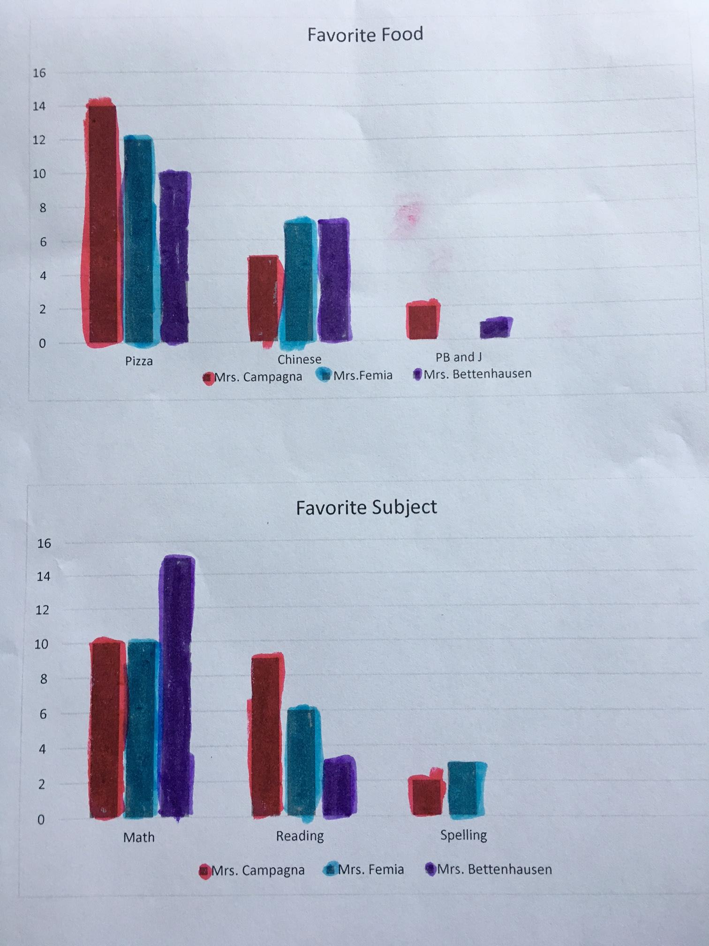

Wordsearch: Spring/Summer Fun

By: Victoria Arnold and Tatianna Kicak

