­­

Port Colden Newspaper

Volume 1



The Panther Press

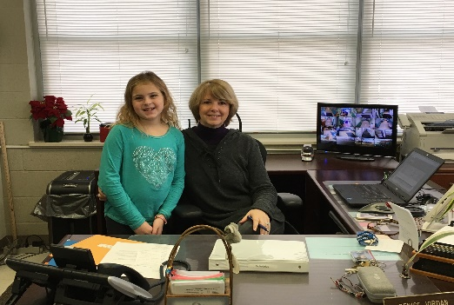

Getting to Know Ms. Jordan

By Victoria Arnold

**Question 1**: How do you like being a secretary?

**Ms. Jordan:** I love it! There is always something new to do or learn.

**Question 2:** What are some jobs that you do?

**Ms. Jordan:** I do State reports, order books and supplies, set up all the programs.

**Question 3:** What is your favorite part of being a secretary? Is it fun?

**Ms. Jordan:** I like seeing kids every day. It is fun when the children come in to the office and tell me a story or what they did over the weekend.

**Question 4**: Do you have any kids? How old are they?

**Ms. Jordan:** I have two kids; one girl who is 33 and one boy who is 31.

**Question 5:** Where do you like to eat? Why is it your favorite place to eat?

**Ms. Jordan:** Dressler (in North Carolina) is my favorite place to eat because it has the best food ever. I enjoy the chicken piccata.

An Interview with Ms. O’Rourke

by Nicholas Kicak

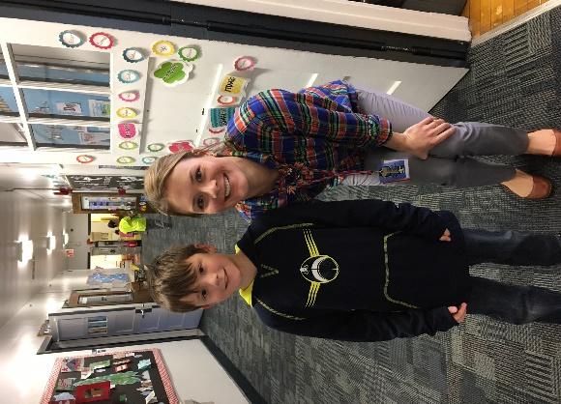

**Question 1**: What do you do in your classroom?

**Ms. O’Rourke:** In my classroom, I teach, Reading, Writing, Math, Science, Social Studies, Health, watch videos, play games, and READ!

**Question 2:** How many year have you taught?

**Ms. O’Rourke:** I been teaching for 4 years.

**Question 3:** Are you happy to be a teacher?

**Ms. O’Rourke:** I am happy to be a teacher because every day it's fun. Each day is different.

**Question 4:** Do you like teaching in your class?

**Ms. O’Rourke:** Yes, I like to teach in the class because third grade is new and exciting.

**Question 5:** What is your favorite subject?

**Ms. O’Rourke:** It is hard to choose a favorite subject because the all teach me new, interesting things. However, I do like teaching Reading because I love to read and get lost in exciting stories! I try to show my students how great reading is too!

**Question 6:** Is it fun to do running club?

**Ms. O’Rourke**: Running club is fun because we get to be outside and running feels good.

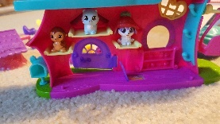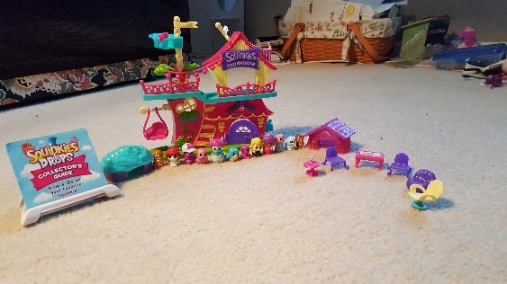

Squinkies, a fun toy!

By Victoria Arnold

Squinkies are a new fun toy to play with. Squinkies are like Shopkins, but instead they’re animals. They have a clubhouse, an airplane and an aquarium. They would be good for kids in grade school. Squinkies would make great stocking stuffers. Squinkies are a terrific new toy to play with!

All About theVeteran’s Day Assembly

By Dominic and Nicholas Kicak

Veterans Day is to celebrate the men and women who served our country in the armed forces. We are thankful for the Veterans who helped and saved our country. At our Veteran’s Day assembly, we saw the veterans fold an American flag. We also sang patriotic songs and saw someone ring the bell 11 times. Ringing the bell 11 times symbolizes that the war started on the 11 month on the 11 day at the 11 hour so that's why we celebrate Veterans Day on November 11. Grade 3 students participated in a contest in which they had to write about why veterans are important or a veteran hero. Ben Marcolini from Mrs. Page's class won. Below is his winning essay.

My veteran heroes are the members in my family that have served in the armed forces. My ninth great grandfather fought in the Revolutionary War to help us gain freedom from England. Also, my sixth great grandfather fought in the Civil War to keep America united. He was in the West Virginia Calvary. My great grandfather loaded bombs on airplanes during World War 2. Also, my great-great Uncle Joe was a sniper and was captured by the Germans at the Battle of the Bulge. My great-great Uncle John was awarded the Purple Heart for being wounded in World War II. Finally, my great Uncle John was deployed overseas over 15 times with the Air National Guard. I feel grateful that people have sacrificed their lives for other people.

My Time in Science Club

By Ivan Kovalev

In Science Club, we did a lot of experiments and different reactions. Then we would show what we learned on the iPads. We had a lot of writing to do by making a list of the stuff we did and materials we used. I had a great time in science club when we did the experiments. My favorite experiment was when had a session outside for our ghost rockets. Mrs. Cruts planned many fun activities! I HAD SO MUCH FUN!

                                                                               By Ivan.Kovalev

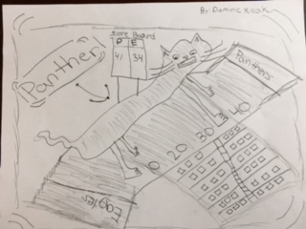

School Subjects

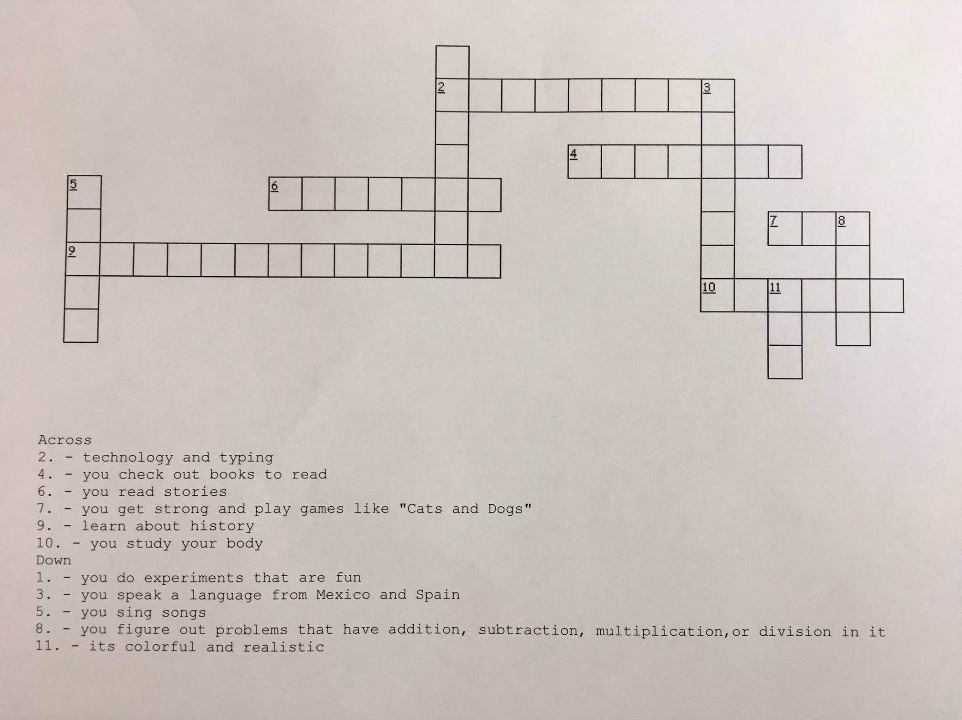

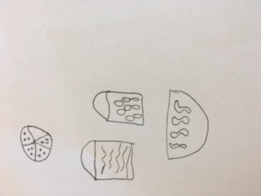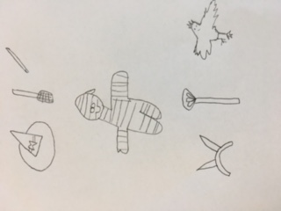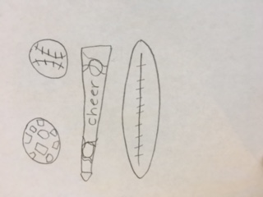

The Winter Concert

By Tatianna Kicak and Sofia Trawin

Port Colden’s winter concert was held Thursday, December 8. The school we held the concert at was Oxford school. Our music teacher, Mrs. Dahmer, practiced and prepared us for the big night. First graders started the night by singing the classic Rudolph the Red Nose Reindeer. Then second grade sang a Hanukkah song. Last, third grade sang This Holiday, Ringing Ringing, and Snowman, Snowman Where'd You Go?. We ended the night with We Wish You a Merry Christmas. The concert was a success.

Survey Says…

By Tatianna Kicak, Yesenia Rudd, and Sofia Trawin

Favorites are listed by class.

Favorite Food:

Buttered Noodles – none

Chinese – Mrs. Kruger, Mrs. Kupcha, Mrs. Cruts

Pizza – Mrs. Femia, Mrs. Campagna, Mrs. Harper, Mrs. Slack, Mrs. Carney, Ms. O’Rourke, Mrs. Page

Favorite Costume:

Witch – Mrs. Campagna, Mrs. Femia

Mummy – Mrs. Kruger, Mrs. Kupcha, Mrs. Cruts, Ms. O’Rourke, Mrs. Page

Maleficent – Mrs. Harper, Mrs. Slack, Mrs. Carney

Favorite Sport:

Soccer – Mrs. Femia, Mrs. Harper, Mrs. Cruts, Ms. O’Rourke

Football – Mrs. Kruger, Mrs. Campagna, Mrs. Kupcha, Mrs. Page

Cheerleading – Mrs. Slack, Mrs. Carney

Baseball - none